Alfriston College

Amendment of Enrolment Scheme

Overview – what is changing?
The Ministry is proposing to amend the Alfriston College home zone so that the eastern portion of the zone extends eastwards to overlap with the northern side of Papakura High School’s proposed zone and so that there is a small western expansion to the railway line. There is no proposed reduction area to the Alfriston College zone. This is shown on the map below. The written description is as follows:
Starting at the intersection of Great South Road and Hill Road, travel southeast along Great South Road (154-226 even addresses only) until Weymouth Road. Travel west along Weymouth Road until the railway line, and then travel southeast along the railway line until Great South Road. Continue along Great South Road until Taka Street, where the southern boundary begins. Addresses on the north side of the southern boundary roads only included: Travel east along Taka Street, north along Takanini School Road, and then east again along Airfield Road until Mullins Road/Alfriston-Ardmore Road. Continue slightly northwest along Alfriston-Ardmore Road and then northeast along Clevedon-Takanini Road until Papakura-Clevedon Road. Travel south along Papakura-Clevedon Road until Tourist Road, at which point turn east and travel along Tourist Road until Mcnicol Road. Briefly travel north along Mcnicol Road and turn east at Olau Mountain Road. Travel along Olau Mountain Road and then continue along as it becomes Mckenzie Road until Mckenzie road ends at Moumoukai Hill Road. Travel east along Moumoukai Hill Road and then continue along Plows Road until St Pauls Road, where the southern boundary ends and the eastern boundary begins. From that point, travel north to the intersection of Orere Point River and Kawakawa-Orere Road, and then northeast to the end of Bays Road in the Orere Point Township. From the end of Bays Road, travel west along the coastline until North Road at Umupuia Beach. From there, travel southwest across country to the end of Solway Road, including both side of North Road. From the end of Solway Road, the boundary continues to the end of Ara-Kotinga and then to the intersection of Polo Lane and Whitford Park Road, including Polo Lane and no exit lanes off of Polo Lane. The boundary then travels to the intersection of Redoubt Road and Umbria Lane (included). Then, travel down Redoubt Road until 159 Redoubt Road, both sides of Redoubt Road from 159 to 651 (odd) and 680 (even) included. Then travel south along the western boundary of Totara Park and then the Auckland Botanic Gardens until the Southern Motorway (SH1). Travel south along SH1 until Hill Road (odd addresses below 89 from the intersection until Great South Road only included) and then west along Hill Road until returning to the boundary’s origin at the intersection of Great South Road and Hill Road.
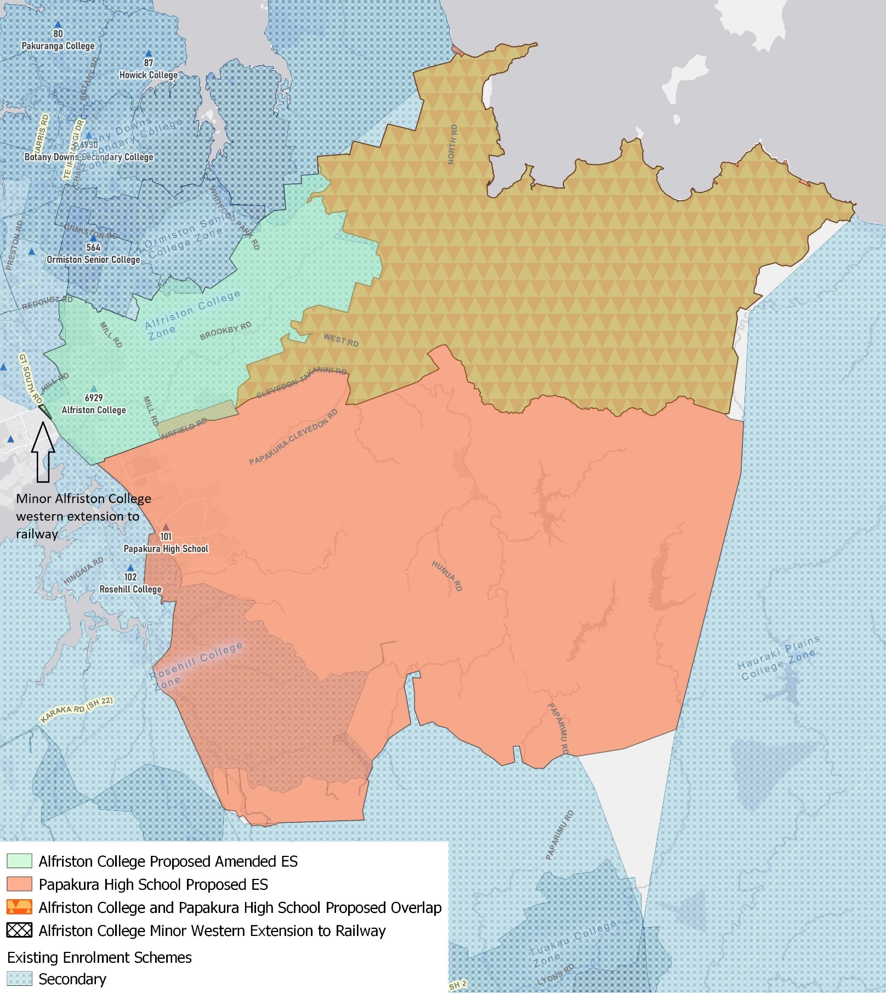

What does this mean for my family?
Any student currently enrolled at Alfriston College will not be impacted by a change to the enrolment scheme. All students enrolled (and have started attending) will be entitled to continue attending Alfriston College, irrespective of where they currently live.
The change to the home zone will affect all enrolments starting in 2022. It is important to note that enrolment starts when you first attend school, not when enrolment forms are completed.
An in zone enrolment is automatically entitled to enrol at the school. An out of zone enrolment is not guaranteed a place at the school and you will need to apply through the school’s out of zone processes if there are spaces available.

Consultation process and timeline
The Ministry of Education is currently undertaking consultation about the proposed changes and new enrolment schemes. You can have your say by:
- Completing the survey at https://consultation.education.govt.nz/education/alfriston-papakura-proposals
- Emailing auckland.enrolmentschemes@education.govt.nz if you have further questions or comments
Consultation will run from Wednesday 7th July, until Friday 13th of August. The Ministry will consider all feedback and liaise with the Board before making a final decision. We expect the School community to be updated about progress made about mid-Term 3 The new schemes and changes will come into effect for the beginning of 2022.

