Papakura High School

New Enrolment Scheme

Overview – what is happening?
The Ministry of Education is developing an enrolment scheme for Papakura High School, which will be in effect for the beginning of term 1 in 2022. Having an enrolment scheme in place will ensure the Board of Trustees has a fair and transparent mechanism to manage the roll as it grows. Children that live within this area will have entitlement to enrol at Papakura High School. The home zone area is shown on the map on the next page and includes:
Starting at the intersection of Taka Street and the railway line, travel southeast down the railway line until Papakura Station. Then, travel west along Wood Street and then south along Great South Road (even numbered addresses 260 to 468 included), and then travel east until Utūwairoa Stream. Continue traveling east along Utūwairoa Stream and then the southern boundary of Ōpaheke Reserve until the railway line. Then, travel south along the railway line until State Highway 1, and then continue south along SH1 until the intersection of Dale South Road and Hillview Road. From that intersection, travel southeast to Matthew Whitford Drive, and then east to Totara Road (excluded), including Ararimu Road to the intersection with Steel Road (excluding Dunn Road). Including Dale, Maxted, Fausett, Turner, and Steel Roads and no exit roads off those roads. Then, travel northwest along Ararimu Road (excluded, but including roads north of the boundary except no exit roads off of Aramiru Road) until Paparimu Road (including north of the intersection). From that intersection, the travel east until A R A Drive mountain biking trail. Then, travel northeast until the end of Mine Road. From there, travel north to the intersection of Orere Point River and Kawakawa-Orere Road, and then northeast to the end of Bays Road in the Orere Point Township.
From the end of Bays Road, travel west along the coastline until North Road at Umupuia Beach. From there, travel southwest along North Road, including both sides of the road, until Clevedon. From Clevedon, travel south along Papakura-Clevedon Road and then west along Clevedon-Takanini Road (including both sides of roads, Twilight Road to 105, West Road to 213, Parish Line Road) until Alfriston-Ardmore Road. Then, travel west along Airfield Road (both sides of road until Mill Road intersection, then only odd addresses) until Takanini School Road. Travel south on Takanini School Road, and then west on Taka Street (odd addresses only) until the railway line to return to the start of the boundary

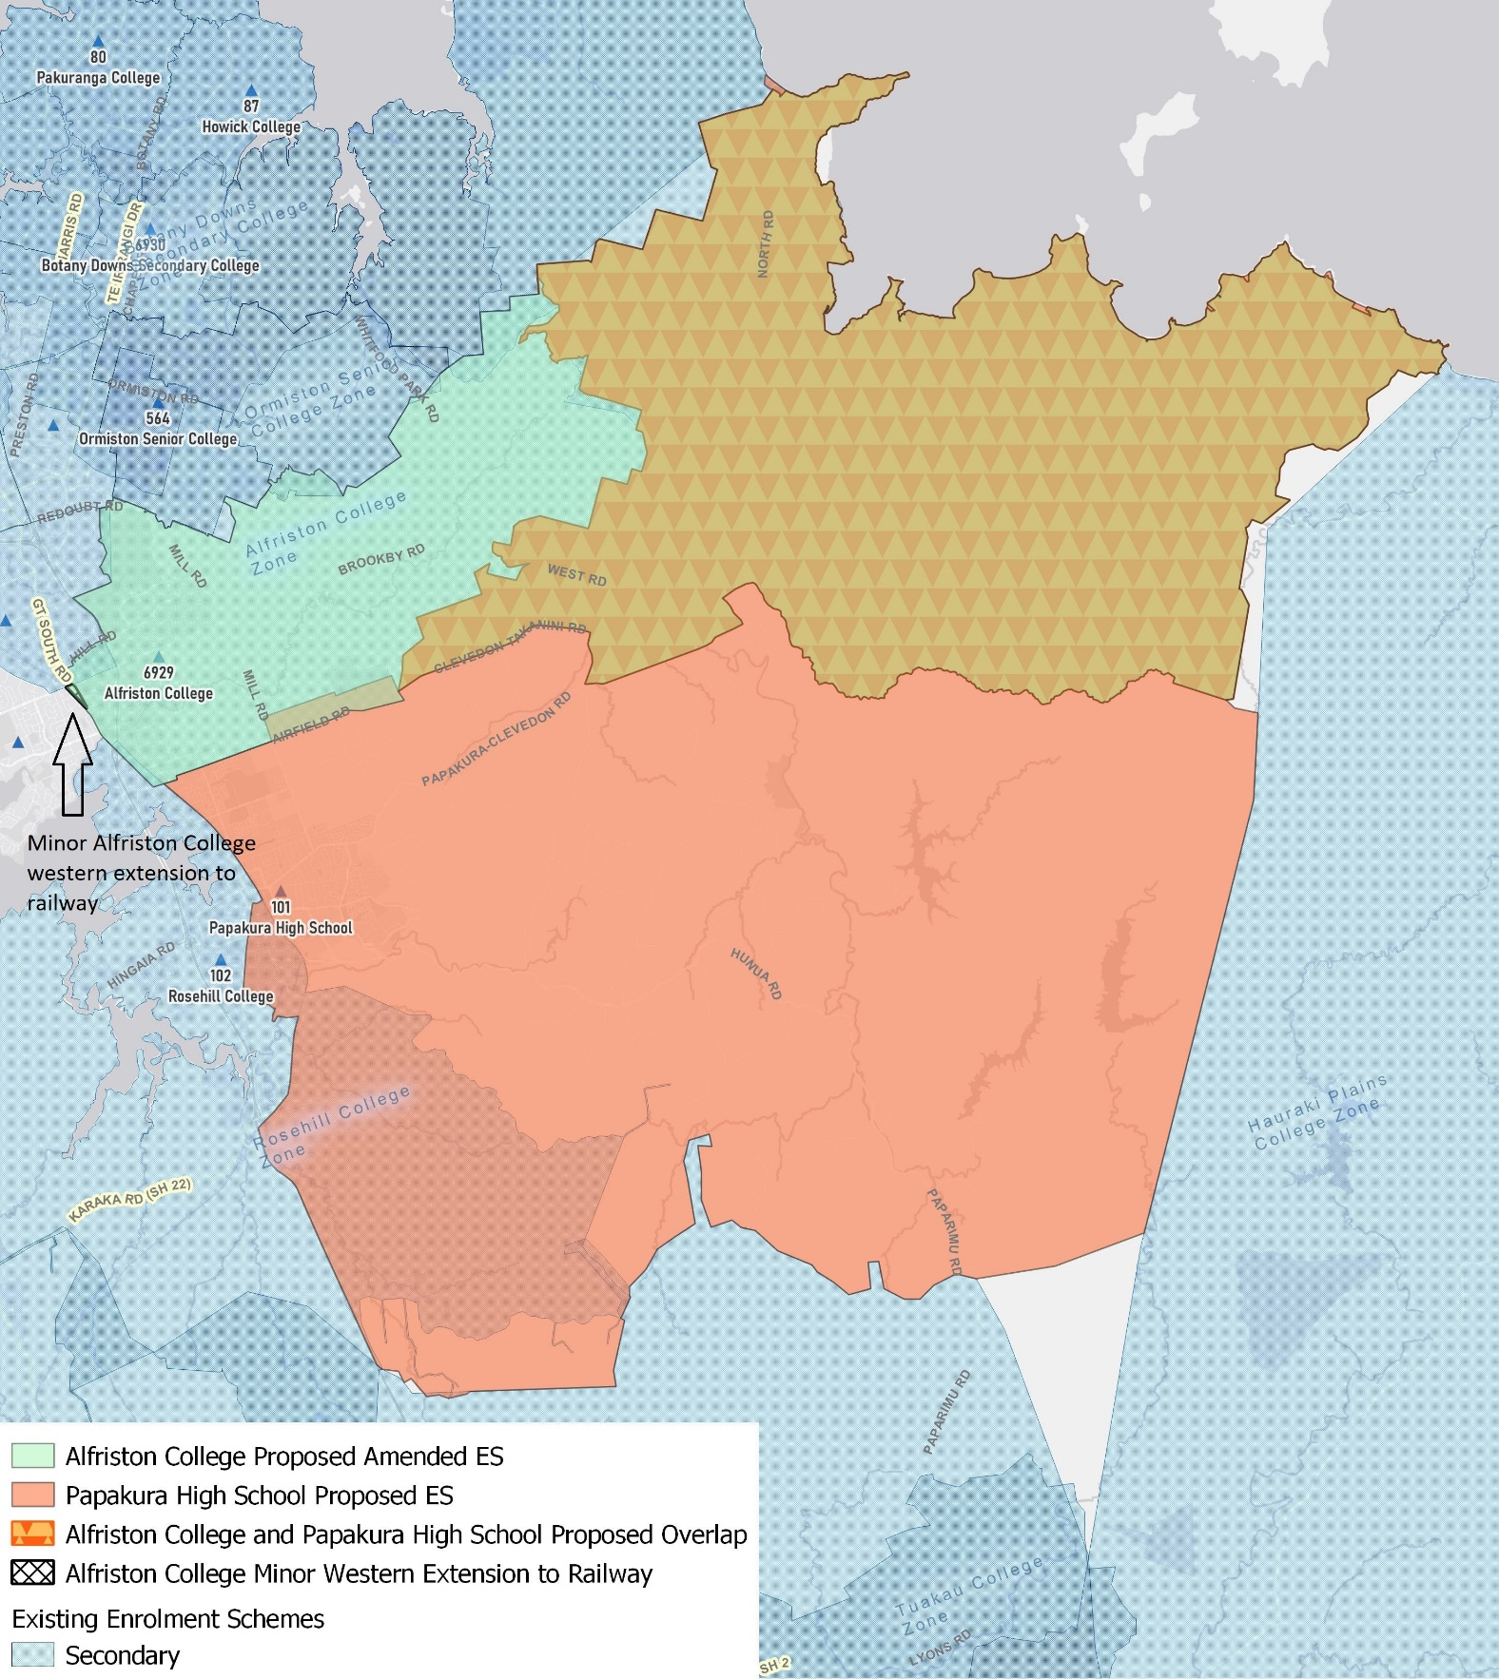

What does this mean for my family?
If you live in enrolment scheme home area for Papakura High School you will be entitled to enrol your child at the school. This entitlement applies to new students starting school, as well as any students currently attending another school in the area.
Families who live outside the enrolment scheme home zone of Papakura High School do not have entitlement to enrol and could only attend if the Board of Trustees planned to enrol any out of zone students. The enrolment scheme will establish the process for this, and places will only be available if the Board of Trustees considers it has the capacity to allow for this. Further information about whether any out of zone places will be made available will be made later in 2021.

Consultation process and timeline
The Ministry of Education is currently undertaking consultation about the proposed changes and new enrolment schemes. You can have your say by:
- Completing the survey at https://consultation.education.govt.nz/education/alfriston-papakura-proposals
- Emailing auckland.enrolmentschemes@education.govt.nz if you have further questions or comments
Consultation will run from Wednesday 7th July, until Friday 13th of August. The Ministry will consider all feedback and liaise with the Board before making a final decision. We expect the School community to be updated about progress made about mid-Term 3 The new schemes and changes will come into effect for the beginning of 2022.

