Avondale Intermediate

Amendment of Enrolment Scheme

Overview – what is changing?
The Ministry is proposing to amend the Avondale Intermediate home zone so that it extends slightly east in the south-eastern boundary of the zone. This is shown on the map below. The written description is as follows:
Starting at the intersection of Ulster Street (excluded) and Wolverton Street, travel east along Wolverton Street (69-85, 70-108 included) to St Georges Road. Travel north east along St Georges Road, east along Chalmers Road and New Windsor Road (even addresses 2-46 included), and then north along Bollard Road (odd addresses 77 and below and even addresses 70 and below included). Travel north east along New North Road (1080, 1081 and above included) and north along Woodward Road. Travel north along the centre of Carrington Road (145 and below, odd numbers only included) to the Northwestern Motorway (SH16). Travel west along the Northwestern Motorway to the coastline and continue along the coastline around the Waterview and Rosebank Peninsulas. Travel south along the western coastline of the Rosebank Peninsula, following the Whau River past Ash Street (included) and Great North Road (1363-2171, 1380-2180 included) to where the river joins the Avondale Stream. Continue south along the Avondale Stream through Olympic Park to Wolverton Street, and back to the starting point.
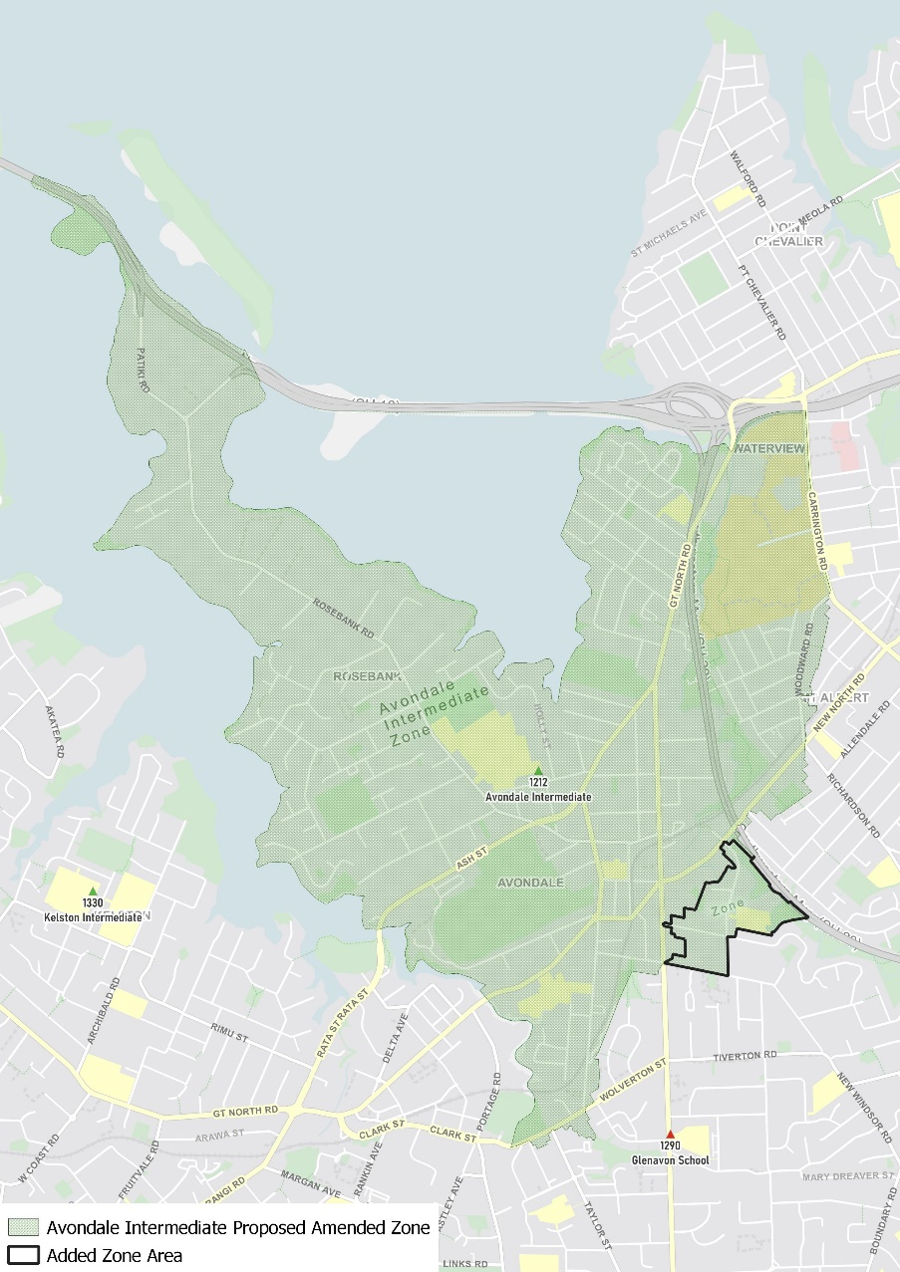

What does this mean for my family?
Any student currently enrolled at Avondale Intermediate will not be impacted by a change to the enrolment scheme. All students enrolled (and have started attending) will be entitled to continue attending Avondale Intermediate, irrespective of where they currently live.
The change to the home zone will affect all enrolments starting in 2022. It is important to note that enrolment starts when you first attend school, not when enrolment forms are completed.
An in zone enrolment is automatically entitled to enrol at the school. An out of zone enrolment is not guaranteed a place at the school and you will need to apply through the school’s out of zone processes if there are spaces available.

Consultation process and timeline
The Ministry of Education is currently undertaking consultation about the proposed changes and new enrolment schemes. You can have your say by:
- Completing the survey at https://consultation.education.govt.nz/education/avondale-intermediate-enrolment-scheme-amendment/consultation/intro/
- Emailing auckland.enrolmentschemes@education.govt.nz if you have further questions or comments
Consultation will run from Monday 14th June, until Friday 30th of July. The Ministry will consider all feedback and liaise with the Board before making a final decision. We expect the School community to be updated about progress made about mid-Term 3 The new schemes and changes will come into effect for the beginning of 2022.

