Bay of Islands College (#8)

New Enrolment Scheme

Overview – what is changing?
The Ministry of Education regularly monitors enrolment patterns, population growth and anticipated school roll changes across the Tai Tokerau district. As part of this monitoring and regular review, we now consider an enrolment scheme is necessary for Bay of Islands College. This is due to growth of the school roll and because we need to ensure the Board has a fair and transparent mechanism to manage the roll. It also means we can ensure we are making best use of educational facilities across the wider Tai Tokerau area.
The new enrolment scheme will have a home zone, like other schools with enrolment schemes in the area. Children that live within this area will have entitlement to enrol at Bay of Islands College. The home zone area is shown on the map below and described here:
BAY OF ISLANDS COLLEGE (#8)
Proposed Draft Enrolment Scheme
Commencement date: 01 January 2025

The guidelines for development and operation of enrolment schemes are issued under Schedule 20, Clause 3 (3) of the Education and Training Act 2020 for the purpose of describing the basis on which the Secretary’s powers in relation to enrolment schemes will be exercised.
Home Zone
All students who live within the home zone described below shall be eligible to enrol at the school.
From Bay of Islands College the zone travels south and east along State Highway 1 as far as the intersection with Domain Road and Tapuhi Road just after Hukerenui School. Turn left onto Tapuhi Road and travel north along Tapuhi Road to the intersection of Waiotu Road and Nelsons Road. Nelson Road addresses are included. From the end of Waiotu Road the zone travels north-east across to number 2916A and 2916B Russell Road. From 2916A and 2916B Russell Road the zone travels north along Russell Road to include addresses on Papakauri Road, Whangaruru Wharf Road, and numbers 53 and 56 Punaruku Estuary up to the intersection with Rawhiti Road. Turn right into Rawhiti Road and travel north along Rawhiti Road to include all Rawhiti Road addresses as far as the boat ramp at Kaimarama Bay. Note that all Pakehaua Road, Whangaruru North Road, Punipuni Road, Whakaturia Ave, Logan Nicks Road, Ngatiwai Place, Martin Road, Hikuwai Road, and Kokinga Point Road addresses are included.

From the intersection of Rawhiti Road and Manawaora Road, travel east along Manawaora Road and then onto Kempthorne Road. Bentzen Drive, Smith-Grey Crescent, Kingfisher Point Road, Jills Bay Lane, Jacks Bay Road addresses are included. Turn right onto Russell Whakapara Road and travel west to the intersection with Waikare Road. All addresses from here and west to Okiato settlement and Russell township are in-zone including Ipiriri Drive, Vittorio Drive, De Nora Drive, Ahutoru Drive, Te Awa o Te Taonga Drive, Te Aramako Drive, Otamarua Road, Paroa Bay Road.

From the Russell Whakapara Road/Waikare Road intersection, travel south and then west along Waikare Road up to the intersection with Paihia Road (Waikare Valley Road, Whaakaurau Valley Road, Kura Road, Owae Road, Pakaru Road, Waikino Road, Piwakawaka Rise, and Ranui Road addresses are included). Turn right into Paihia Road and travel north along Paihia Road to include all Opua, Te Haumi, and Paihia addresses. From Paihia Road (SH11) the zone continues onto Seaview Road and Marsden Road, and then travels north through the roundabout with Puketona Road onto Te Karuwha Parade up to the intersection with Te Kemara Avenue by the Waitangi causeway. All addresses on Te Kemara Avenue, Tahuna Road and Ngatirahiri Road are included.

From here the zone turns back to the intersection with Puketona Road (SH11) and travels west along Puketona Road as far as Kaipatiki Road just before the causeway over to Haruru. The zone travels along Kaipatiki Road and then south-west through the Opua forest to where the forest meets Oromahoe Road, just to the east of, but not including number 951 Oromahoe Road. From here the zone travels east along Oromahoe Road to the intersection with Whangae Road.

Travel south along Whangae Road from the Oromahoe Road intersection to the intersection with State Highway 1. Number 404 McIntyres Road is in-zone as are addresses from number 565-774 McIntyre Road inclusive. From Whangae Road turn right onto State Highway 1 and travel west through Moerewa and then through Pakaraka as far as number 7048 State Highway 1. From here turn back east along State Highway 1 to the intersection with State Highway 10. Waikopiro Lane addresses are in-zone. Ludbrook Road, Olive Grove, Parkland Drive, Meadow Lane, Lakeland Lane are in-zone. State Highway 10 addresses from the intersection with State Highway 1 up to number 254 State Highway 10 are in-zone. Hupara Road, Ngahuhu Road, Smeath Road, Pinehill Road, Hautapu Road, Smith Road, and Marshall Road addresses are in-zone.

From the intersection of SH1 and Pembroke St turn right onto Pembroke St and then left onto Otiria Road. Travel east along Otiria Road and then continue along Ngapipito Road as far as number 1193 Ngapipito Road. All addresses on Ngawhitu Road, Packer Road, Rodger Road, Cherrington Road, Tana Road and Davey Road are included. Turn back east from 1193 Ngapipito Road and travel back to the intersection with Pokapu Road. Turn left into Pokapu Road. Travel south along Pokapu Road up to the intersection with Orakau Road. Addresses on Davis Road, Kaka Road, Mangu Road, Paraha Road, and Peri Road are included. Number 1609 Orakau Road by the Orakau Road/Pokapu Road intersection is included in-zone. From the intersection with Orakau Road travel east into Matawaia-Maromaku Road. Travel along Matawaia-Maromaku Road up to the intersection with Callaghan Road. Pipiwai Road addresses from the Matawaia-Maromaku Road intersection down to number 4623 Pipiwai Road are included, as is Waa Hoterene Road. Kupa Road, Martin Road, Pokere Road, Opahi Road, Henare Road, Tipene Road, Mihirata Road, Puhitia Road, Taikirau Road, and Masons Road addresses are in-zone. Callaghan Road, Horahora Road, Inksters Road and Rata Tipene Road addresses are in-zone.

From the Callaghan Road intersection continue along Maromaku-Towai Road onto Oetzmans Road and then Browns Road through to the intersection with Paiaka Road. Marlow Road addresses from number 71 Marlow Road up to the intersection with Callaghan Road are in-zone as are Bolero Road and Oetzmans Road addresses.

From Browns Road turn right into Paiaka Road and travel south along Paiaka Road to the Crows Nest Road intersection. Wallace Road addresses are in-zone. Turn right onto Crows Nest Road and travel up to the intersection with Smit Road. From here turn back left along Crows Nest Road to SH1. Turn right onto SH1 and back to the intersection with Tapuhi Road.

All residential addresses on included sides of boundary roads and all no exit roads off included sides of boundary roads are included in the zone unless otherwise stated.

Section 75 of the Education and Training Act 2020 states that

“the Secretary may authorise an enrolment scheme to permit a student to enrol at the school as if the student lived in the home zone of the school if, -

(b) in the case of a new enrolment scheme, the student,

1. lives outside of the home zone of the new enrolment scheme; and
2. has a sibling who is enrolled at the school at the time that the new enrolment scheme is implemented.”

Special Programmes
This priority category is not applicable at this school because the school does not run a Special programme approved by the Secretary.
Out of Zone Enrolments
Each year the Board of Trustees will determine the number of places which are likely to be available in the following year for the enrolment of students who live outside the home zone. The Board will publish this information by public notice in a medium appropriate to the area served by the school. The notice will indicate how applications are to be made and will specify a date by which all applications must be received.
Applications for enrolments will be processed in the following order of priority:
First Priority
This priority is not applicable at this school because the school does not run a special programme approved by the Secretary for Education.
Second Priority
will be given to applicants who are siblings of current students.
Third Priority
will be given to applicants who are siblings of former students.
Fourth Priority
will be given to any applicant who is a child of a former student of the school.
Fifth Priority
will be given to any applicant who is either a child of an employee of the board of the school or a child of a member of the board of the school.
Sixth Priority
will be given to all other applicants.

If there are more applicants in the second, third, fourth, fifth or sixth priority groups than there are places available, selection within the priority group will be by ballot conducted in accordance with instructions by the Secretary, under Schedule 20, Clause 3 (1) of the Education and Training Act 2020. Parents will be informed of the date of any ballot by public notice in a medium appropriate to the area served by the school.
Applicants seeking second or third priority status may be required to give proof of a sibling relationship.

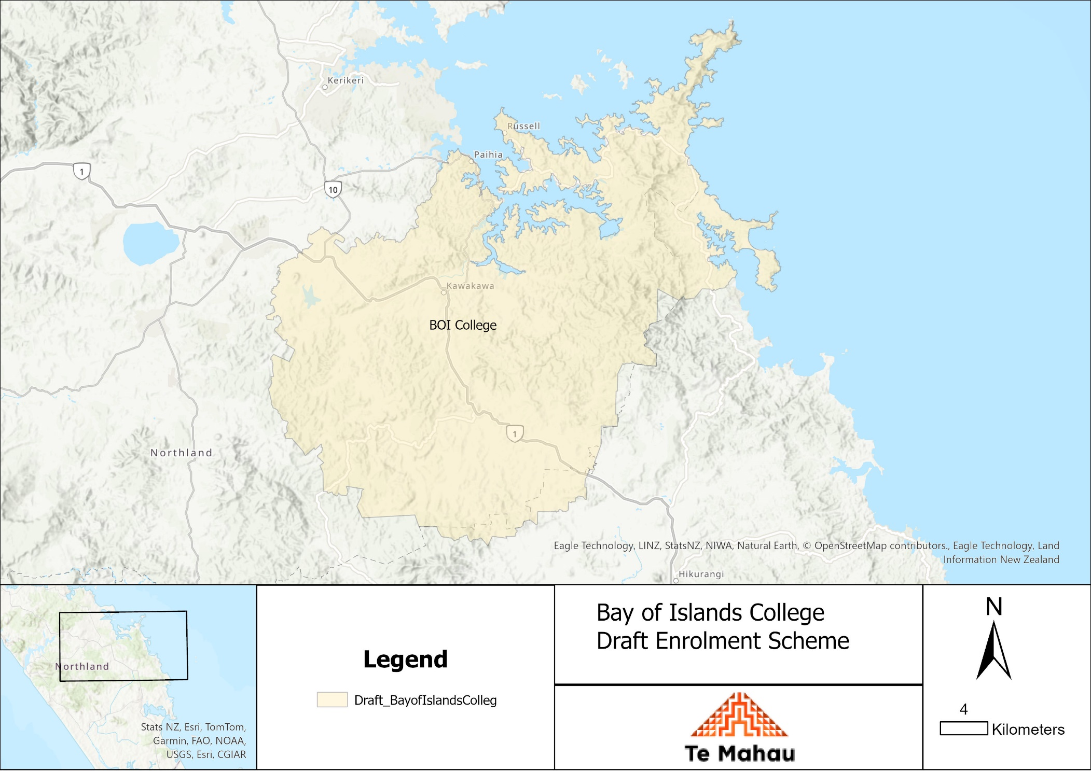
What does this mean for my family?
Any student currently enrolled at Bay of Islands College will not be impacted by the new enrolment scheme. All students enrolled (and attending school) will be entitled to continue attending Bay of Islands College, irrespective of where they currently live.
The establishment of the enrolment scheme and home zone will affect all enrolments starting at the beginning of Term 1 2025. This includes current families who have a younger sibling looking to enrol at Bay of Islands College starting on 1 January 2025 (the commencement date) or later. The flowchart below will help you assess your indicative eligibility to enrol after the commencement date.
Does your child (enrolling in 2025 or later) live within the enrolment scheme home zone? (check map for reference)
In zone enrolment
YES

NO
Out of zone enrolment
(if places available)

YES
Does your child (enrolling in 2025 or later) live outside of the zone?

Consultation process and timeline
The Ministry of Education is currently undertaking consultation about the proposed changes and new enrolment schemes. You can have your say by:
Completing the survey at: https://consultation.education.govt.nz/bay-of-islands-college Consultation page.

- This site also has further information about the proposed scheme.
- Emailing taitokerau.enrolmentschemes@education.govt.nz if you have further questions or comments.
Consultation will run 6 March 2024 to 31 March 2024. The Ministry will consider all feedback and liaise with the Bay of Islands College Board before making a final decision. We expect the school community to be updated about progress made 12 April 2024. The new scheme and changes will come into effect for enrolments after the commencement date.

