Draft Enrolment Scheme and Transport Zone
This consultation is asking for feedback about the shape of the blue area, the transport zone will not change in any way at all with this consultation.
The below map shows the transport zone for Bay of Islands College as a black outline, the blue area is the proposed enrolment scheme. The area to the north that is not blue but inside the transport zone is Kerikeri highschool zone.
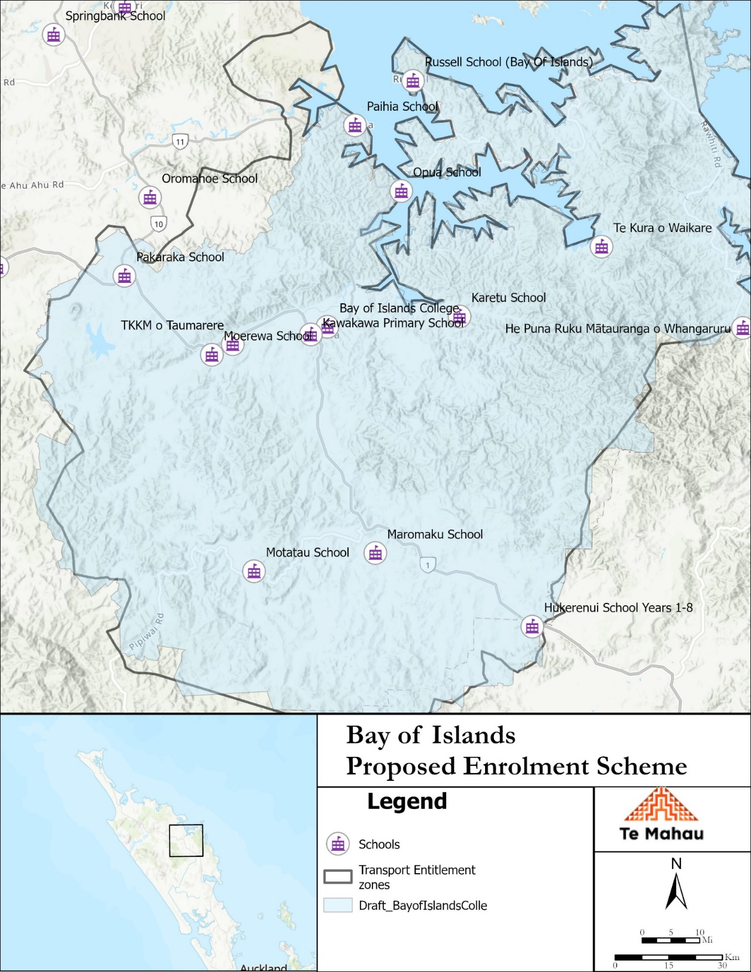
Grandparenting Clause
There is legislation that assists in the transition to an enrolment zone.
When a student is out of zone
If a student is enrolled at the school at the time when the zone starts
Then a sibling enrols in years after, while the original student is still at the school the younger sibling is counted as in zone.
Once the student that was enrolled at the school has left the school any more siblings that come to enrol are not counted as in zone.
Section 75 of the Education and Training Act 2020 states that

“the Secretary may authorise an enrolment scheme to permit a student to enrol at the school as if the student lived in the home zone of the school if, -

(b) in the case of a new enrolment scheme, the student,

1. lives outside of the home zone of the new enrolment scheme; and
2. has a sibling who is enrolled at the school at the time that the new enrolment scheme is implemented.”
Definition of a sibling
In this context, child A is the sibling of child B If any of the following apply:
a) both children have the same parent; 2 or
b) a parent of child A is married to, or in a civil union with, a parent of child B; or
2 Clause 2(3)(a) of Schedule 20 uses the term “share a common parent”. The Ministry treats the
two wordings as having the same meaning – sharing a common parent. The remaining paragraphs
are identical to those in Clause 2.
c) a parent of child A was married to, or in a civil union with, a parent of child B at
the time when child B’s parent died; or
d) a parent of child A is the de facto partner of a parent of child B; or
e) both children live in the same household and, in recognition of family obligations,
are treated by the adults of that household as if they were siblings; or
f) the Secretary, by written notice to the school, advises that child A is to be treated
as the sibling of child B.

