Colwill School Massey

New Enrolment Scheme

Overview – what is happening?
The Ministry of Education is developing an enrolment scheme for Colwill School Massey, which will be in effect for the beginning of term 1 in 2023. Having an enrolment scheme in place will ensure the Board of Trustees has a fair and transparent mechanism to manage the roll as it grows. Children that live within this area will have entitlement to enrol at Colwill School Massey. The home zone area is shown on the map on the next page and includes:
All students who live within the home zone described below and/or shown on the attached map shall be entitled to enrol at the school.
Starting at the intersection of Moire Road and Granville Drive, head southeast along Granville Drive (even addresses 90 and below included, odd addresses 21 and below included) until Royal Road. Head east on Royal Road (even addresses 130 to 364 included, odd addresses 189 to 361 included and Allington Road, Pipitea Place, Realm Place and Wickstead Place included) until Spargo Road. Head southeast on Spargo Road (both sides included, Quincey Place, Claverdon Drive and Reinga Place included) until Colwill Road. Travel west along Colwill Road (all addresses, both sides included and Kintara Drive, Redwood Drive, Darcy Place, Hanui Place, Sari Place, Mahinga Place, Bangla Place, Mescal Street and Tatyana Place included) until Royal Road. Head west along Royal Road (Sturm Avenue and Backhurst Grove included) until Moire Road. Travel north along Moire Road (odd addresses 21 to 69 included) back to the starting point.

All residential addresses on included sides of boundary roads and all no exit roads off included sides of boundary roads are included in the zone unless otherwise stated.
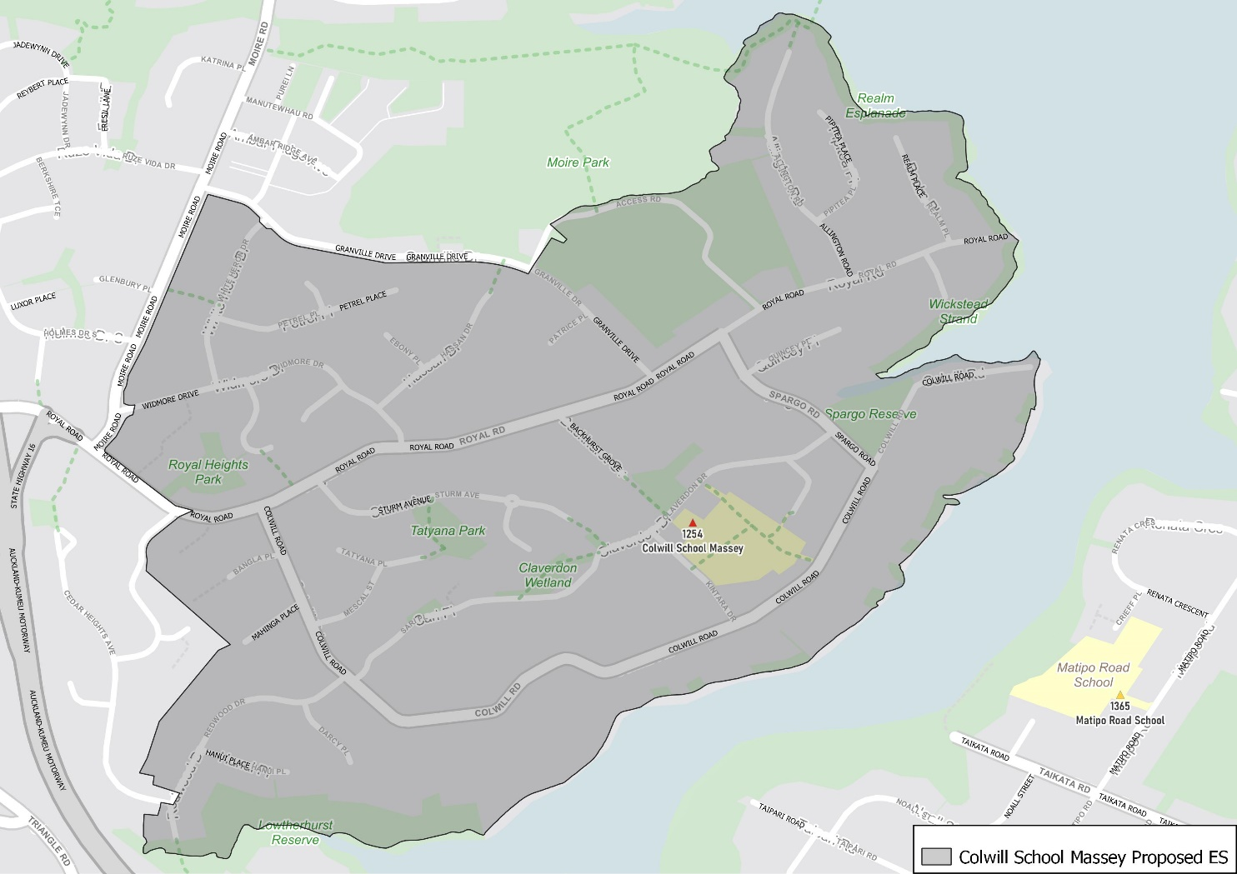

What does this mean for my family?
If you live in enrolment scheme home area for Colwill School Massey, you will be entitled to enrol your child at the school. This entitlement applies to new students starting school, as well as any students currently attending another school in the area.
Families who live outside the enrolment scheme home zone of Colwill School Massey do not have entitlement to enrol and could only attend if the Board of Trustees planned to enrol any out of zone students. The enrolment scheme will establish the process for this, and places will only be available if the Board of Trustees considers it has the capacity to allow for this. Further information about whether any out of zone places will be made available later in 2022.

Consultation process and timeline
The Ministry of Education is currently undertaking consultation about the proposed changes and new enrolment schemes. You can have your say by:
- Completing the survey at https://consultation.education.govt.nz/education/colwill-school-massey-enrolment-scheme
- Emailing auckland.enrolmentschemes@education.govt.nz if you have further questions or comments
The Ministry will consider all feedback and liaise with the Board before making a final decision. We expect the School community to be updated about progress. The new schemes and changes will come into effect for the beginning of term 1 2023.

