Tamaki School

New Enrolment Scheme

Overview – what is happening?
The Ministry of Education is developing an enrolment scheme for Tamaki School, which will be in effect for the beginning of term 1 in 2022. Having an enrolment scheme in place will ensure the Board of Trustees has a fair and transparent mechanism to manage the roll as it grows. Children that live within this area will have entitlement to enrol at Tamaki School. The home zone area is shown on the map on the next page and includes:
Starting at the intersection of Dunkirk Road and Matapan Road, travel west along Matapan Road (odd addresses included) until Tripoli Road. Travel slightly northeast along Tripoli Road and then turn northwest along Stewart Avenue (odd addresses included) and then travel slightly south along Pilkington Road before turning west along Green Road (even addresses included). Turn north at Jellicoe Road (even addresses included) and then at the end of the road continue east along Hobson Drive (2-6 even addresses excluded, 2-8 Martin Place included) until turning north at Coates Crescent (52 and below even, 17 and below odd included, also include 99-111 odd Pilkington Road addresses and Sanda Road). Travel northeast along the walkway to Court Crescent (84 and below even, 59 and below odd included) and then continue initially northeast along Oran Road until Tripoli Road, turning north at Tripoli Road briefly and then east along Tobruk Road until Dunkirk Road. Travel south along Dunkirk Road (17 and above odd, 22 and above even included, also include 192 Riverside Avenue and Riverside Reserve) back to the origin point.

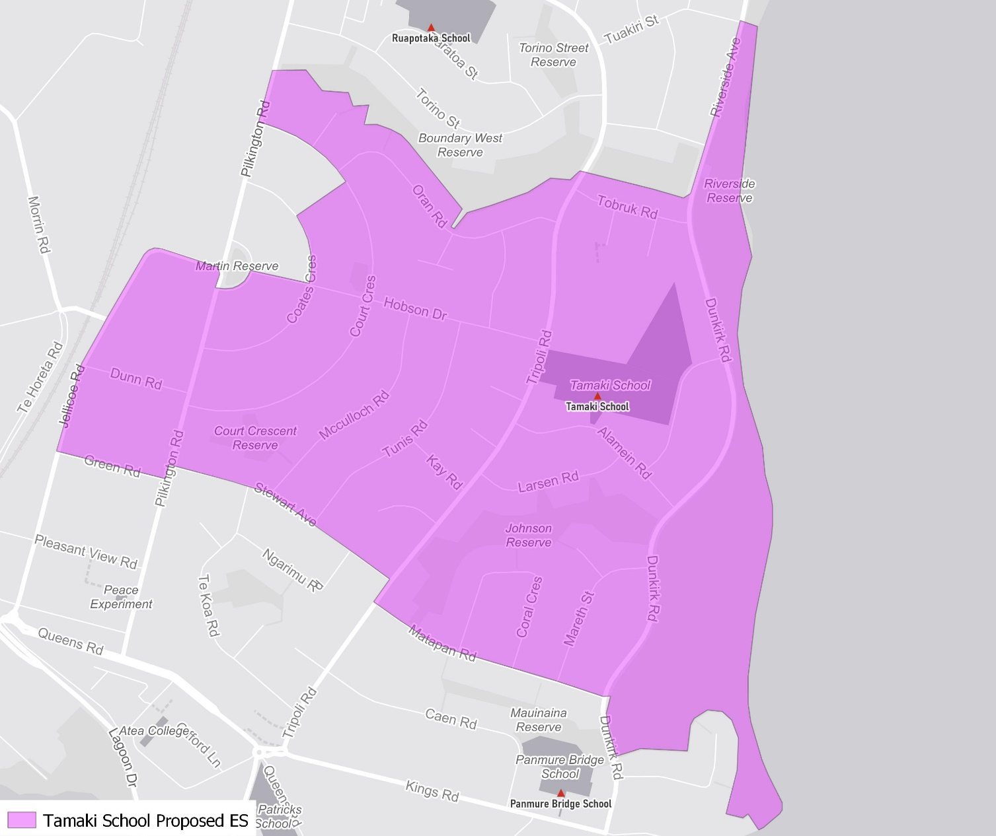

What does this mean for my family?
If you live in enrolment scheme home area for Tamaki School you will be entitled to enrol your child at the school. This entitlement applies to new students starting school, as well as any primary school aged children currently attending another school in the area.
Families who live outside the enrolment scheme home zone of Tamaki School do not have entitlement to enrol and could only attend if the Board of Trustees planned to enrol any out of zone students. The enrolment scheme will establish the process for this, and places will only be available if the Board of Trustees considers it has the capacity to allow for this. Further information about whether any out of zone places will be made available will be made later in 2021.

Consultation process and timeline
The Ministry of Education is currently undertaking consultation about the proposed changes and new enrolment schemes. You can have your say by:
- Completing the survey at https://consultation.education.govt.nz/education/tamaki-primaries-enrolment-schemes/consultation/intro/
- Emailing auckland.enrolmentschemes@education.govt.nz if you have further questions or comments
The Ministry will consider all feedback and liaise with the Board before making a final decision. The new schemes and changes will come into effect for the beginning of 2022.

