Chaucer School

New Enrolment Scheme

Overview – what is happening?
The Ministry of Education is developing an enrolment scheme for Chaucer School, which will be in effect for the beginning of term 1 in 2022. Having an enrolment scheme in place will ensure the Board of Trustees has a fair and transparent mechanism to manage the roll as it grows. Children that live within this area will have entitlement to enrol at Chaucer School. The home zone area is shown on the map on the next page and includes:
Starting at the corner of Clark Street and Portage Road, travel south down Portage Road (odd addresses 55-187 and even addresses 44-128 only included; Neville Street, Hill Crescent, Links Road excluded) until Bolton Road. Travel east along Bolton Road until Blockhouse Bay Road, including only odd numbered addresses. The southern boundary continues north along Blockhouse Bay Road (odd addresses 353-455 and even addresses 360-468 only included) until Terry Street. The boundary then heads east along Terry Street (even addresses 88 and below only included) until Whitney Street. Then travel north along Whitney Street, including addresses on both sides of the street (ending at 141 odd address and 168 even address) until Dundale Avenue (excluded). The boundary then travels west to Blockhouse Bay Road, including all addresses on Maui Pomare Street, Geneva Place, Cleland Crescent and Maclaurin Street. The boundary then travels along Miranda Reserve until Wolverton Street, excluding Miranda Street but including addresses south of the reserve. The boundary then travels west from 75A Wolverton Street down Wolverton Street until the boundary’s origin at Clark Street, including addresses on both sides of Wolverton Street.
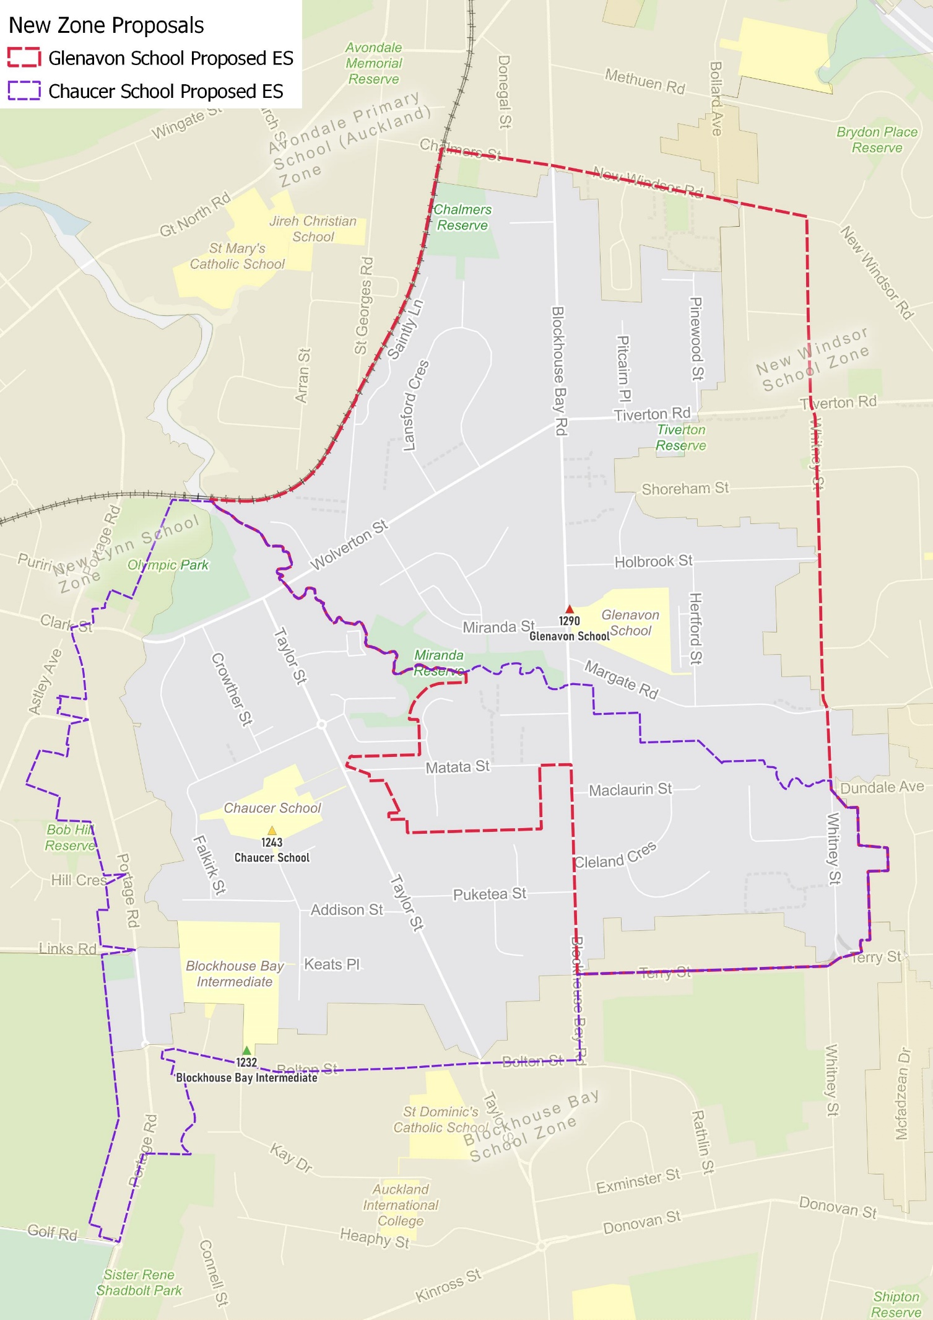

What does this mean for my family?
If you live in enrolment scheme home area for Chaucer School you will be entitled to enrol your child at the school. This entitlement applies to new students starting school, as well as any primary school aged children currently attending another school in the area.
Families who live outside the enrolment scheme home zone of Chaucer School do not have entitlement to enrol and could only attend if the Board of Trustees planned to enrol any out of zone students. The enrolment scheme will establish the process for this, and places will only be available if the Board of Trustees considers it has the capacity to allow for this. Further information about whether any out of zone places will be made available will be made later in 2021.

Consultation process and timeline
The Ministry of Education is currently undertaking consultation about the proposed changes and new enrolment schemes. You can have your say by:
- Completing the survey at https://consultation.education.govt.nz/education/glenavon-chaucer-schools-enrolment-schemes/consultation/intro/
- Emailing auckland.enrolmentschemes@education.govt.nz if you have further questions or comments
Consultation will run from Thursday 17th June, until Friday 30th of July. The Ministry will consider all feedback and liaise with the Board before making a final decision. We expect the School community to be updated about progress made about mid-Term 3 The new schemes and changes will come into effect for the beginning of 2022.

