Glenavon School

New Enrolment Scheme

Overview – what is happening?
The Ministry of Education is developing an enrolment scheme for Glenavon School, which will be in effect for the beginning of term 1 in 2022. Having an enrolment scheme in place will ensure the Board of Trustees has a fair and transparent mechanism to manage the roll as it grows. Children that live within this area will have entitlement to enrol at Glenavon School. The home zone area is shown on the map on the next page and includes:
Starting at the corner of Whitney Street and New Windsor Road, the boundary travels west along New Windsor Road and then Chalmers Street until the railway line. The boundary then travels south down the railway line (addresses east of the railway line included) until Olympic Park, traveling down the eastern side of the park until 73 Wolverton Road. The zone boundary then travels southeast along Miranda Reserve, including houses to the north of the reserve on Miranda Street and Otira Street. The boundary then follows the perimeter of Matata Street and Covic Avenue, including all houses on these roads. The boundary then travels down Blockhouse Bay Road until Terry Street (including Blockhouse Bay Road addresses with odd numbers 199-369 and with even numbers 210-468). The zone then follows Terry Street east (even addresses 2-88 only included), and then travels north along Whitney Street (even addresses 168-212 included, odd addresses 5-189 included) until New Windsor Road.
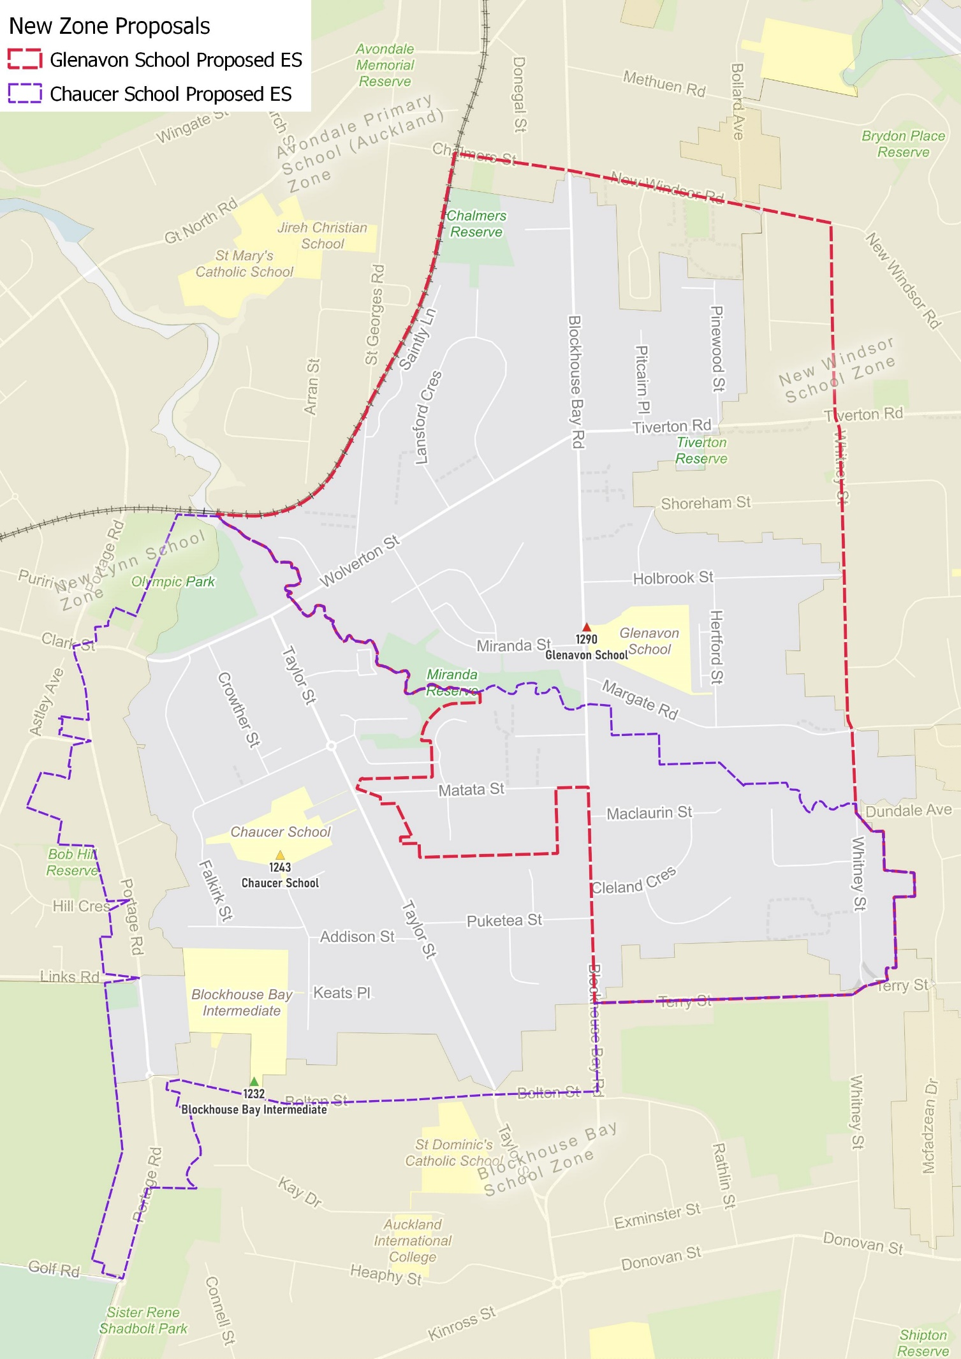

What does this mean for my family?
If you live in enrolment scheme home area for Glenavon School you will be entitled to enrol your child at the school. This entitlement applies to new students starting school, as well as any primary school aged children currently attending another school in the area.
Families who live outside the enrolment scheme home zone of Glenavon School do not have entitlement to enrol and could only attend if the Board of Trustees planned to enrol any out of zone students. The enrolment scheme will establish the process for this, and places will only be available if the Board of Trustees considers it has the capacity to allow for this. Further information about whether any out of zone places will be made available will be made later in 2021.

Consultation process and timeline
The Ministry of Education is currently undertaking consultation about the proposed changes and new enrolment schemes. You can have your say by:
- Completing the survey at https://consultation.education.govt.nz/education/glenavon-chaucer-schools-enrolment-schemes/consultation/intro/
- Emailing auckland.enrolmentschemes@education.govt.nz if you have further questions or comments
Consultation will run from Thursday 17th June, until Friday 30th of July. The Ministry will consider all feedback and liaise with the Board before making a final decision. We expect the School community to be updated about progress made about mid-Term 3 The new schemes and changes will come into effect for the beginning of 2022.

