Glenfield College

Enrolment Scheme

Overview – what is happening?
The Ministry of Education is proposing an enrolment scheme for Glenfield College, which will be in effect for the beginning of term 2 in 2024. Having an enrolment scheme in place will ensure the School Board has a fair and transparent mechanism to manage the roll as it grows. Children that live within this area will have entitlement to enrol at Lincoln Heights School. The home zone area is shown on the map below and includes:
Starting at the intersection of Glendhu Road and Sunset Road, travel east along Sunset Road (excluded, Highgrove Lane excluded) towards State Highway 1. Follow State Highway 1 (streets west of the highway included) south towards Northcote Road. Travel southwest along Northcote Road (excluded) towards Sunnybrae Road. Travel northwest along Sunnybrae Road (addresses 70,99 and below excluded, streets below Benders Avenue also excluded) to Coronation Road. Travel west along Coronation Road to Glenfield Road. Follow Glenfield Road south (272-618, 275-641 included, Eskdale Road excluded) and then southwest around Birkenhead Domain, through Eskdale Bush Scenic Reserve and Lauderdale Reserve towards the coastline. Follow the coastline north and then east along the back of Glendhu Road properties back to the starting point.
All residential addresses on included sides of boundary roads and all no exit roads off included sides of boundary roads are included in the zone unless otherwise stated.
All no exit roads within the boundaries described above are included in the zone unless otherwise stated.
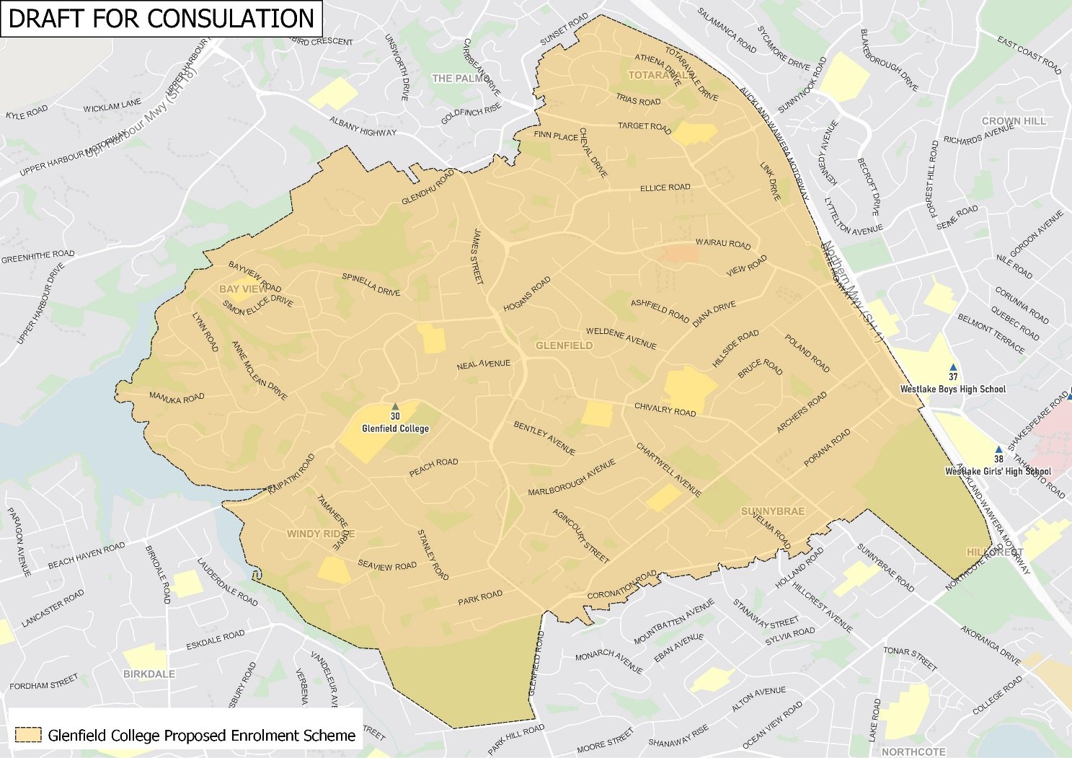

What does this mean for my family?
If you live in the proposed enrolment scheme home area for Glenfield College, you will be entitled to enrol your child at the school. This entitlement applies to new students starting school, as well as any intermediate school aged children currently attending another school in the area.
Families who live outside the proposed enrolment scheme home zone do not have entitlement to enrol and could only attend if the school planned to enrol any out of zone students. The enrolment scheme will establish the process for this, and places will only be available if the School Board considers it has the capacity to allow for this. Further information about whether any out of zone places will be made available will be made later in 2023.

Consultation process and timeline
The Ministry of Education is currently undertaking consultation about the proposed changes and new enrolment schemes. You can have your say by:
- https://consultation.education.govt.nz/education/glenfield-college-enrolment-scheme
- Emailing auckland.enrolmentschemes@education.govt.nz if you have further questions or comments.
The Ministry will consider all feedback and liaise with the Board before making a final decision. The new schemes and changes will come into effect for the beginning of Term 2 2024.

