Greenmeadows Intermediate School

Enrolment Scheme

Overview – what is happening?
The Ministry of Education is proposing an enrolment scheme for Greenmeadows School, which will be in effect for the beginning of term 2 in 2024. Having an enrolment scheme in place will ensure the School Board has a fair and transparent mechanism to manage the roll as it grows. Children that live within this area will have entitlement to enrol at Lincoln Heights School. The home zone area is shown on the map below and includes:
Starting at the intersection of Manukau Station Road and Wiri Station Road, travel east along Manukau Station Road (even addresses 10-50 included) and continue eastwards along Redoubt Road (odd addresses 149 and below included) until Totara Park.
Follow the western boundary of Totara Park south and then east along the back of properties on Nyssa Place, Corokia Place and Everglade Drive towards State Highway 1. Follow State Highway 1 south towards Alfriston Road. Turn east along Alfriston Road (odd addresses 141 and below, and even addresses 238 and below included; Senator Drive and addresses 17,12 and below Saralee Drive also included) to Magic Way. Travel south along Magic Way (excluded) to Skelton Avenue. Follow Skelton Avenue south and continue onto Shinfnal Drive (Secretariat Place included) towards 56 Trimdon Street. From Trimdon Street (33, 56 and above included) travel west towards Great South Road, Manurewa (included; even addresses 8-30 Great South Road, Takanini also included) and then southwest along the back of Holmes Road properties (52, 49 and below included) to 49 Holmes Road.
From Holmes Road, travel north along Fields Road (excluded; Clayton Road excluded) towards Mahia Road. Travel east along Mahia Road (61, 64 and below included; Totara Road addresses 13, 16 and below included; Rimu Road addresses 28,31 and below included; Christmas Road addresses 37,60 and below included) towards Great South Road.
Travel northwest along Great South Road, Wiri (726,747 and above included) to Kerrs Road. Travel west along Kerrs Road (79, 10 and below included) to Druces Road. Travel north along Druces Road (odd addresses included) to Wiri Station Road. From Wiri Station Road, travel northeast back to the starting point.
All no exit roads within the boundaries described above are included in the zone unless otherwise stated.
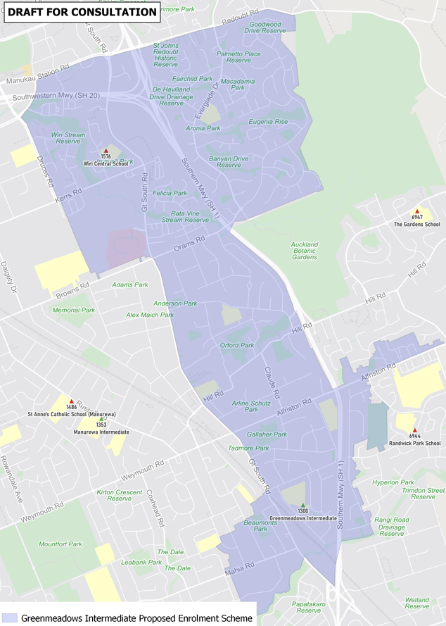

What does this mean for my family?
If you live in the proposed enrolment scheme home area for Greenmeadows Intermediate School, you will be entitled to enrol your child at the school. This entitlement applies to new students starting school, as well as any intermediate school aged children currently attending another school in the area.
Families who live outside the proposed enrolment scheme home zone do not have entitlement to enrol and could only attend if the School planned to enrol any out of zone students. The enrolment scheme will establish the process for this, and places will only be available if the School Board considers it has the capacity to allow for this. Further information about whether any out of zone places will be made available will be made later in 2023.

Consultation process and timeline
The Ministry of Education is currently undertaking consultation about the proposed changes and new enrolment schemes. You can have your say by:
- https://consultation.education.govt.nz/education/greenmeadows-intermediate-enrolment-scheme
- Emailing auckland.enrolmentschemes@education.govt.nz if you have further questions or comments
The Ministry will consider all feedback and liaise with the Board before making a final decision. The new schemes and changes will come into effect for the beginning of Term 2 2024.

