Henderson North School

Enrolment Scheme Amendment

Overview – what is happening?
The Ministry of Education is amending the enrolment scheme for Henderson North School, which will be in effect for the beginning of term 2 in 2023. Having an enrolment scheme in place will ensure the Board of Trustees has a fair and transparent mechanism to manage the roll as it grows. Children that live within this area will have entitlement to enrol at Henderson North School. The home zone area is shown on the map below and includes:
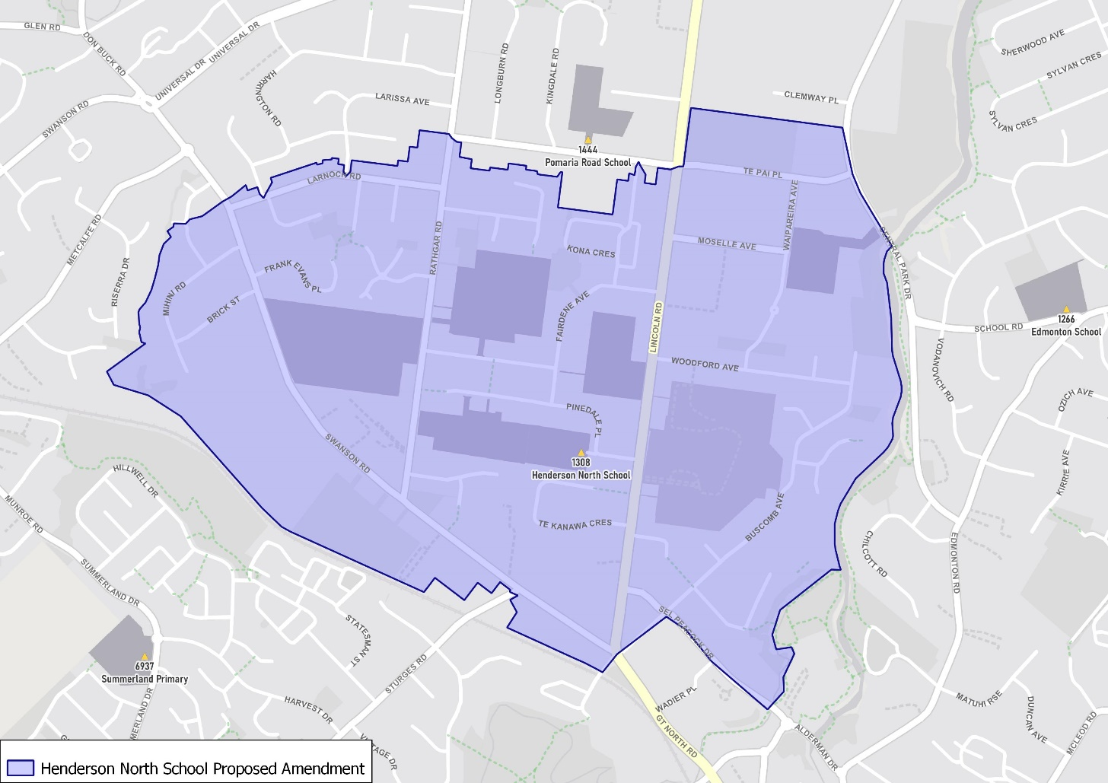
Starting at intersection of Swanson Road and Lincoln Road, travel northwest along Swanson Road (1-229 addresses included) until Larnoch Road. Continue east along Larnoch Road (both sides included) until Rathgar Road (1-138 addresses included). Travel eastwards along Glen Norman Avenue (both sides, Normandy Place, Kona Crescent, Stephen Avenue, Nephrite Lane included, and Pomaria Road excluded) until Lincoln Road. Head south down Lincoln Road (1-156 addresses, Te Pai Place, Moselle Avenue, Waipareira Avenue, Fairdene Avenue, Pinedale Place, Edwards Avenue, Norval Road, Epping Road included) until Woodford Avenue. Head east along Woodford Avenue (both sides included) until Epping Road. Travel south along Epping Road and continue onto Buscomb Avenue (even addresses 2 and above, odd addresses 13 and above, Hoya Court, Jubaea Place and Millstream Drive included), crossing Sel Peacock Drive (1-44 addresses included) on the way back to the starting point.

What does this mean for my family?
If you live in enrolment scheme home area for Henderson North School you will be entitled to enrol your child at the school. This entitlement applies to new students starting school, as well as any primary school aged children currently attending another school in the area.
Families who live outside the enrolment scheme home zone of Henderson North School do not have entitlement to enrol and could only attend if the Board of Trustees planned to enrol any out of zone students. The enrolment scheme will establish the process for this, and places will only be available if the Board of Trustees considers it has the capacity to allow for this. Further information about whether any out of zone places will be made available will be made later in 2022.

Consultation process and timeline
The Ministry of Education is currently undertaking consultation about the proposed changes and new enrolment schemes. You can have your say by:
- Completing the survey at https://consultation.education.govt.nz/education/henderson-primaries-enrolment-schemes
- Emailing auckland.enrolmentschemes@education.govt.nz if you have further questions or comments
The Ministry will consider all feedback and liaise with the Board before making a final decision. The new schemes and changes will come into effect for the beginning of Term 2 2023.

