Henderson School

Enrolment Scheme Amendment

Overview – what is happening?
The Ministry of Education is proposing an enrolment scheme for Henderson School, which will be in effect for the beginning of term 2 in 2023. Having an enrolment scheme in place will ensure the Board of Trustees has a fair and transparent mechanism to manage the roll as it grows. Children that live within this area will have entitlement to enrol at Henderson School. The home zone area is shown on the map below and includes:
Starting at the intersection of James Laurie Street and Great North Road, head west along James Laurie Street (2-62 even addresses included) until View Road. Continue northwest along View Road (even addresses 2 to 50, odd addresses 3 to 17 and Vitasovich Avenue included) until Railside Avenue. Travel north along Railside Avenue (both sides included) until Great North Road.
Following Great North Road (233-449 addresses included) west to Buscomb Avenue:
- Henderson Valley Road (1-24 addresses included)
- Smythe Road
- Wilsher Crescent
- Serjeant Street
- Wadier Place
Head northeast on Buscomb Avenue (1-11 odd addresses included, even addresses excluded) until Sel Peacock Drive and head southeast down Sel Peacock Drive (13-17 addresses included) until Alderman Drive (both sides included). Follow Waikumete Stream north until Central Park Drive (2-26 even addresses, 1-25 odd addresses, Swan Lane and Chilcott Road included) and head southeast down Central Park Drive until Edmonton Road.
Heading down Edmonton Road (1-165 odd addresses, 2-142 even addresses included) to Great North Road:
- Alma Street included
- Claude Brooks Drive included
- Matuhi Rise included
- Duncan Avenue included
- Takapu Street included
- Ciprian Place included
Head east along Great North Road to Mcleod Road and head north along Mcleod Road (2-70 even addresses, 1-77 odd addresses, Sheehan Road, Adriatic Avenue and Willem Straat included) until Te Atatu Road.
Heading south down Te Atatu Road (2-60 even addresses included):
- Norcross Avenue included
- Humphrey Kemp Avenue included
- Blacklock Avenue included
- Elcoat Avenue included
- Miltonia Avenue excluded
- Orchid Place excluded
- Divich Avenue excluded
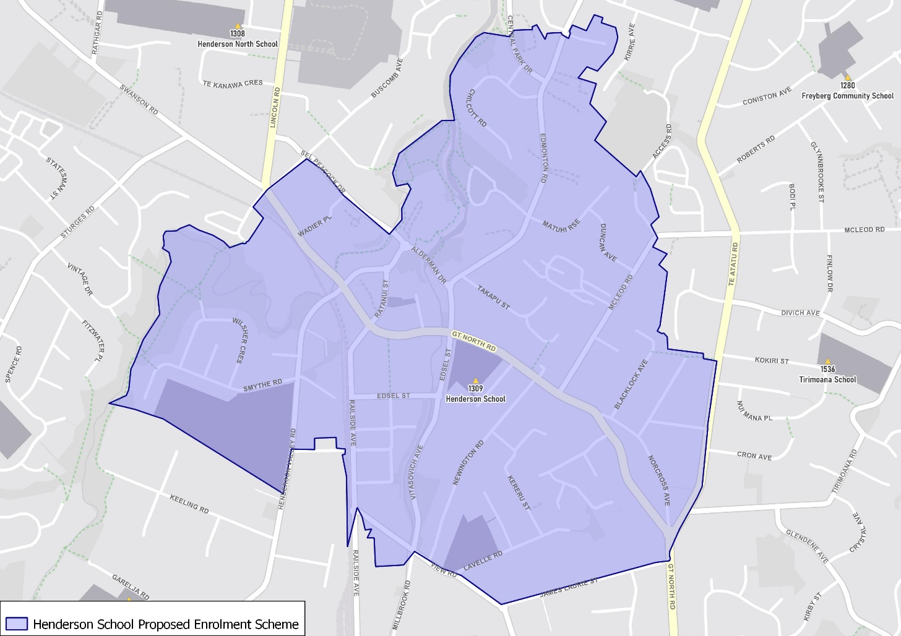
To the intersection of Great North Road, Norcross Avenue and Te Atatu Road. Travel south to head back to the starting point.

What does this mean for my family?
If you live in enrolment scheme home area for Henderson School, you will be entitled to enrol your child at the school. This entitlement applies to new students starting school, as well as any primary school aged children currently attending another school in the area.
Families who live outside the enrolment scheme home zone of Henderson School do not have entitlement to enrol and could only attend if the Board of Trustees planned to enrol any out of zone students. The enrolment scheme will establish the process for this, and places will only be available if the Board of Trustees considers it has the capacity to allow for this. Further information about whether any out of zone places will be made available will be made later in 2022.

Consultation process and timeline
The Ministry of Education is currently undertaking consultation about the proposed changes and new enrolment schemes. You can have your say by:
- Completing the survey at https://consultation.education.govt.nz/education/henderson-primaries-enrolment-schemes
- Emailing auckland.enrolmentschemes@education.govt.nz if you have further questions or comments
The Ministry will consider all feedback and liaise with the Board before making a final decision. The new schemes and changes will come into effect for the beginning of Term 2 2023.

