Henderson South School

New Enrolment Scheme

Overview – what is happening?
The Ministry of Education is developing an enrolment scheme for Henderson South School, which will be in effect for the beginning of term 3 in 2022. Having an enrolment scheme in place will ensure the Board of Trustees has a fair and transparent mechanism to manage the roll as it grows. Children that live within this area will have entitlement to enrol at Henderson South School. The home zone area is shown on the map on the next page and includes:
Starting at intersection of Railside Avenue and View Road, travel south down Railside Avenue (96-192 addresses included) and then continue south down the railway line and then southwest along Oratia Stream until the end of Chistlehurst Street. Travel along the northeastern boundary of 132 Bruce Mclaren Road (excluded) until 130A Bruce Mclaren Road, then head southwest along Bruce Mclaren Road (137 and below odd, 130 and below even included) until turning northwest along Farwood Drive (odd addresses only included). Then, turn north along Forest Hill Road (34 and below even, 29 and below odd addresses included) and then turn northwest along Border Road (included, as are all roads attached to Border Road. 201-23 odd and 166 -26 even addresses for Henderson Valley Road also included) until Opanuku Stream. Travel northeast along Opanuku Stream until Keeling Road, and then travel south east down Keeling Road (included, all no exit roads also included) until traveling slightly north along Henderson Valley Road to Hickory Avenue, and then turning east at Hickory Avenue and along Hickory Avenue until the railway line. Then, travel south along the railway line to the zone’s origin point.

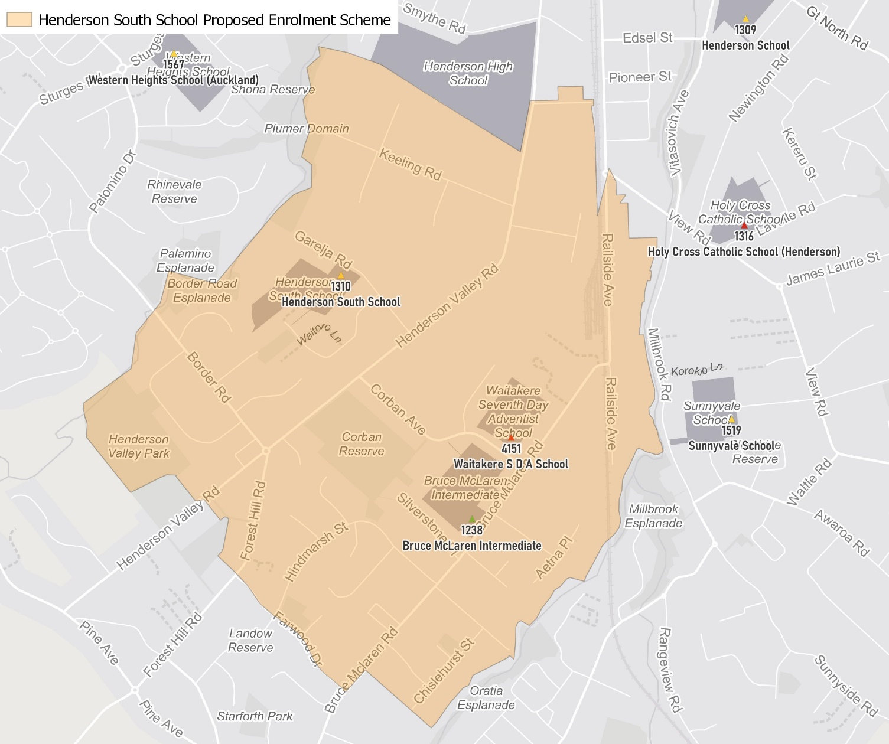

What does this mean for my family?
If you live in enrolment scheme home area for Henderson South School you will be entitled to enrol your child at the school. This entitlement applies to new students starting school, as well as any primary school aged children currently attending another school in the area.
Families who live outside the enrolment scheme home zone of Henderson South School do not have entitlement to enrol and could only attend if the Board of Trustees planned to enrol any out of zone students. The enrolment scheme will establish the process for this, and places will only be available if the Board of Trustees considers it has the capacity to allow for this. Further information about whether any out of zone places will be made available will be made later in 2022.

Consultation process and timeline
The Ministry of Education is currently undertaking consultation about the proposed changes and new enrolment schemes. You can have your say by:
- Completing the survey at https://consultation.education.govt.nz/education/henderson-primaries-enrolment-schemes
- Emailing auckland.enrolmentschemes@education.govt.nz if you have further questions or comments
The Ministry will consider all feedback and liaise with the Board before making a final decision. The new schemes and changes will come into effect for the beginning of Term 3 2022.

