Oratia School

Amended Enrolment Scheme

Overview – what is happening?
The Ministry of Education is proposing a minor amendment of Oratia School’s enrolment scheme to include an additional portion of West Coast Road. This will help share the influx of students from a new development along that portion of road between Oratia School and Prospect School. Additionally, the remainder of the zone has been redrawn to land parcels, but this does not change the zone boundaries besides adding visual clarity. The home zone area is shown on the map on the next page and includes:
In-zone constitutes all the areas within the following boundaries:
- Glengarry Road from Autumn Ave to West Coast Road. The zone includes all properties with frontage on this section of Glengarry Road (from 179 and 176 upwards in numbers), also side roads Meynell Court and Nicolas Ave.
- West Coast Road between Glengarry Road and Parrs Park roundabout (456 and 481 being the lowest numbers in the zone).
- Up Parrs Cross Road (west side only) to Holdens Road and up Holdens Road (both sides) to Forest Hill Road.
- The boundary then goes up Forest Hill Road (both sides) from 148 and 145 upwards in numbers to the intersection with West Coast Road.
- From Forest Hill Road the boundary follows West Coast Road to Scenic Drive, including all properties with frontage on this section of West Coast Road.
- All properties with frontage on Scenic Drive between 147 and 158 in the south and 573 and 574 in the north are included in the zone.
- All properties accessed from Piha Road and side roads are also included within the zone.
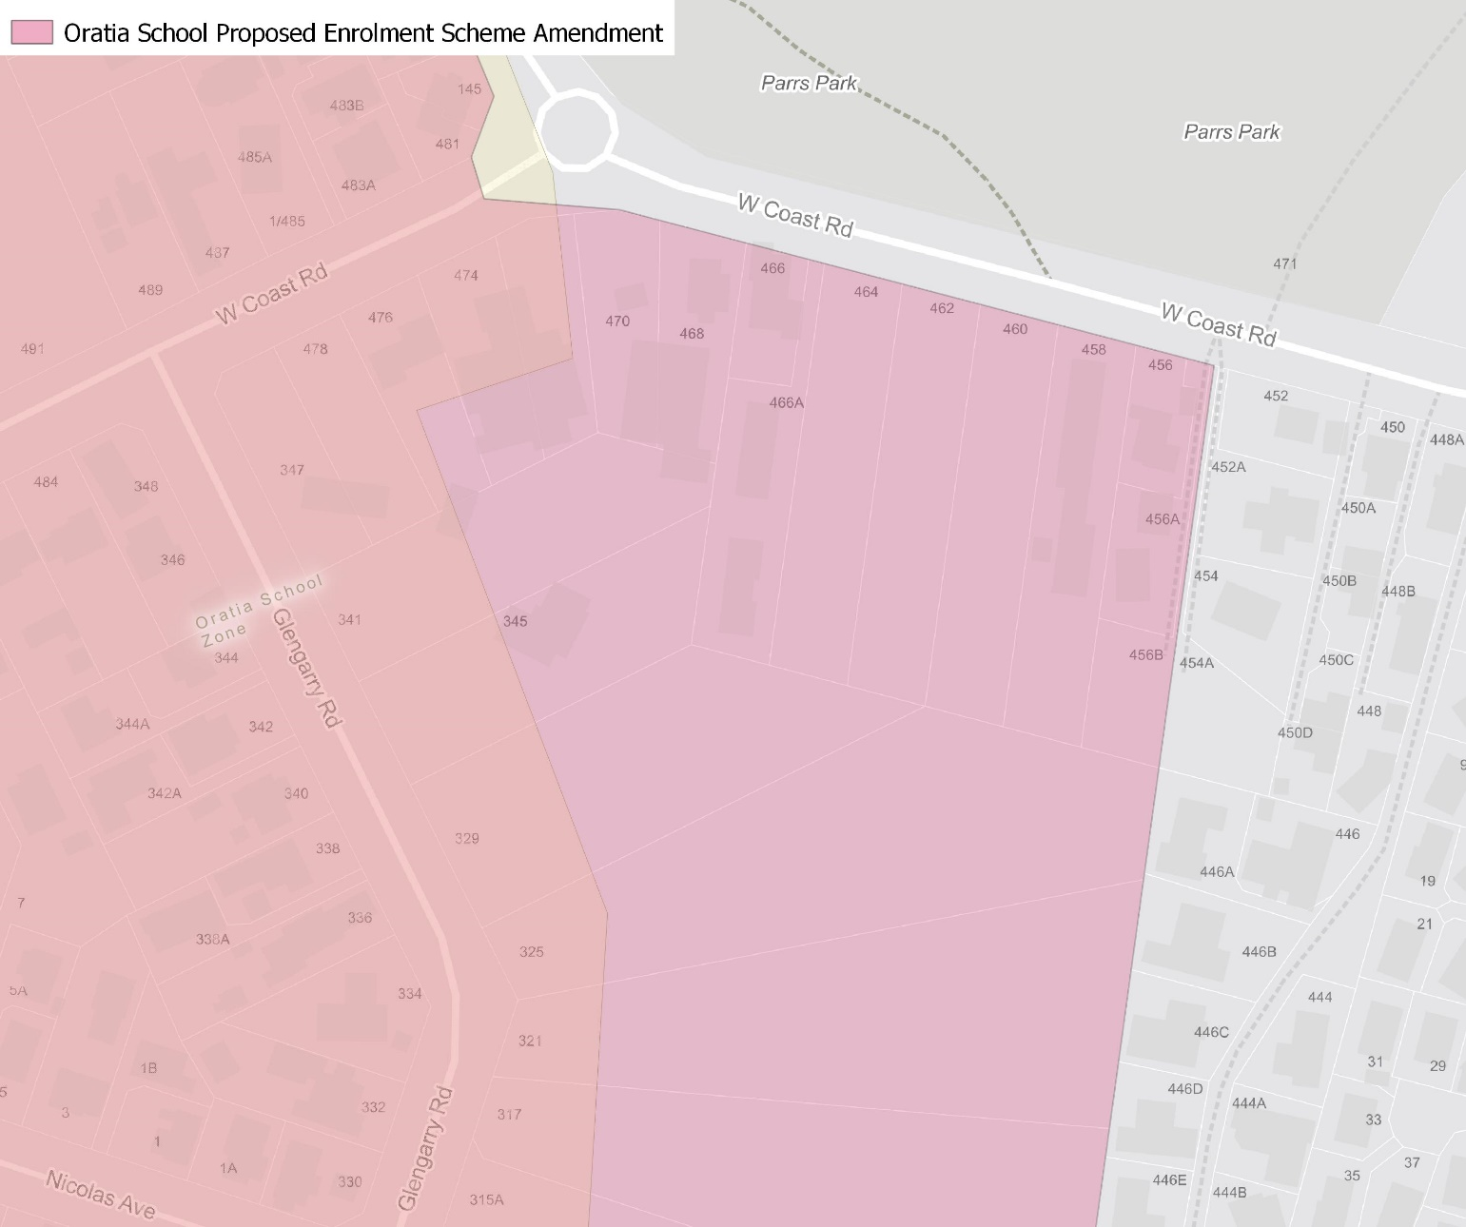
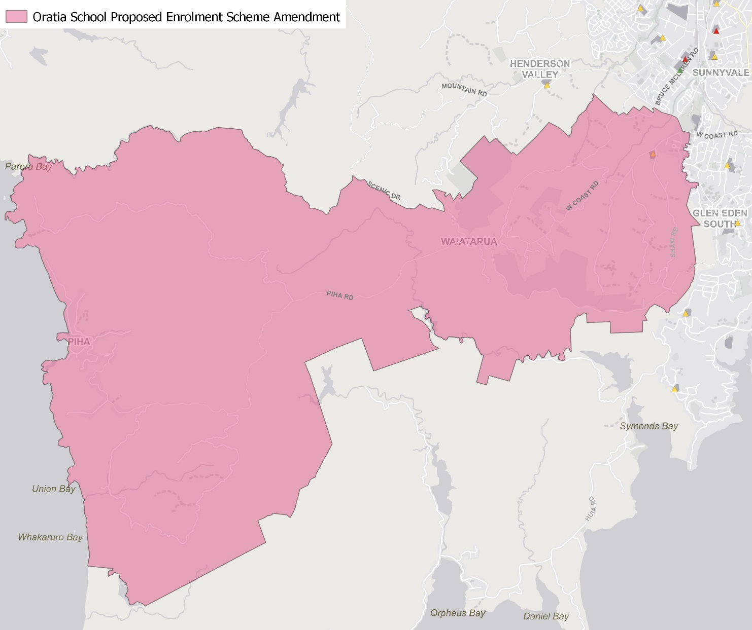

What does this mean for my family?
Any student currently enrolled at Oratia School will not be impacted by a change to the enrolment scheme. All students enrolled (and have started attending) will be entitled to continue attending Oratia School, irrespective of where they currently live.
The change to the home zone will affect all enrolments starting in term 3 2022. It is important to note that enrolment starts when you first attend school, not when enrolment forms are completed.
An in-zone enrolment is automatically entitled to enrol at the school. An out of zone enrolment is not guaranteed a place at the school and you will need to apply through the school’s out of zone processes if there are spaces available.

Consultation process and timeline
The Ministry of Education is currently undertaking consultation about the proposed changes and new enrolment schemes. You can have your say by:
- Completing the survey at https://consultation.education.govt.nz/education/henderson-primaries-enrolment-schemes
- Emailing auckland.enrolmentschemes@education.govt.nz if you have further questions or comments
The Ministry will consider all feedback and liaise with the Board before making a final decision. The new schemes and changes will come into effect for the beginning of Term 3 2022.

