Pomaria School

Enrolment Scheme Amendment

Overview – what is happening?
The Ministry of Education is proposing an enrolment scheme for Pomaria School, which will be in effect for the beginning of term 2 in 2023. Having an enrolment scheme in place will ensure the Board of Trustees has a fair and transparent mechanism to manage the roll as it grows. Children that live within this area will have entitlement to enrol at Pomaria School. The home zone area is shown on the map below and includes:
Starting at intersection of Universal Drive, Don Buck Road and Swanson Road, heading east along Universal Drive (both sides and all no exit roads included) until Lincoln Road:
- Don Buck Road (1-29A odd addresses, 2-14 even addresses included)
- Swanson Road (302-320 even addresses included, 229-279 odd addresses included)
- Woodside Road (both sides included)
Head north on Lincoln Road (90-339 addresses and all no exit roads, Selwood Road, The Concourse, Fairdene Avenue and Woodford Avenue included) until Triangle Road (357-385 addresses included). Travel southeast along Central Park Drive (65-327 addresses and all no exit roads included) until Te Pai Place.
Head west along Te Pai Place (both sides included) and continue onto Pomaria Road (both sides and all no exit roads included) until Rathgar Road. Head south on Rathgar Road (61-197 addresses included and all no exit roads included) until Larnoch Road. Head west along Larnoch Road (both sides and all no exit roads included) until Swanson Road. Head north up Swanson Road back to the starting point.
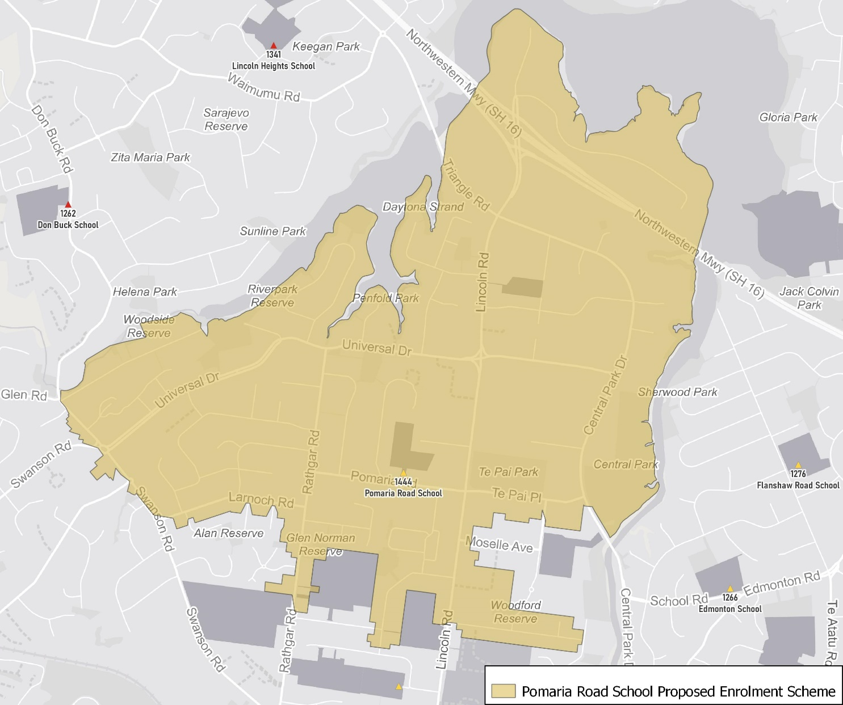

What does this mean for my family?
If you live in enrolment scheme home area for Pomaria School, you will be entitled to enrol your child at the school. This entitlement applies to new students starting school, as well as any primary school aged children currently attending another school in the area.
Families who live outside the enrolment scheme home zone of Pomaria School do not have entitlement to enrol and could only attend if the Board of Trustees planned to enrol any out of zone students. The enrolment scheme will establish the process for this, and places will only be available if the Board of Trustees considers it has the capacity to allow for this. Further information about whether any out of zone places will be made available will be made later in 2022.

Consultation process and timeline
The Ministry of Education is currently undertaking consultation about the proposed changes and new enrolment schemes. You can have your say by:
- Completing the survey at https://consultation.education.govt.nz/education/henderson-primaries-enrolment-schemes
- Emailing auckland.enrolmentschemes@education.govt.nz if you have further questions or comments
The Ministry will consider all feedback and liaise with the Board before making a final decision. The new schemes and changes will come into effect for the beginning of Term 2 2023.

