Ranui School

Enrolment Scheme Amendment

Overview – what is happening?
The Ministry of Education is proposing an enrolment scheme for Ranui School, which will be in effect for the beginning of term 2 in 2023. Having an enrolment scheme in place will ensure the Board of Trustees has a fair and transparent mechanism to manage the roll as it grows. Children that live within this area will have entitlement to enrol at Ranui School. The home zone area is shown on the map below and includes:
Starting at intersection of Luanda Road and Armada Road, head east along Luanda Road (49-67 odd addresses included) until Waitemata Road. Head southeast along Waitemata Road (156-206 even addresses, 155 address included) until Swanson Road.
Following Swanson Road (229-529 odd addresses, 302-532 even addresses) east until Metcalfe Road:
- Afton Place included
- Muriel Place included
- Don Buck Road (1-29A odd addresses, 2-14 even addresses included)
- Rakich Place (13-65 odd addresses, 24-38 even addresses included)
- Sun Place included
Heading southwest along Metcalfe Road (1-179 odd addresses, 2-132 odd addresses and all no exit roads included) until Ranui Station Road:
- Pooks Road included
- Ranui Drive included
- Ilana Place included
- Jillian Drive included
- Clearview Heights included
- Kahikatea Place included
Travel west along Ranui Station Road (both sides, Carlas Way, Robertson Road, Arney Road included) until Swanson Road. Follow Swanson Road west until Luanda Road and head north up Luanda Road (both sides and all no exit roads included) back to the starting point.
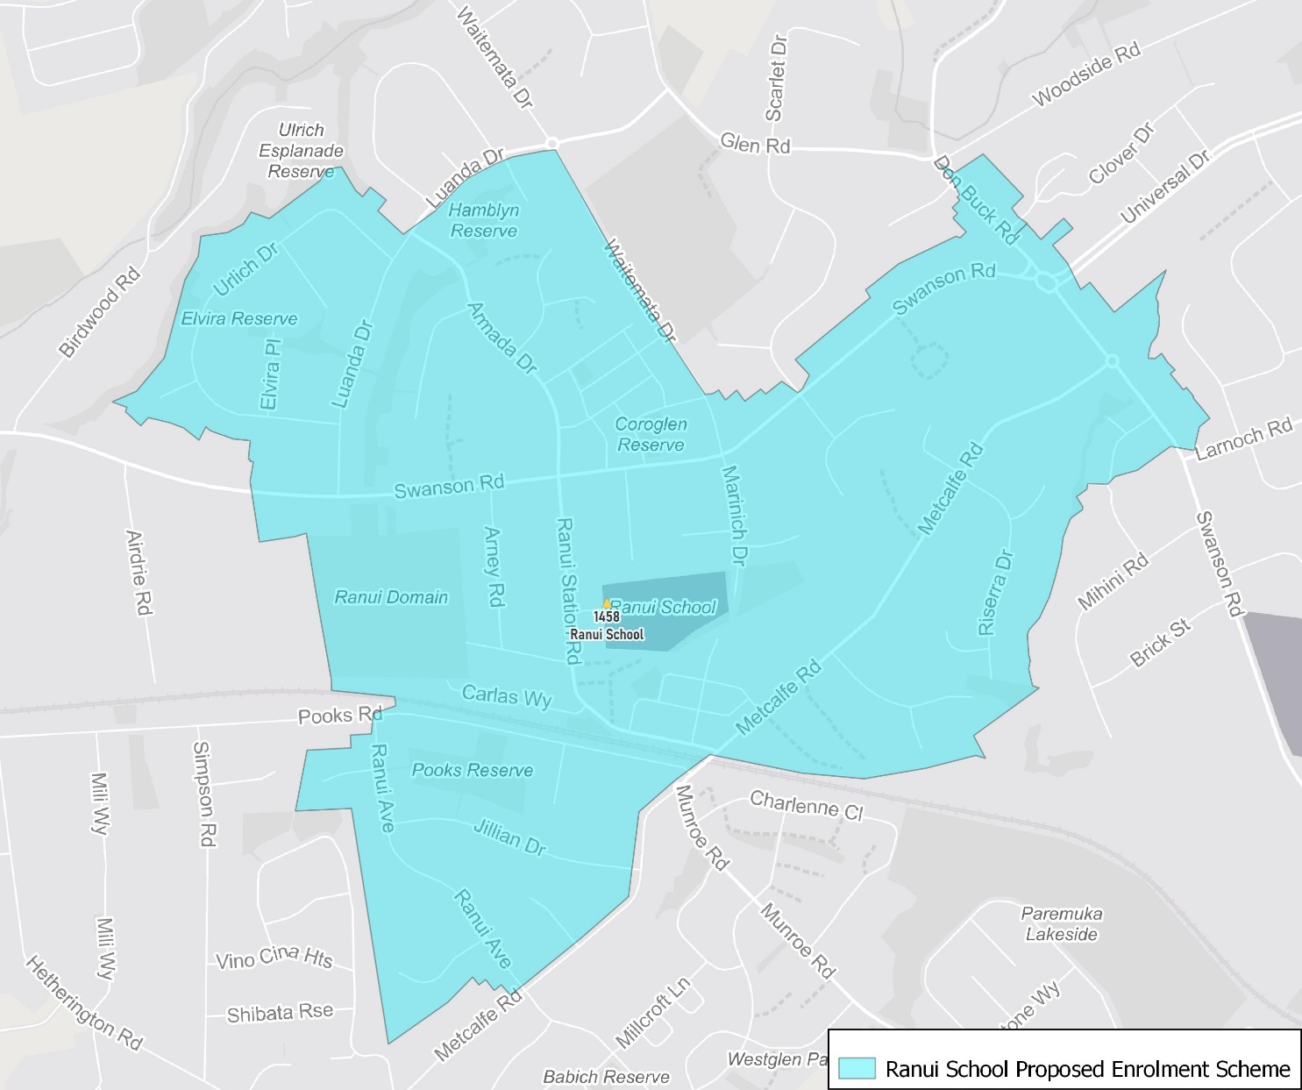

What does this mean for my family?
If you live in enrolment scheme home area for Ranui School, you will be entitled to enrol your child at the school. This entitlement applies to new students starting school, as well as any primary school aged children currently attending another school in the area.
Families who live outside the enrolment scheme home zone of Ranui School do not have entitlement to enrol and could only attend if the Board of Trustees planned to enrol any out of zone students. The enrolment scheme will establish the process for this, and places will only be available if the Board of Trustees considers it has the capacity to allow for this. Further information about whether any out of zone places will be made available will be made later in 2022.

Consultation process and timeline
The Ministry of Education is currently undertaking consultation about the proposed changes and new enrolment schemes. You can have your say by:
- Completing the survey at https://consultation.education.govt.nz/education/henderson-primaries-enrolment-schemes
- Emailing auckland.enrolmentschemes@education.govt.nz if you have further questions or comments
The Ministry will consider all feedback and liaise with the Board before making a final decision. The new schemes and changes will come into effect for the beginning of Term 2 2023.

