Tirimoana School

Enrolment Scheme Amendment

Overview – what is happening?
The Ministry of Education is amending the enrolment scheme for Tirimoana School, which will be in effect for the beginning of term 2 in 2023. Having an enrolment scheme in place will ensure the Board of Trustees has a fair and transparent mechanism to manage the roll as it grows. Children that live within this area will have entitlement to enrol at Tirimoana School. The home zone area is shown on the map below and includes:
Starting at intersection of Great North Road and Felgrove Street, head north along Great North Road (4265-4355 odd addresses included) until the intersection between Great North Road, Norcross Avenue and Te Atatu Road.
Heading north along Te Atatu Road (1-119 odd addresses, 2-108 even addresses included) until Mcleod Road:
- Norcross Avenue (17-41 addresses included)
- Humphrey Kemp (both sides included)
- Elcoat Avenue included
- Cron Avenue included
- Taitua Drive included
- Nui Mana Place included
- Kokiri Street included
- Miltonia Avenue included
- Orchid Place included
Head east on Mcleod Road (104-200 even addresses, 113-193 odd addresses, Bodi Place and Fowey Avenue included) until Finlow Drive. Follow Finlow Drive (both sides included) to Divich Avenue and head east along Divich Avenue (both sides included) to Tirimoana Road. Head south down Tirimoana Road (both sides, Meadow Crescent, Talavera Place, Tracey Terrace, James Scott Place, Valron Road and Crystal Avenue included) until Glendene Avenue.
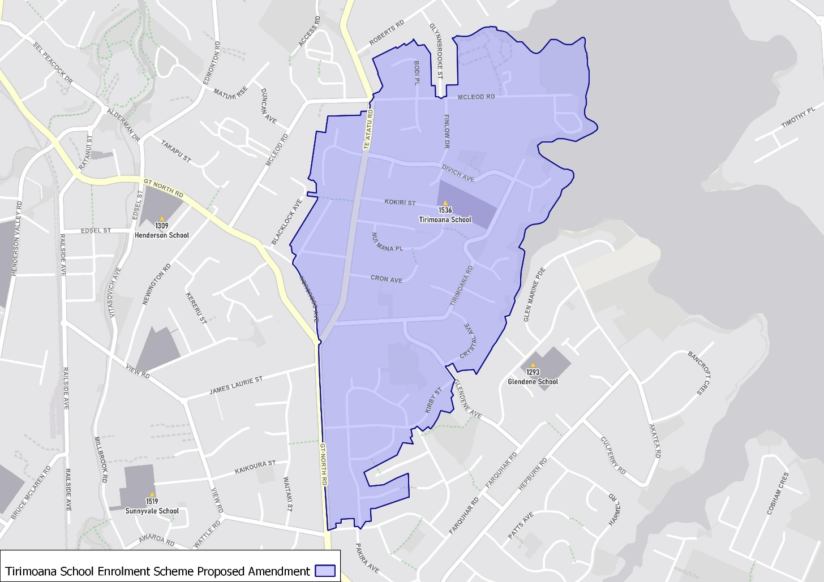
Head southeast along Glendene Avenue (51-75 odd addresses, 56-96 even addresses included) until Kirby Street. Head west along Kirby Street (both sides, Juneau Place, Milwaukee Place, Fairbanks Place and Jenelin Road included) until Manhattan Heights. Head south down Manhattan Heights (both sides, Tanoa Place included) to Felgrove Street and head west along Felgrove Street (both sides excluded) back to the starting point.

What does this mean for my family?
If you live in enrolment scheme home area for Tirimoana School, you will be entitled to enrol your child at the school. This entitlement applies to new students starting school, as well as any primary school aged children currently attending another school in the area.
Families who live outside the enrolment scheme home zone of Tirimoana School do not have entitlement to enrol and could only attend if the Board of Trustees planned to enrol any out of zone students. The enrolment scheme will establish the process for this, and places will only be available if the Board of Trustees considers it has the capacity to allow for this. Further information about whether any out of zone places will be made available will be made later in 2022.

Consultation process and timeline
The Ministry of Education is currently undertaking consultation about the proposed changes and new enrolment schemes. You can have your say by:
- Completing the survey at https://consultation.education.govt.nz/education/henderson-primaries-enrolment-schemes
- Emailing auckland.enrolmentschemes@education.govt.nz if you have further questions or comments
The Ministry will consider all feedback and liaise with the Board before making a final decision. The new schemes and changes will come into effect for the beginning of Term 2 2023.

