Howick Primary School

New Enrolment Scheme

Overview – what is happening?
The Ministry of Education is developing an enrolment scheme for Howick Primary School, which will be in effect for the beginning of term 1 in 2023. Having an enrolment scheme in place will ensure the Board of Trustees has a fair and transparent mechanism to manage the roll as it grows. Children that live within this area will have entitlement to enrol at Howick Primary School. The home zone area is shown on the map on the next page.
All students who live within the home zone described below and/or shown on the attached map shall be entitled to enrol at the school.
Starting at the intersection of Cascades Road and Lochend Place, travel east along Cascades Road (196-206 even addresses and Lochend Place included) to Aviemore Drive. Head north along Aviemore Drive (both sides included) until Pakuranga Road. Head east on Pakuranga Road (odd addresses 503 and above included, and even addresses 590, and 624 and above included) until Hutchinsons Road. Head northeast along Hutchinson Road (odd addresses included) and continue along Gills Road (15 and below odd addresses included) until Bleakhouse Road. Head east along Bleakhouse Road (62 and below even addresses included) until Ridge Road and travel south down Ridge Road (53-145 odd addresses included) until Botany Road. Continue along Botany Road (61 and below odd addresses included) until Bradbury Road and continue travelling southwest along Bradbury Road (both sides included) to Aviemore Drive. Head south along Aviemore Drive back to the starting point.
All residential addresses on included sides of boundary roads and all no exit roads off included sides of boundary roads are included in the zone unless otherwise stated.
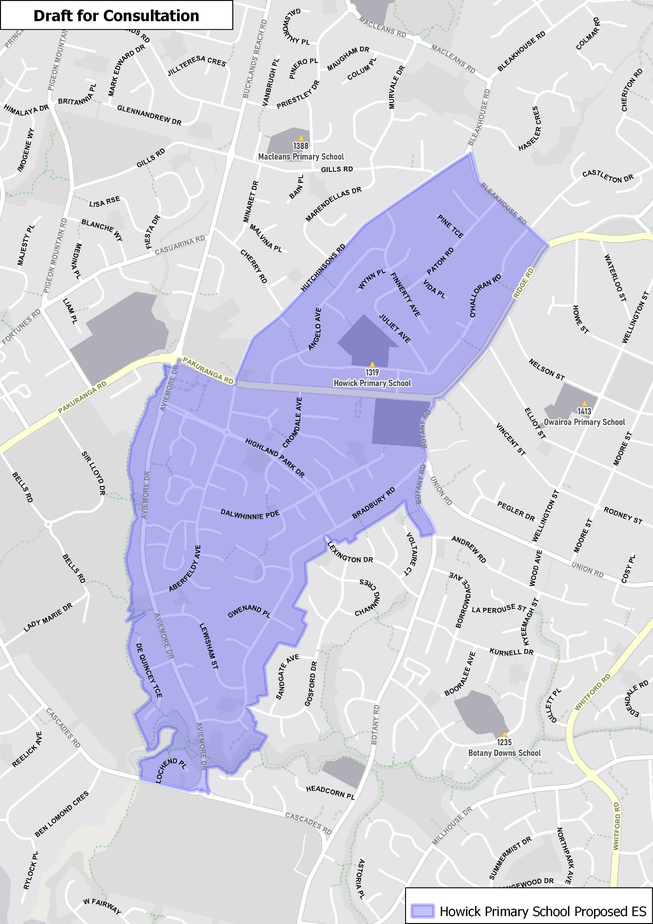

Special programme

Howick Primary School provides a Montessori special programme which will be formalised and would become priority one for out of zone enrolments.

What does this mean for my family?
If you live in enrolment scheme home area for Howick Primary School, you will be entitled to enrol your child at the school. This entitlement applies to new students starting school, as well as any students currently attending another school in the area.
Families who live outside the enrolment scheme home zone of Howick Primary School do not have entitlement to enrol and could only attend if the Board of Trustees planned to enrol any out of zone students. The enrolment scheme will establish the process for this, and places will only be available if the Board of Trustees considers it has the capacity to allow for this. Further information about whether any out of zone places will be made available in early 2022.

Consultation process and timeline
The Ministry of Education is currently undertaking consultation about the proposed changes and new enrolment schemes. You can have your say by:
- Completing the survey at https://consultation.education.govt.nz/education/Howick Primary-school-enrolment-scheme/
- Emailing auckland.enrolmentschemes@education.govt.nz if you have further questions or comments
The Ministry will consider all feedback and liaise with the Board before making a final decision. We expect the School community to be updated about progress. The new schemes and changes will come into effect for the beginning of term 1 2023.

