Te Kamo Intermediate School

New Enrolment Scheme

Overview – what is changing?
The Ministry of Education regularly monitors enrolment patterns, population growth and anticipated school roll changes across the Whangarei district. As part of this monitoring and regular review, we now consider an enrolment scheme is necessary for Te Kamo Intermediate School. This is due to growth of the school roll and because we need to ensure the Board has a fair and transparent mechanism to manage the roll. It also means we can ensure we are making best use of educational facilities across the wider Te Kamo Intermediate School area.
The new enrolment scheme will have a home zone, like other schools with enrolment schemes in the area. Children that live within this area will have entitlement to enrol at Te Kamo Intermediate School. The home zone area is shown on the map below and described here:
Te KAMO INTERMEDIATE SCHOOL (#1029)
Proposed Draft Enrolment Scheme
Commencement date: 1 January 2025

The guidelines for development and operation of enrolment schemes are issued under Schedule 20, Clause 3 (3) of the Education and Training Act 2020 for the purpose of describing the basis on which the Secretary’s powers in relation to enrolment schemes will be exercised.
Home Zone
All students who live within the home zone described below shall be eligible to enrol at the school.

The zone starts at Gillingham Rd from the Waitaua Stream end and travels south to the Station Rd intersection. Addresses on Corks Rd to up to number 48 Corks Rd are in-zone. The zone then turns right into Station Rd and travels to the Te Rauponga SH 1 intersection. All addresses accessing Gillingham Rd, and the section of Cork Rd mentioned above, and Station Rd are in-zone. From here the zone travels south along Te Rauponga SH 1 to the Kamo Rd intersection. The zone turns left onto Kamo Rd and then left onto McClintock Street to include Rupert Clark Rd and McClintock Lane addresses. From McClintock St, turn right into Weaver St and then turn left into Moody Avenue and back onto Kamo Rd.

Travel south on Kamo Rd to the Keyte St intersection. Turn left into Keyte St and then right into McLean St (to include addresses on the left side only) to King St. Continue along King St and turn right onto Cairnfield Rd. From Cairnfield Rd turn right onto Mains Ave and then turn left onto Churchill St. Note that numbers 31, 33, 35, 35A, 37, 39, 44, 46, 46A, 48, and 50 Mains Ave are in-zone. Travel along Churchill St to Mill Rd. Turn left onto Mill Road and then right onto Whareora Rd. Radcliffe St addresses are included. Travel east along Whareora Rd up to the intersection with Harris Rd. Note that all addresses accessing Whareora Rd are in-zone i.e, Hakawai Lane, Koromiko Lane, Halo Rise, Abbey Caves Rd from numbers 3 to 45 Abbey Caves Rd, and Parahaki Parish Rd. Turn left into Harris Rd and travel west to Ngunguru Rd. Turn left into Ngunguru Rd and travel up to the intersection with Kiripaka Rd by Whangarei Falls on the Hatea River. Note that number 5 Ngunguru Rd is in-zone. From number 8 Ngunguru Rd the zone moves across to Fantail Lane and travels onto Clapham Rd and then back onto Whareora Rd. Turn left onto Whareora Rd and travel to the Paranui Valley Rd intersection. Turn right onto Paranui Valley Rd and travel west to the intersection with Kiripaka Rd. Turn left onto Kiripaka road and continue onto Waiatawa Rd. Travel south down Waiatawa Rd turn right onto Cairnfield Rd. Travel north along Cairnfield Rd back to the intersection with King St. Travel back along King St to the intersection with Kamo Rd.

Turn right into Kamo Rd and travel north to the Park Ave intersection. Turn left into Park Ave with Park Ave addresses up to the Marist Sports Club at Kensington Sports Park included. Park Lane and Corns St addresses are included.

From the intersection of Park Ave and Kamo Rd turn left and travel north along Kamo Rd to Percy St. Turn left into Percy St and then turn left onto Western Hills Drive to include addresses up to number 78 Western Hills Drive. Turn back along Western Hills Drive and then turn left into Percy Street and onto Bedlington Street. Travel along Bedlington Street to the Kamo Rd intersection, with Beauzami Place and John McGill Place addresses included in-zone. Turn left onto Kamo Rd and then turn left into Whau Valley Rd. Travel west along Whau Valley Rd as far as the Whau Valley Reservoir. Bullock Ridge, Halcyon Place, Huia Street, and Eric Wakelin Drive addresses are included in-zone.

From the Whau Valley Reservoir, the zone travels west across country to the end of Karanui Rd. The zone travels down Karanui Rd to the Three Mile Bush intersection to include all addresses accessing Karanui Rd (i.e., Pekapeka Pl, Capstone Pl, Cornerstone Pl, Heartstone Pl, Keystone Pl, Howie Ln). The zone travels west along Three Mile Bush Rd as far as number 602 Three Mile Bush Rd. Forest View Rd, Palm Grove, Stoney Hill Rd, and Clover Lane addresses are in-zone, as are numbers 200-229 Church Rd inclusive.

From 602 Three Mile Bush Rd the zone turns back and travels east to Dip Rd, turning left into Dip Rd and travelling north up to the roundabout with Pipiwai Rd. All addresses accessing this section of Three Mile Bush Rd, Dip Rd, and Pipiwai Rd are in-zone. The zone continues to follow Pipiwai Rd up to number 310 Pipiwai Rd, just before the Crane Rd intersection. From here the zone turns back along Pipiwai Rd through the roundabout with Dip Rd and continues east along Pipiwai Road onto Great North Rd (SH 1). Parakiore Rd, Northcroft Road, Onoke Lane, and Waipanga Road addresses are included. Turn left onto Great North Rd (SH 1) and travel north up to number 471 SH 1. All addresses accessing this section of Great North Rd (SH 1) are in-zone. Apotu Rd addresses are included from SH 1 intersection up to number 283 Apotu Rd just before the intersection with Taha Rd and addresses on the south side of Taha Road are included i.e., numbers 3 and 11 Taha Road. Crane Rd addresses from number 354 to number 640 Crane Road up to the intersection with Apotu Road are included in-zone. All addresses accessing the above-described sections of Apotu Road and Crane Road are in-zone.

From 471 SH 1 the zone turns back and heads south along SH 1 to the intersection with Station Rd. Saleyards Rd addresses from the intersection with Jounneaux Rd up to number 78 Saleyards Road are in-zone, as are all Jounneaux Rd, Snake Hill Rd, and Gully Lane addresses.
All residential addresses on included sides of boundary roads and all no exit roads off included sides of boundary roads are included in the zone unless otherwise stated.

Section 75 of the Education and Training Act 2020 states that

“the Secretary may authorise an enrolment scheme to permit a student to enrol at the school as if the student lived in the home zone of the school if, -

(b) in the case of a new enrolment scheme, the student,

1. lives outside of the home zone of the new enrolment scheme; and
2. has a sibling who is enrolled at the school at the time that the new enrolment scheme is implemented.”

Special Programmes
This priority category is not applicable at this school because the school does not run a Special programme approved by the Secretary.
Out of Zone Enrolments
Each year the Board of Trustees will determine the number of places which are likely to be available in the following year for the enrolment of students who live outside the home zone. The Board will publish this information by public notice in a medium appropriate to the area served by the school. The notice will indicate how applications are to be made and will specify a date by which all applications must be received.
Applications for enrolments will be processed in the following order of priority:
First Priority
This priority is not applicable at this school because the school does not run a special programme approved by the Secretary for Education.
Second Priority
will be given to applicants who are siblings of current students.
Third Priority
will be given to applicants who are siblings of former students.
Fourth Priority
will be given to any applicant who is a child of a former student of the school.
Fifth Priority
will be given to any applicant who is either a child of an employee of the board of the school or a child of a member of the board of the school.
Sixth Priority
will be given to all other applicants.

If there are more applicants in the second, third, fourth, fifth or sixth priority groups than there are places available, selection within the priority group will be by ballot conducted in accordance with instructions by the Secretary, under Schedule 20, Clause 3 (1) of the Education and Training Act 2020. Parents will be informed of the date of any ballot by public notice in a medium appropriate to the area served by the school.
Applicants seeking second or third priority status may be required to give proof of a sibling relationship.

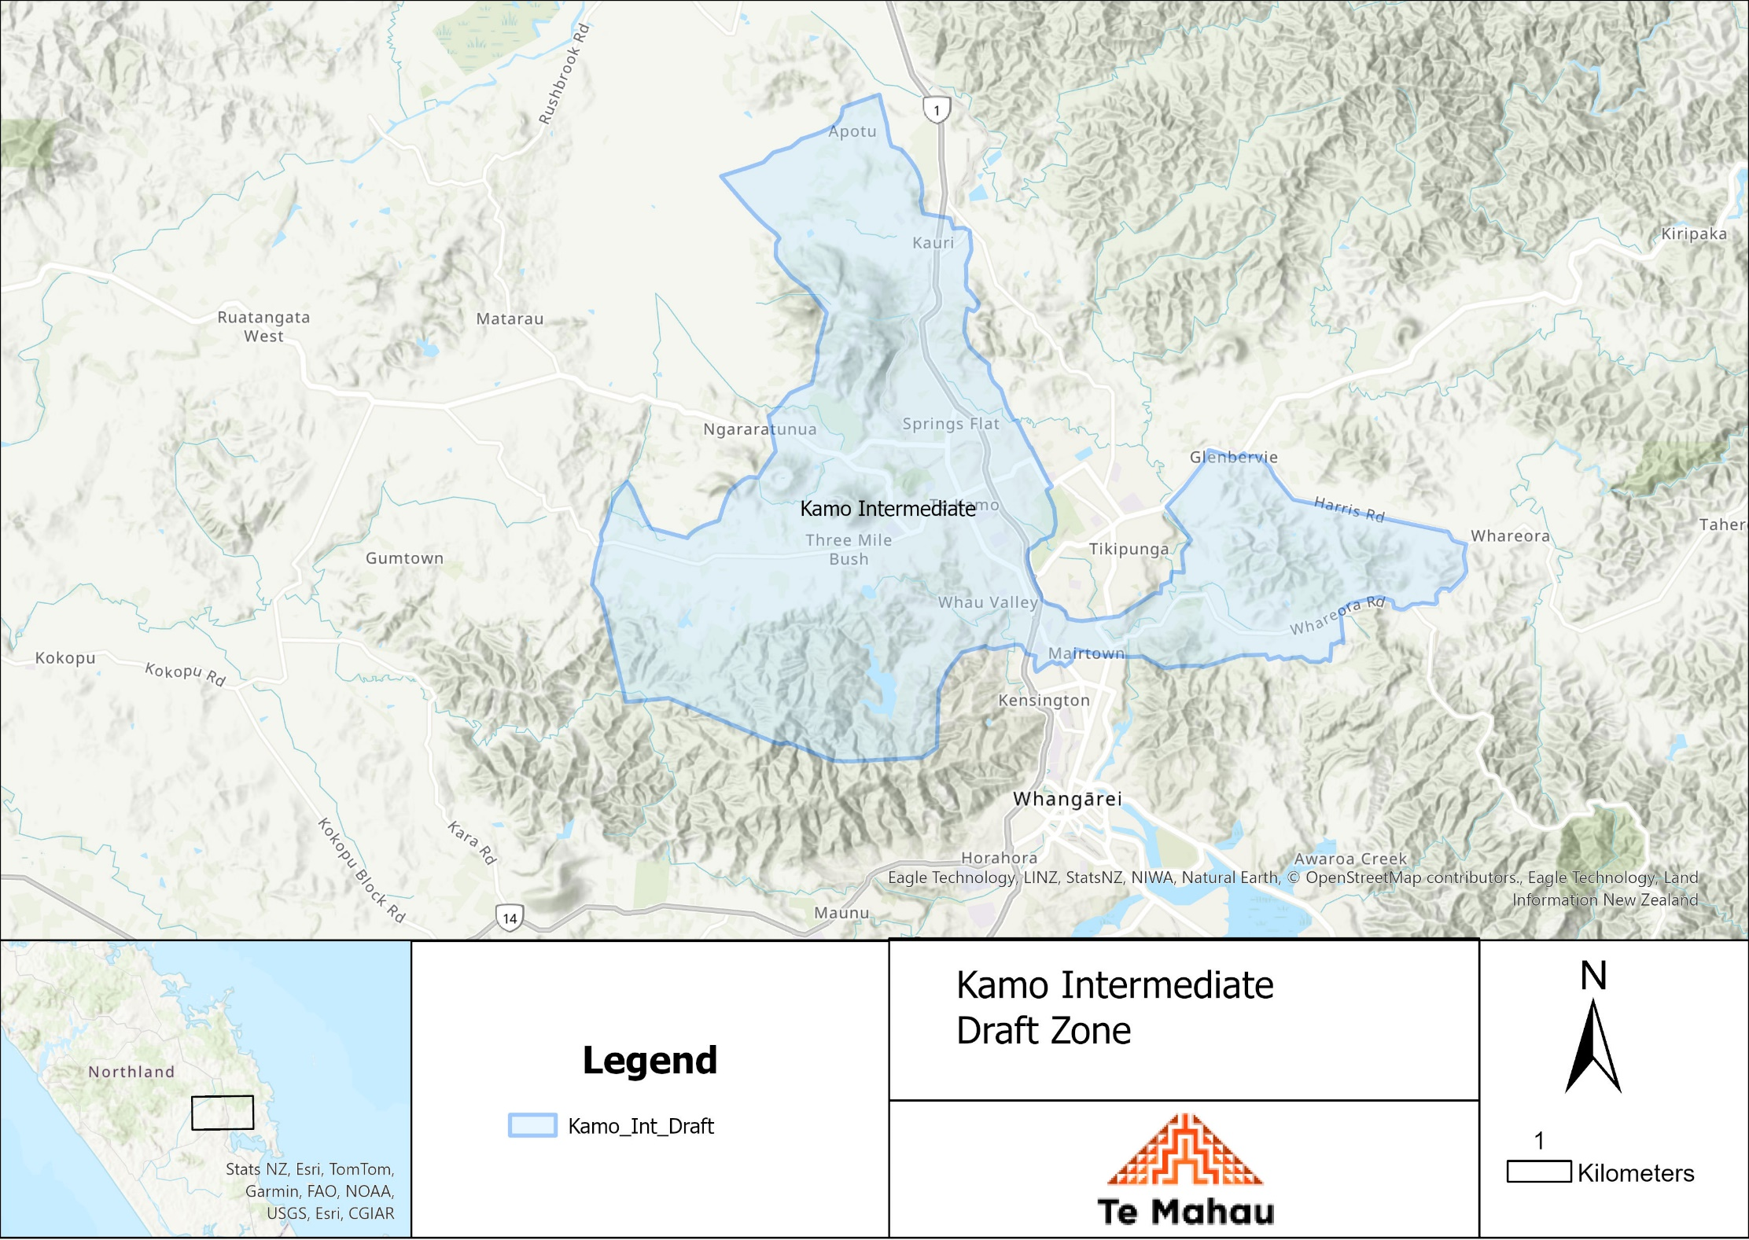

What does this mean for my family?
Any student currently enrolled at Te Kamo Intermediate School will not be impacted by the new enrolment scheme. All students enrolled (and attending school) will be entitled to continue attending Te Kamo Intermediate School, irrespective of where they currently live.
The establishment of the enrolment scheme and home zone will affect all enrolments starting at the beginning of Term 1 2025. This includes current families who have a younger sibling looking to enrol at Te Kamo Intermediate School starting on 1 January 2025 (the commencement date) or later. The flowchart below will help you assess your indicative eligibility to enrol after the commencement date.
Does your child (enrolling in 2025 or later) live within the enrolment scheme home zone? (check map for reference)
In zone enrolment
YES

NO
Out of zone enrolment
(if places available)

YES
Does your child (enrolling in 2025 or later) live outside of the zone?

Consultation process and timeline
The Ministry of Education is currently undertaking consultation about the proposed changes and new enrolment schemes. You can have your say by:
Completing the survey at: https://consultation.education.govt.nz/ on the Te Kamo Intermediate School Consultation page.

- This site also has further information about the proposed scheme.
- Emailing taitokerau.enrolmentschemes@education.govt.nz if you have further questions or comments.
Consultation will run 1 April 2024 to 13 May 2024. The Ministry will consider all feedback and liaise with the Kamo Intermediate School Board before making a final decision. We expect the school community to be updated about progress made in June 24. The new scheme and changes will come into effect for enrolments after the commencement date.

