Bruce McLaren Intermediate

New Enrolment Scheme

Overview – what is happening?
The Ministry of Education is developing an enrolment scheme for Bruce McLaren Intermediate. Having an enrolment scheme in place will ensure the Board of Trustees has a fair and transparent mechanism to manage the roll as it grows. Children that live within this area will have entitlement to enrol at Bruce McLaren Intermediate. The home zone area is shown on the map (close up on urban area and full extent) on the next page and includes:
Starting at intersection of Lake Panorama Drive and Simpsons Road (104-110 even addresses included), travel east along Lake Panorama Drive (included, Murray Becroft Avenue, Toledo Avenue, Luna Place, all no exit road on west of Lake Panorama Drive included) included) until turning northeast on Sturges Road (26 and above even, 129 and above odd included). Turn east on Vintage Drive (69 and below odd, and 78 and below even included; Miriam Corban Heights excluded) before travelling east at Henderson Park until the railway line (also including Alderman Drive, Ratanui Street, Great North Road (405-384 included)). Follow the railway line south and along Railside Avenue (96 and above even included), before turning southeast onto View Road (even side included). From View Road, travel south to Waikumete Cemetery, and follow the western boundary of the cemetery to the intersection of West Coast Road (353 and above included) and Rosier Road. Travel south along Rosier Road (odd addresses included) and then west along Glengarry Road (93 and above odd, 124 and above even addresses). Turn southwest onto West Coast Road and follow it before travelling south onto Shaw Road. Continue along Shaw Road (all addresses included) towards the intersection with Scenic Drive (119, 158 and above included). Continue west along Scenic Drive to address number 579 (Piha Road, Quinns Road, and all side roads off Piha Road to the coast are included) and travel northwest across country to meet and follow Mountain Road. Continue east on Mountain Road until it turns into Henderson Valley Road. Turn north on Candia Road (Vineyard Road and Seibel Road included) and then east along Simpson Road back to the zone’s origin point.

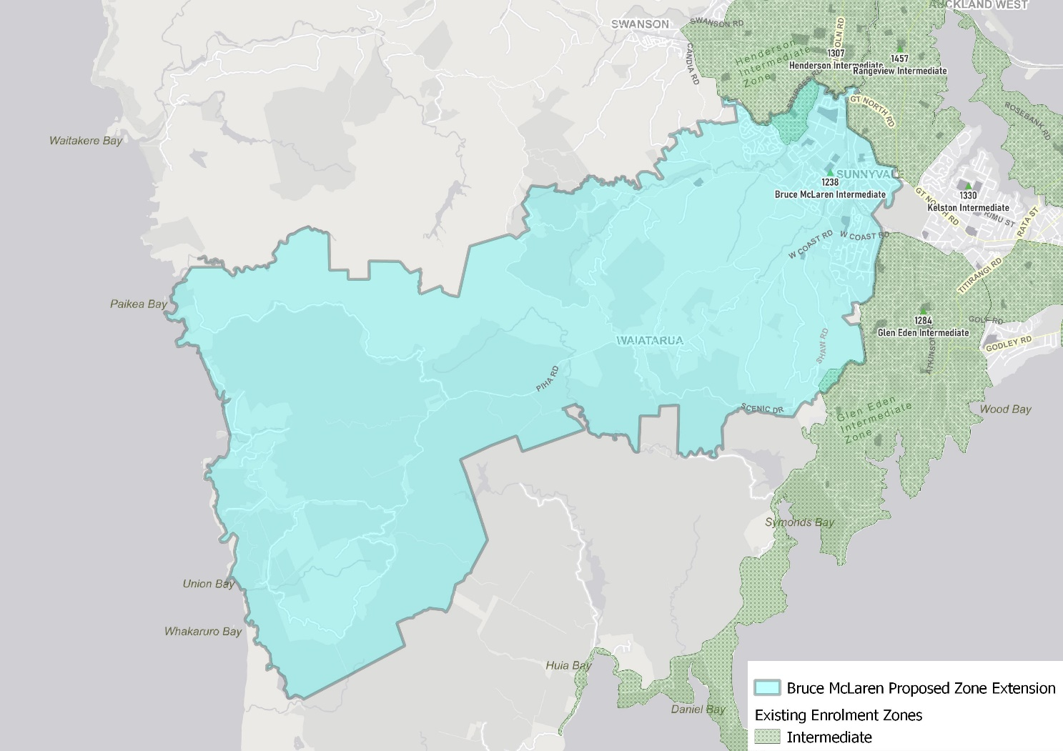

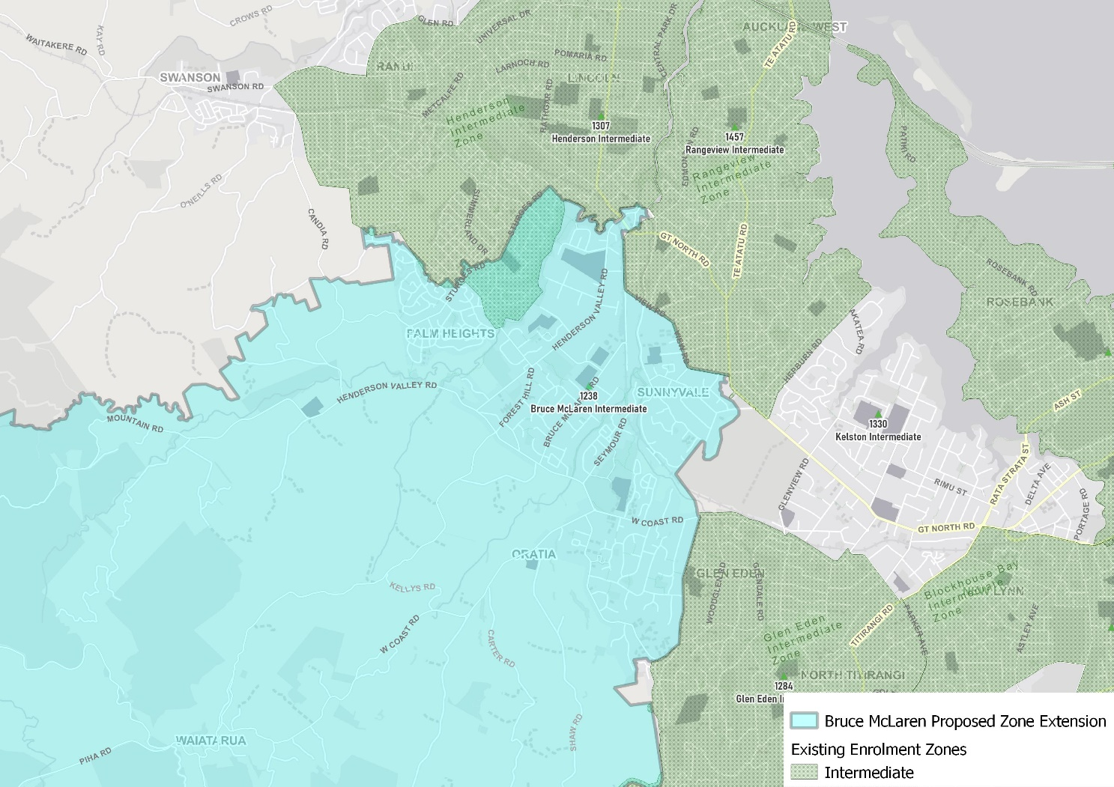

What does this mean for my family?
If you live in enrolment scheme home area for Bruce McLaren Intermediate, you will be entitled to enrol your child at the school. This entitlement applies to new students starting school, as well as any intermediate school aged children currently attending another school in the area.
Families who live outside the enrolment scheme home zone of Bruce McLaren Intermediate do not have entitlement to enrol and could only attend if the Board of Trustees planned to enrol any out of zone students. The enrolment scheme will establish the process for this, and places will only be available if the Board of Trustees considers it has the capacity to allow for this. Further information about whether any out of zone places will be made available will be made later in 2021.

Consultation process and timeline
The Ministry of Education is currently undertaking consultation about the proposed changes and new enrolment schemes. You can have your say by:
- Completing the survey at https://consultation.education.govt.nz/education/kelston-intermediate-secondaries-enrolment-schemes
- Emailing auckland.enrolmentschemes@education.govt.nz if you have further questions or comments
The Ministry will consider all feedback and liaise with the Board before making a final decision.

