Kelston Intermediate, Boys’ High School and Girls’ College

New Enrolment Scheme

Overview – what is happening?
The Ministry of Education is developing enrolment schemes for Kelston Intermediate, Boys’ High School and Girls’ College. Having an enrolment scheme in place will ensure the Board of Trustees have a fair and transparent mechanism to manage the schools’ rolls as they grow. Children that live within this area will have entitlement to enrol at Kelston Intermediate, Boys’ High School and Girls’ College. The schools operate independently, but are consulting on the same enrolment scheme area for all three schools. The home zone area is shown on the map on the next page and includes:
Starting at intersection of Great North Road and Hepburn Road, travel north on Hepburn Road (included) and continue in a straight line along the southeastern edge of Hepburn Park to the coastline. Travel initially east and then follow the coastline all the way until where the Whau River becomes the Avondale Stream, and continue along the Avondale Stream until Wolverton Street. Travel west along Wolverton Street before turning south at Portage Road (included up to 74 even and 107 odd addresses). Turn west at Links Road (included) and then turn south along the western edge of Titirangi Golf Course until Akehurst Avenue. Travel west along Akehurst Avenue (even addresses included) and then north along Astley Ave (93 and below odd, 120 and below even included). Turn west at Gardner Avenue (included) and then southwest along Seabrook Avenue (91 and below odd, 58 and below even addresses included), continuing as it becomes West Lynn Road (excluded). Then turn north at Titirangi Road (240 and below even, 223 and blow odd included) and then west at Pleasant Road (94 and below even, 31 and below odd included). Turn west at Routley Drive (included) and then south at Captain Scott Road (67 and below odd, 72 and below even included no exit roads Terra Nova Street and north of Terra Nova Street also included). Travel west along the northern edge of Ceramco Park until Glendale Road, turning north along Glendale Road (even addresses 110 and below, odd addresses 29 and below included) until West Coast Road. Turn west along West Coast Road (340 and below even, 297 and below odd included), and then travel north along the western edge of Waikumete Cemetery back to the origin of the zone.

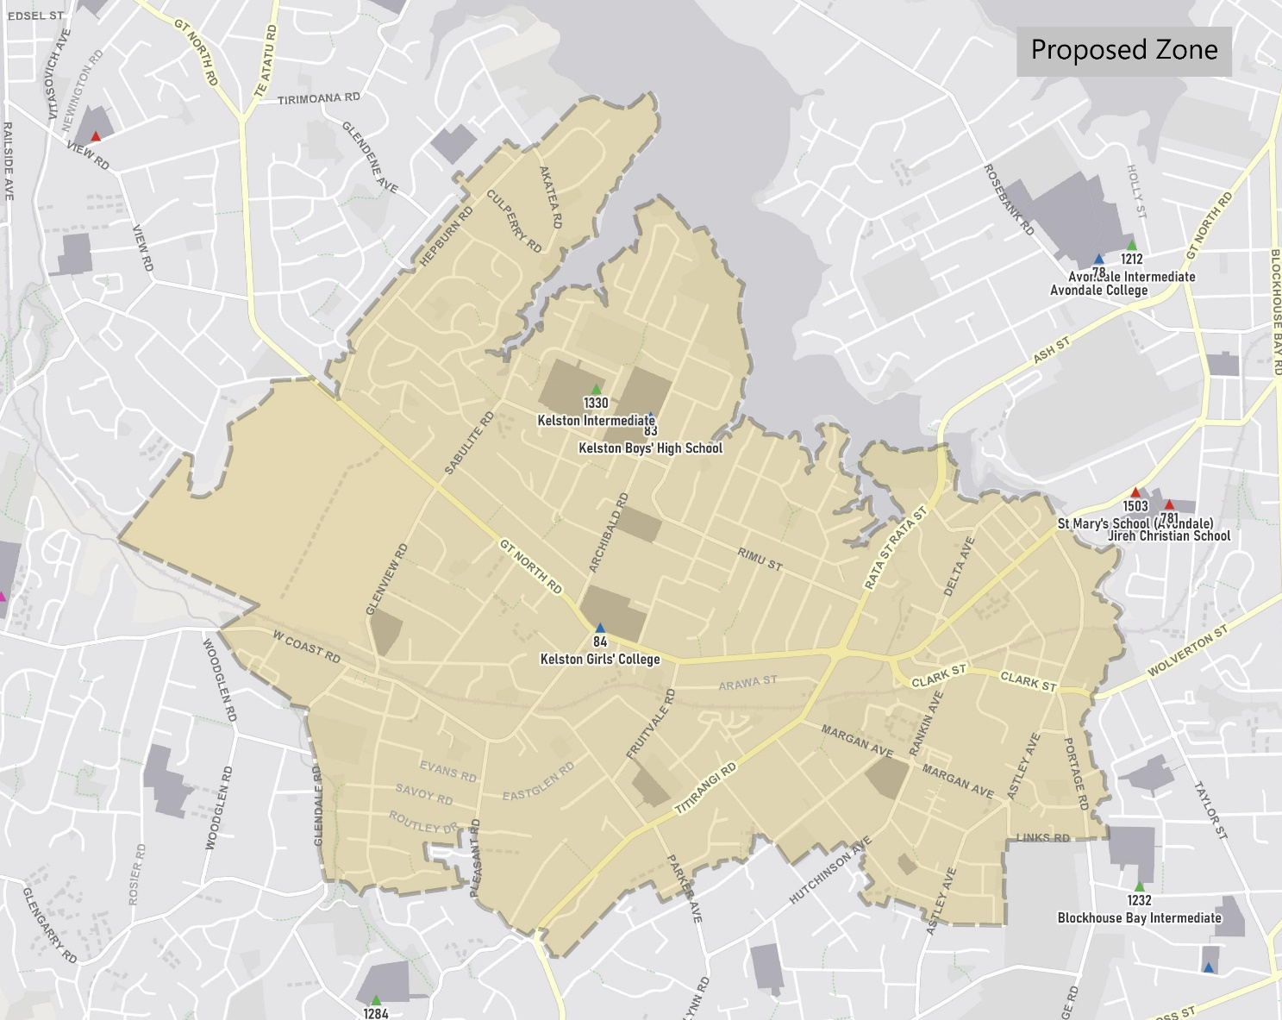

What does this mean for my family?
If you live in enrolment scheme home areas for Kelston Intermediate, Boys’ High School and Girls’ College, you will be entitled to enrol your child at the schools. This entitlement applies to new students starting school, as well as any intermediate and secondary school aged children currently attending another school in the area.
Families who live outside the enrolment scheme home zone of Kelston Intermediate, Boys’ High School and Girls’ College do not have entitlement to enrol and could only attend if the Boards of Trustees planned to enrol any out of zone students. The enrolment schemes will establish the process for this, and places will only be available if the Boards of Trustees considers it has the capacity to allow for this. Further information about whether any out of zone places will be made available by the individual school will be made later in 2021.

Consultation process and timeline
The Ministry of Education is currently undertaking consultation about the proposed changes and new enrolment schemes. You can have your say by:
- Completing the survey at https://consultation.education.govt.nz/education/kelston-intermediate-secondaries-enrolment-schemes
- Emailing auckland.enrolmentschemes@education.govt.nz if you have further questions or comments
The Ministry will consider all feedback and liaise with the Boards before making a final decision.

