Kelston School

New Enrolment Scheme

Overview – what is happening?
The Ministry of Education is developing an enrolment scheme for Kelston School, which will be in effect for the beginning of term 3 in 2022. Having an enrolment scheme in place will ensure the Board of Trustees has a fair and transparent mechanism to manage the roll as it grows. Children that live within this area will have entitlement to enrol at Kelston School. The home zone area is shown on the map on the next page and includes:
Starting at intersection of Rata Street and Great North Road, travel west along Great North Road (3999-3133 odd addresses included) until turning northeast along Archibald Road (2-76 even addresses, all odd addresses included). Travel until the end of Archibald Road, and then continue straight from the end of the road to Whau River, then turn east at the coastline and travel along the coastline until the Rata Street / SH19 Bridge. At the bridge, turn south and travel down Rata Street / SH19 (all even addresses included) until the zone’s origin.

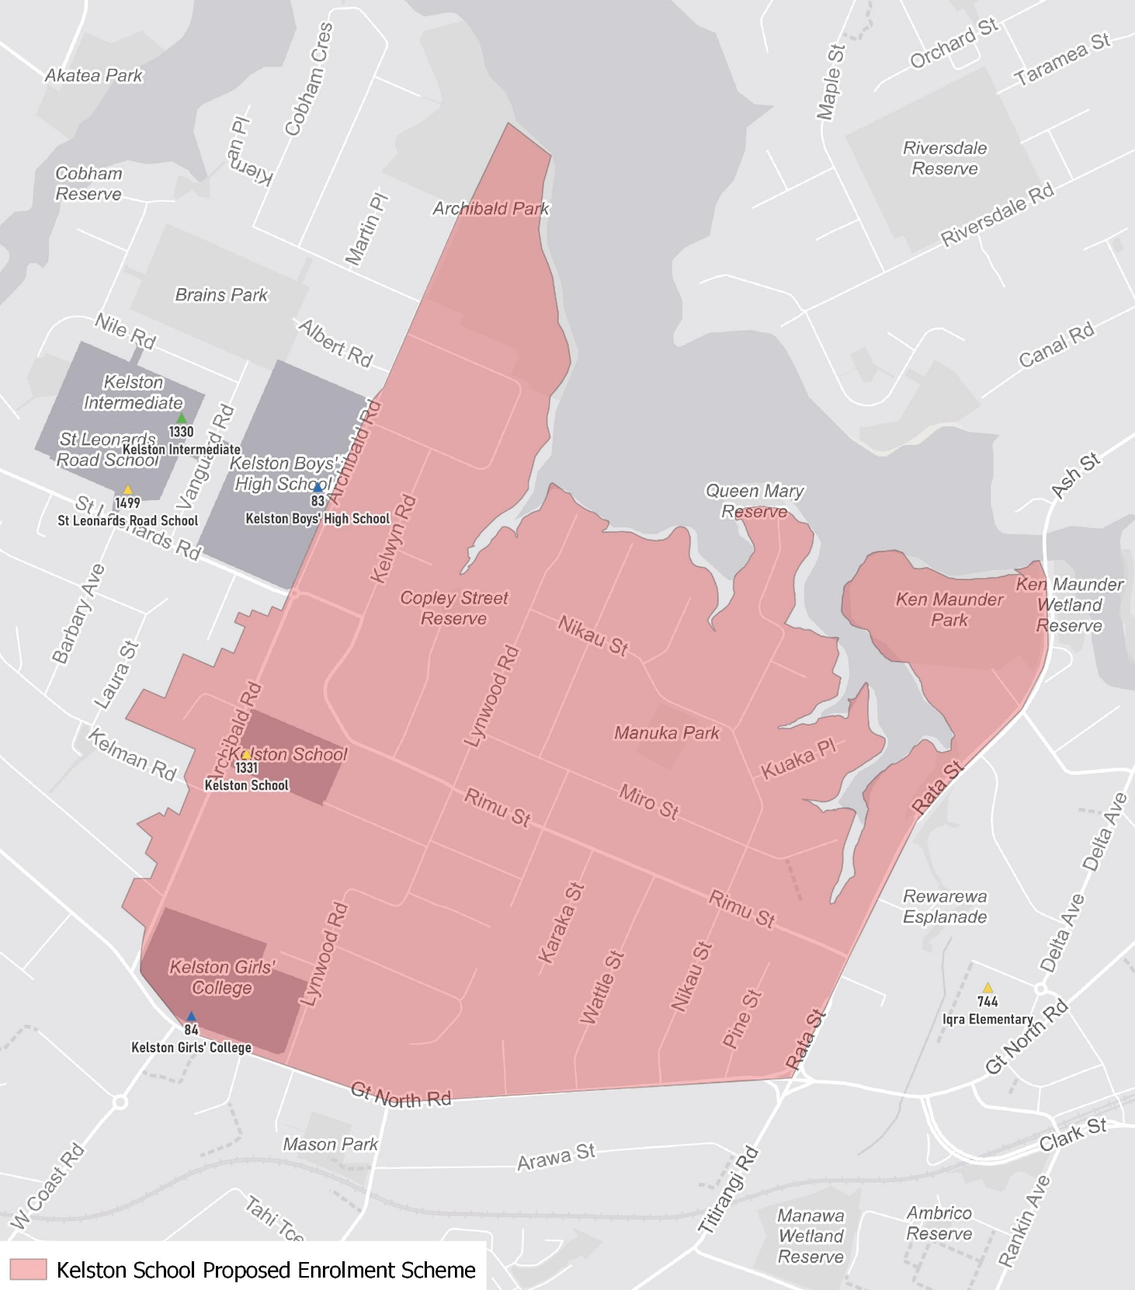

What does this mean for my family?
If you live in enrolment scheme home area for Kelston School you will be entitled to enrol your child at the school. This entitlement applies to new students starting school, as well as any primary school aged children currently attending another school in the area.
Families who live outside the enrolment scheme home zone of Kelston School do not have entitlement to enrol and could only attend if the Board of Trustees planned to enrol any out of zone students. The enrolment scheme will establish the process for this, and places will only be available if the Board of Trustees considers it has the capacity to allow for this. Further information about whether any out of zone places will be made available will be made later in 2022.

Consultation process and timeline
The Ministry of Education is currently undertaking consultation about the proposed changes and new enrolment schemes. You can have your say by:
- Completing the survey at https://consultation.education.govt.nz/education/kelston-primaries-enrolment-schemes
- Emailing auckland.enrolmentschemes@education.govt.nz if you have further questions or comments
The Ministry will consider all feedback and liaise with the Board before making a final decision. The new schemes and changes will come into effect for the beginning of Term 3 2022.

