23/10/2023

Lincoln Heights School

Proposed Enrolment Scheme

Overview – what is happening?
The Ministry of Education is proposing an enrolment scheme for Lincoln Heights School, which will be in effect for the beginning of term 3 in 2024. Having an enrolment scheme in place will ensure the School Board has a fair and transparent mechanism to manage the roll as it grows. Children that live within this area will have entitlement to enrol at Lincoln Heights School. The home zone area is shown on the map below and includes:
All students who live within the home zone described below and/or shown on the attached map shall be entitled to enrol at the school.
Starting at the intersection of Waimumu Road and Don Buck Road (odd addresses 171-227 included), travel east along Waimumu Road to Hewlett Road. Then travel north along Hewlett Road to Reynella Drive and follow Reynella Drive north to Triangle Road. Travel southeast along Triangle Road (odd addresses 77-353, and even addresses 142-334 included; Makora Road excluded), across the Northwestern Motorway towards Lowtherhurst Reserve. Follow the coastline southeast from Lowtherhurst Reserve around Taitapu Park and then southwest until Sunline Park. From Sunline Park, travel northwest towards Anich Road. Follow Anich Road towards Zita Maria Drive. From Zita Maria Drive (odd addresses included, even addresses 34 and below included), travel west towards Don Buck Road and then north along Don Buck Road back to the starting point.
All no exit roads within the boundaries described above are included in the zone unless otherwise stated.

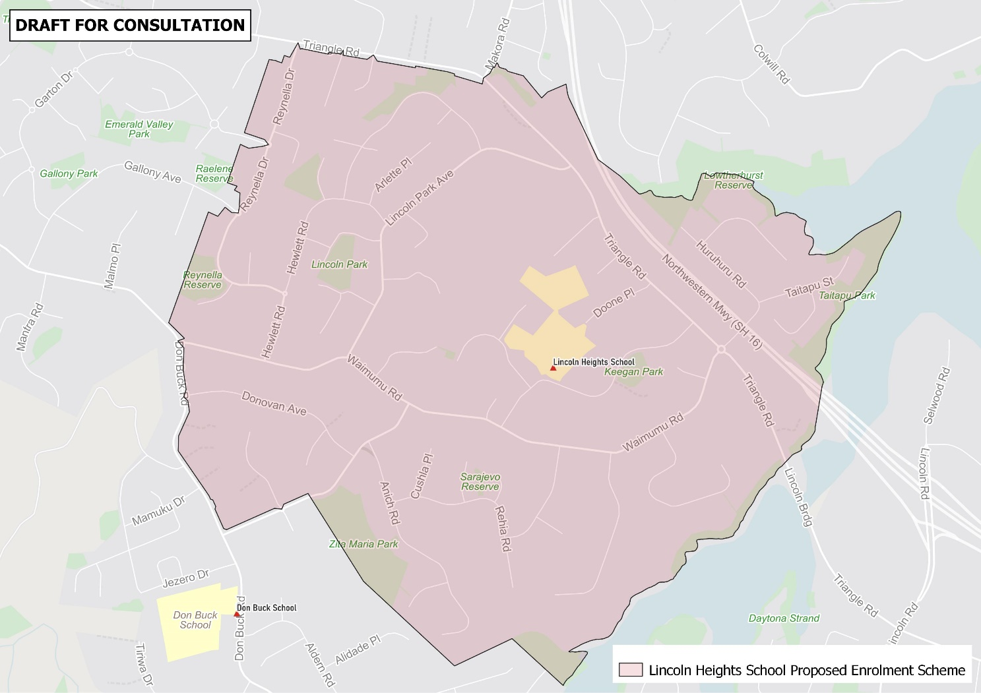

What does this mean for my family?
If you live in the proposed enrolment scheme home area for Lincoln Heights School, you will be entitled to enrol your child at the school. This entitlement applies to new students starting school, as well as any primary school aged children currently attending another school in the area.
Families who live outside the proposed enrolment scheme home zone do not have entitlement to enrol and could only attend if the School planned to enrol any out of zone students. The enrolment scheme will establish the process for this, and places will only be available if the School Board considers it has the capacity to allow for this. Further information about whether any out of zone places will be made available will be made later in 2023.

Consultation process and timeline
The Ministry of Education is currently undertaking consultation about the proposed changes and new enrolment schemes. You can have your say by:
- Completing the survey at https://consultation.education.govt.nz/education/lincoln-heights-school-enrolment-scheme
- Emailing auckland.enrolmentschemes@education.govt.nz if you have further questions or comments
The Ministry will consider all feedback and liaise with the Board before making a final decision. The new schemes and changes will come into effect for the beginning of Term 1 2024. Consultation closes 17 November, 2023.

