Jean Batten School

New Enrolment Scheme

Overview – what is happening?
The Ministry of Education is developing an enrolment scheme for Jean Batten School, which will be in effect for the beginning of term 1 in 2023. Having an enrolment scheme in place will ensure the Board of Trustees has a fair and transparent mechanism to manage the roll as it grows. Children that live within this area will have entitlement to enrol at Jean Batten School. The home zone area is shown on the map and includes:
At the intersection of the Southwestern Motorway and Bader Drive, travel southwest along Bader Drive (excluded) and then turn southeast along Ashgrove Road (even addresses included) until Friesian Drive. Turn east along Friesian Drive (54 and below even addresses and 19 and below odd addresses included) and then west along Wayne Drive (even addresses included) before turning south on Duggan Avenue (17 and below odd addresses included). At Massey Road (502-626 even, 485-569 odd included) turn west slightly and then southwest down Pukaki Road (37-59 odd addresses excluded, rest included). Travel southwest along the northern boundary of 67 Pukaki Road to the coastline, and then travel south and then east along the coastline to the Manukau Memorial Gardens Chapel. Travel along the northern edge of the Chapel grounds to the Southwestern Motorway, and then travel northwest along the Southwestern Motorway to the zone’s origin point.

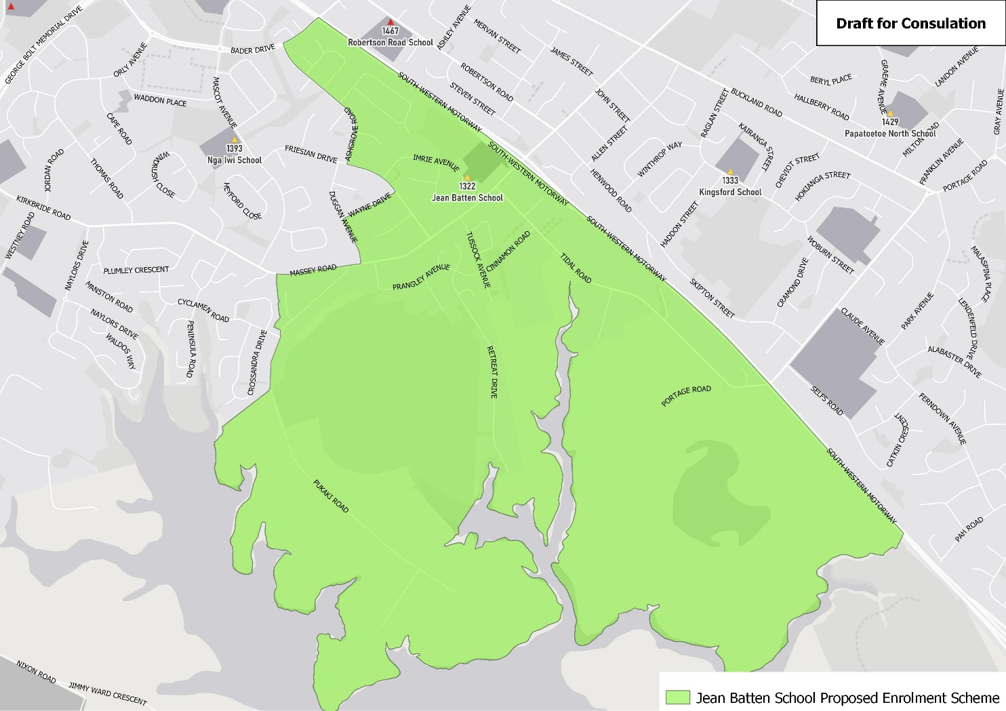

What does this mean for my family?
If you live in enrolment scheme home area for Jean Batten School you will be entitled to enrol your child at the school. This entitlement applies to new students starting school, as well as any primary school aged children currently attending another school in the area.
Families who live outside the enrolment scheme home zone of Jean Batten School do not have entitlement to enrol and could only attend if the Board of Trustees planned to enrol any out of zone students. The enrolment scheme will establish the process for this, and places will only be available if the Board of Trustees considers it has the capacity to allow for this. Further information about whether any out of zone places will be made available will be made later in 2022.

Consultation process and timeline
The Ministry of Education is currently undertaking consultation about the proposed changes and new enrolment schemes. You can have your say by:
- Completing the survey at https://consultation.education.govt.nz/education/mangere-primaries-enrolment-schemes
- Emailing auckland.enrolmentschemes@education.govt.nz if you have further questions or comments
The Ministry will consider all feedback and liaise with the Board before making a final decision. The new schemes and changes will come into effect for the beginning of Term 1 2023.

