Mountain View School

New Enrolment Scheme

Overview – what is happening?
The Ministry of Education is developing an enrolment scheme for Mountain View School, which will be in effect for the beginning of term 1 in 2023. Having an enrolment scheme in place will ensure the Board of Trustees has a fair and transparent mechanism to manage the roll as it grows. Children that live within this area will have entitlement to enrol at Mountain View School. The home zone area is shown on the map and includes:
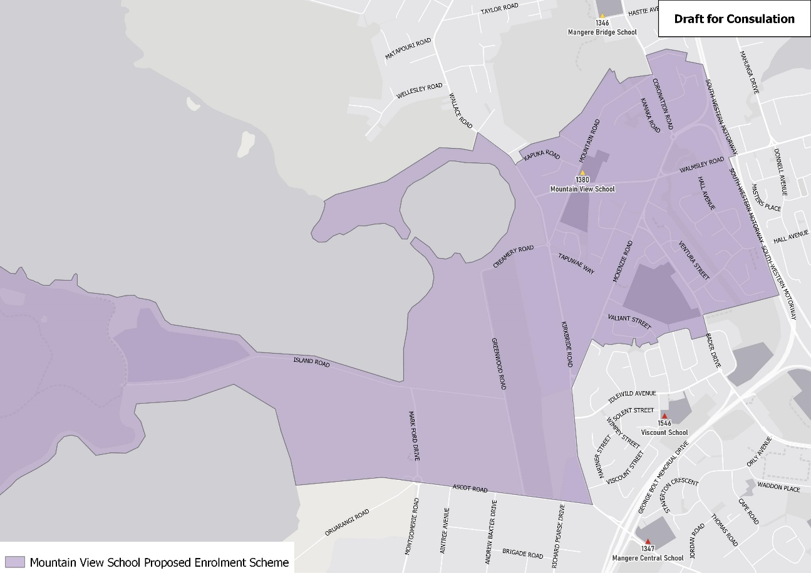
Start on the intersection of Kirkbride Road and Ascot Road and travel west along Ascot Road (odd addresses included) to the coastline. At the coastline travel initially north and continue around Puketutu Island and the Māngere Lagoon before returning to the intersection of Wallace Road and Pikitea Road (excluded). Travel southeast along Wallace Road (163 and above included) before turning east on Kapuka Road (included) and then north along Mountain Road (included) to Coronation Road (103 and above included). Travel slightly north along Coronation Road before turning east along Hocken Place (included) and continue along the northern edge of Tanners Road (included) to the Southwestern Motorway. Travel south down the Southwestern Motorway until traveling west along the northern boundary of Moyle Park to Bader Drive (46 and below even, 65 and below odd included; Walmsley Road addresses 37 and below included). Travel slightly south along Bader Driver before traveling west along the alleyway to Caravelle Close. Travel north then east around Caravelle Close (36 and below even included), and then travel north along Valiant Street (40 and below included; Fono Crescent and Vickers Crescent included) until Mackenzie Road. Travel southwest along Mackenzie Road (118 and below included) to Kirkbride Road before travelling south down Kirkbride Road to the zone’s origin point.

What does this mean for my family?
If you live in enrolment scheme home area for Mountain View School you will be entitled to enrol your child at the school. This entitlement applies to new students starting school, as well as any primary school aged children currently attending another school in the area.
Families who live outside the enrolment scheme home zone of Mountain View School do not have entitlement to enrol and could only attend if the Board of Trustees planned to enrol any out of zone students. The enrolment scheme will establish the process for this, and places will only be available if the Board of Trustees considers it has the capacity to allow for this. Further information about whether any out of zone places will be made available will be made later in 2022.

Consultation process and timeline
The Ministry of Education is currently undertaking consultation about the proposed changes and new enrolment schemes. You can have your say by:
- Completing the survey at https://consultation.education.govt.nz/education/mangere-primaries-enrolment-schemes
- Emailing auckland.enrolmentschemes@education.govt.nz if you have further questions or comments
The Ministry will consider all feedback and liaise with the Board before making a final decision. The new schemes and changes will come into effect for the beginning of Term 1 2023.

