Nga Iwi School

New Enrolment Scheme

Overview – what is happening?
The Ministry of Education is developing an enrolment scheme for Nga Iwi School, which will be in effect for the beginning of term 1 in 2023. Having an enrolment scheme in place will ensure the Board of Trustees has a fair and transparent mechanism to manage the roll as it grows. Children that live within this area will have entitlement to enrol at Nga Iwi School. The home zone area is shown on the map and includes:
Starting at the intersection of Thomas Road and Massey Road, travel east along Massey Road (573-737 odd addresses, 630-640 even included, Otaimako Place also included) to Duggan Avenue. Travel north along Duggan Avenue (even addresses and odd addresses above 23 included) and then east along Wayne Drive (odd addresses included), and then turn northwest along Friesian Drive (odd addresses 25 and above, even addresses 58 and above included) until turning north at Ashgrove Road (odd addresses and even addresses 34 and above included, Ilford Crescent also included) until Bader Drive. Turn northeast at Bader Drive and then northwest along the Southwestern Motorway (SH20) until turning southwest along SH20a back to Bader Drive (86-98 even, 117-141 odd included – section between SH20a and SH20). Travel southeast along Bader Drive and then southwest down Orly Avenue (34-44 even, 49 odd addresses included) before turning south along Cape Road (17 and below included) until Thomas Road. Travel southeast along Thomas Road (15 and below odd included) to the zone’s origin point.
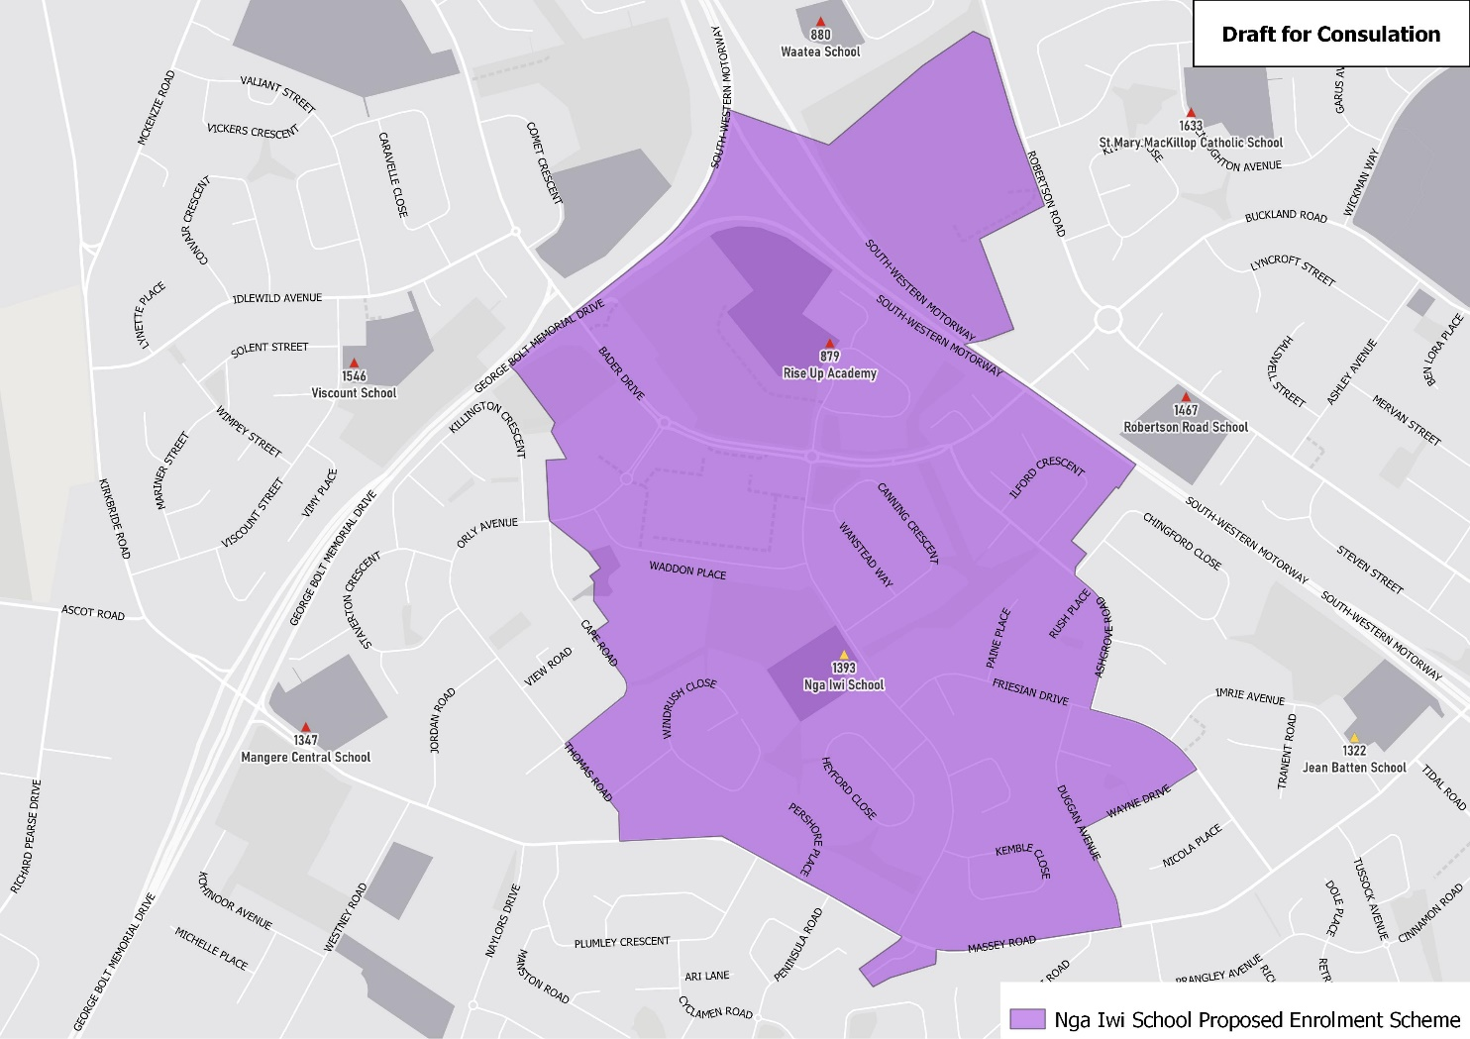

What does this mean for my family?
If you live in enrolment scheme home area for Nga Iwi School you will be entitled to enrol your child at the school. This entitlement applies to new students starting school, as well as any primary school aged children currently attending another school in the area.
Families who live outside the enrolment scheme home zone of Nga Iwi School do not have entitlement to enrol and could only attend if the Board of Trustees planned to enrol any out of zone students. The enrolment scheme will establish the process for this, and places will only be available if the Board of Trustees considers it has the capacity to allow for this. Further information about whether any out of zone places will be made available will be made later in 2022.

Consultation process and timeline
The Ministry of Education is currently undertaking consultation about the proposed changes and new enrolment schemes. You can have your say by:
- Completing the survey at https://consultation.education.govt.nz/education/mangere-primaries-enrolment-schemes
- Emailing auckland.enrolmentschemes@education.govt.nz if you have further questions or comments
The Ministry will consider all feedback and liaise with the Board before making a final decision. The new schemes and changes will come into effect for the beginning of Term 1 2023.

