Massey Primary School

Enrolment Scheme Amendment

Overview – what is happening?
The Ministry of Education is amending the enrolment scheme of Massey Primary School. The amendment is being aligned to the opening of a second campus of Whenuapai School at Trig Road and is planned to take effect 20 November, 2023. Children living in the amended area, already attending Massey Primary School, will still have an entitlement to attend Massey Primary School. The amendment will remain in place until the proposed new school at Massey- Redhills opens. This is likely to be in 2026.

What does this mean for my family?
If you live in the enrolment scheme home area for Massey Primary School, you will be entitled to enrol your child at the school. The enrolment remains in place for the length of your child’s primary education or until you choose other schooling options.
Families who live outside the amended enrolment scheme home zone of Massey Primary School do not have entitlement to enrol and could only attend if the School Board planned to enrol any out of zone students through an official ballot process. Places will only be available if the Board considers it has the capacity to allow for this. Further information about whether any out of zone places will be made available by the school.
Amended Area
The home zone area is shown on the map on the next page and includes:
All students who live within the home zone described below and/or shown on the attached map shall be entitled to enrol at the school.

Starting at the intersection of Don Buck Road and Waimumu Road, travel east along Waimumu Road (odd addresses 185-207 included) to Hewlett Road. Turn left onto Hewlett Road (odd addresses 59 and below included) and continue north until Lincoln Park Avenue. Turn left onto Lincoln Park Avenue (odd addresses 9-67 included) to Triangle Road. Turn left onto Triangle Road (addresses 12-38, 1-183 included, McClintock Road included) and travel west to Don Buck Road. Turn left onto Don Buck Road (addresses 206-456, 223-399 included) and travel southwest to Red Hills Road. Travel west along Red Hills Road (addresses 2-62, 1-67 included) to Sunnyvale Road. Turn left onto Sunnyvale Road (odd addresses 39-103 included) and travel south until 39 Sunnyvale Road at which point travel across country east to Birdwood Road (addresses 222-230, 245-349 included) and then east again to Mantra Road. Travel north along Mantra Road and then turn right back onto Don Buck Road and back to the starting point.
All residential addresses on included sides of boundary roads and all no exit roads off included sides of boundary roads are included in the zone unless otherwise stated.
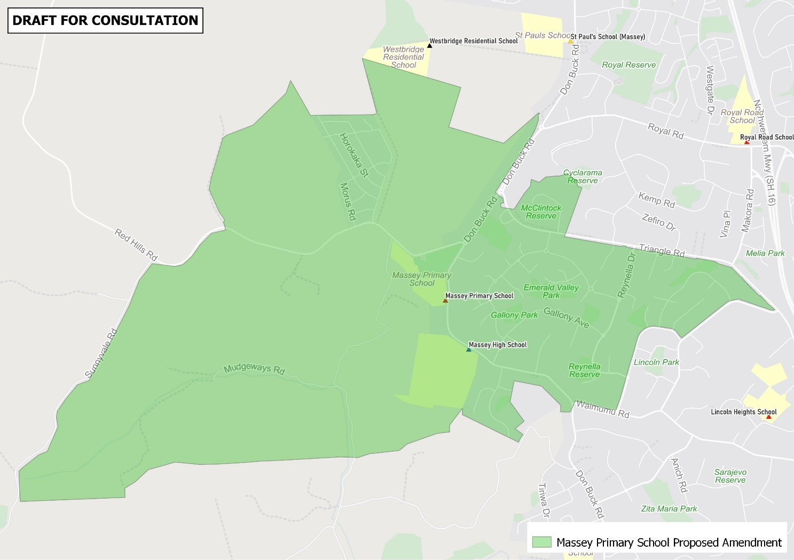

Consultation process and timeline
The Ministry of Education is currently undertaking consultation about the proposed amendment of the Massey Primary School enrolment scheme. You can have your say by:
- Completing the survey at https://consultation.education.govt.nz/education/massey-school-enrolment-scheme-amendment
- Emailing auckland.enrolmentschemes@education.govt.nz if you have further questions or comments

Consultation closes 10 November 2023.
The Ministry will consider all feedback and liaise with the Board before making a final decision. The new changes are planned to come into effect from 20 November, 2023.

