Mauku School

New Enrolment Scheme

Overview – what is happening?
The Ministry of Education is developing an enrolment scheme for Mauku School, which will be in effect for the beginning of term 2 in 2023. Having an enrolment scheme in place will ensure the School Board has a fair and transparent mechanism to manage the roll as it grows. Children that live within this area will have entitlement to enrol at Mauku School. The home zone area is shown on the map on the next page and includes:

Beginning at 500 Waiuku Road (only even numbered addresses 500 and above included, odd numbered addresses between Waller Road (excluded) and Bald Hill Road (excluded)) until intersection with Glenbrook Station Road) follow the road northwest to the intersection with Glenbrook Station Road. Follow Glenbrook Station Road (only even numbered addresses included) to the intersection with Glenbrook Road. Turn right into Glenbrook Road (only odd numbered addresses 1303 until Pearson Road included) and follow road until Pearson Road. Turn right into Pearson Road (only odd numbered addresses included) and follow until intersection with Kingseat Road. Follow Kingseat Road (only odd numbered addresses between Pearson Road and Costello Road included) and turn into Day Road at the intersection with Kingseat Road, Costello Road and Day Road. Follow Day Road (only even numbered addresses included) and turn right into Mauku Road (addresses 68 and above included, 77.and above included). Continue from Mauku Road into Union Road (both sides included) and follow Union Road until the intersection with Patumahoe Road (excluded).

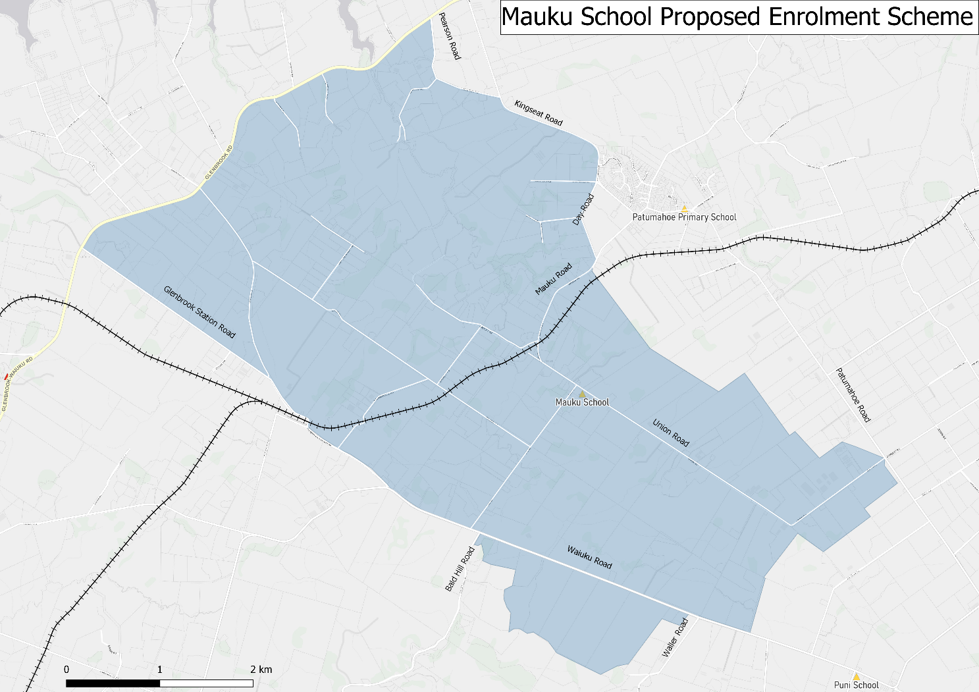

What does this mean for my family?
If you live in enrolment scheme home area for Mauku School you will be entitled to enrol your child at the school. This entitlement applies to new students starting school, as well as any primary school aged children currently attending another school in the area.
Families who live outside the enrolment scheme home zone of Mauku School do not have entitlement to enrol and could only attend if the Board of Trustees planned to enrol any out of zone students. The enrolment scheme will establish the process for this, and places will only be available if the Board of Trustees considers it has the capacity to allow for this. Further information about whether any out of zone places will be made available will be made later in 2021.

Consultation process and timeline
The Ministry of Education is currently undertaking consultation about the proposed changes and new enrolment schemes. You can have your say by:
- Completing the survey at https://consultation.education.govt.nz/education/mauku-school-enrolment-scheme/consultation/intro/
- Emailing auckland.enrolmentschemes@education.govt.nz if you have further questions or comments
The Ministry will consider all feedback and liaise with the Board before making a final decision. The new schemes and changes will come into effect at the beginning of Term 2,2023.

