Mayfield School

New Enrolment Scheme

Overview – what is happening?
The Ministry of Education is developing an enrolment scheme for Mayfield School, which will be in effect for 1 January 2023. Having an enrolment scheme in place will ensure the Board of Trustees has a fair and transparent mechanism to manage the roll as it grows. Children that live within this area will have entitlement to enrol at Mayfield School. The home zone area is shown on the map on the next page and includes:
All residential addresses on boundary roads are included and all no exit roads off included sides of boundary roads are included in the zone unless otherwise stated.
Starting at the southwestern corner of the intersection of East Tamaki Road and 168 East Tamaki Road (excluded) travel north and follow the edge of Otara Creek Reserve travelling east and still following the coastline of the creek, head towards the intersection of Pearl Baker Drive and Springs Road. Travel south along Springs Road (even addresses 22 and below) which turns into East Tamaki Road at the intersection with Johnstones Road. Continue South along East Tamaki Road (including even addresses 280 to 184) until meeting the starting point.

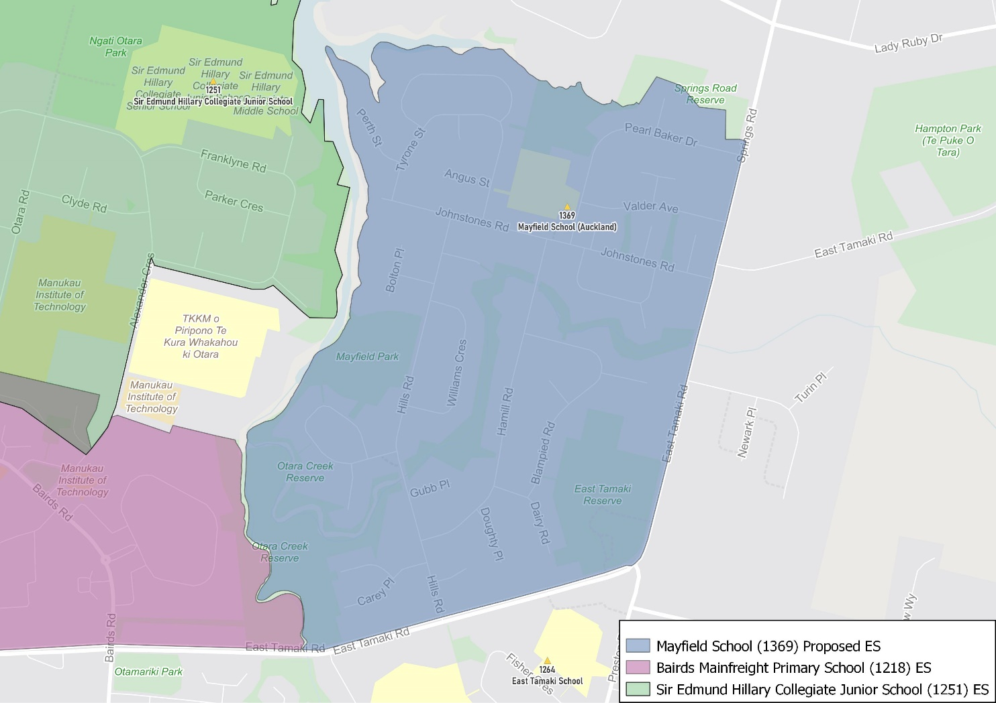

What does this mean for my family?
If you live in enrolment scheme home area for Mayfield School you will be entitled to enrol your child at the school. This entitlement applies to new students starting school, as well as any primary school aged children currently attending another school in the area.
Families who live outside the enrolment scheme home zone of Mayfield School do not have entitlement to enrol and could only attend if the Board of Trustees planned to enrol any out of zone students. The enrolment scheme will establish the process for this, and places will only be available if the Board of Trustees considers it has the capacity to allow for this. Further information about whether any out of zone places will be made available will be made later in 2022.

Consultation process and timeline
The Ministry of Education is currently undertaking consultation about the proposed changes and new enrolment schemes. You can have your say by:
- Completing the survey at https://consultation.education.govt.nz/education/mayfield-school-enrolment-scheme
- Emailing auckland.enrolmentschemes@education.govt.nz if you have further questions or comments
The Ministry will consider all feedback and liaise with the Board before making a final decision. The new schemes and changes will come into effect 1 January 2023.

