Enrolment Scheme Consultation Summary
School Name | Midhirst School
School ID | 2198
Date | 4 October 2021
Lead Advisor Network | Darryl Leath
Lead Advisor contact details |  | 06 757 6477 |  |  |  | darryl.leath@education.govt.nz

Summary
On 19 October 2020 the Education Advisor Network met with the Principal and the Board to discuss why the proposed enrolment scheme had not progressed. The School Board requested that, if possible, could the scheme progress in 2021 under the Education and Training Act 2020.

On 22 February 2021, in collaboration with the school board and principal, a communication plan was developed to collect, consider, and respond to questions and viewpoints of the school community, interested parties and iwi.

In collaboration with the school board and principal, we sent an email to neighbouring schools and other interested schools within the Principal Association area to advise them of the intention to implement an enrolment scheme at Midhirst School to prevent the risk of overcrowding.

On 24 March we met with other school boards and principals.

In collaboration with the school board and principal we advertised through school Facebook page, school newsletter and local newspaper. A public meeting was held to respond to questions and viewpoints of the community, interested parties and Iwi.

On 28 July a public meeting was held.

On 22 August 2021 the Manager Education, Taranaki, Whanganui, Manawatū approved formal consultation as required by schedule 20, clause 4(2) of the Education and Training Act 2020.

Formal consultation was via MOE consultation page and ran from 24 August through to 21 September 2021.
Midhirst School, and all those schools informally consulted, advertised the link to formal consultation via their individual school Facebook pages and newsletters.

At the conclusion of formal consultation there were 8 respondents, 6 in agreement of the proposed scheme and 2 in disagreement. The 2 respondents in disagreement did not object to the zone map or description. Both had concerns over the management of enrolments schemes. We responded to both concerns and received no further follow up.

Informal Consultation |  |  | Dates: 19 October 2020 – 22 August 2021
On 03 March 2020 the Manager Education, Taranaki, Whanganui, Manawatū, approved informal consultation as part of the development of a proposed enrolment scheme at Midhirst School (2198) pursuant to Section 11A of the Education and Training Act 1989.

School boards and principals informally consulted
School Name | School ID | School Name | School ID
Avon School | 2153 | St Joseph’s School Stratford | 2238
Stratford Primary School | 2244 | Norfolk School | 2206
Pembroke School | 2220 | Ratapiko School | 2227
Toko School | 2254 | Kaimata School | 2178

Letter sent to school boards and principals informally consulted
11 March 2021

Tēnā koe

The development of an enrolment scheme for Midhirst School.

In 2020 we identified that Midhirst School was at risk of overcrowding and gave the Midhirst School Board of Trustees notice of this under section 11H (1) of the Education Act 1989. The Midhirst School Board of Trustees have agreed to develop an enrolment scheme to manage this risk.

The purpose of the enrolment scheme is to:
- avoid overcrowding, or the likelihood of overcrowding, at a school
- ensure that the selection of applicants for enrolment at a school is carried out in a fair and transparent manner
- enable the Secretary of Education to make the best use of the existing network of state schools

To assist the Midhirst School Board of Trustees we have offered to help with informal consultation of the boards of all schools in the area that could be affected by an enrolment scheme at Midhirst School. Through open consultation with boards, we have found that many concerns can be addressed and resolved before formal submissions and wider community consultation is undertaken.

A consultation meeting for principals and boards will be held at the Midhirst School Library on Wednesday 24 March at 5:00pm to discuss the development of the enrolment scheme and proposed zone. We would invite members of your board and your principal to attend and will provide you with an opportunity to share how the implementation of this scheme and the proposed boundaries may impact upon your school.

Please contact Darryl Leath, Education Advisor Network, by email to confirm your attendance Darryl.leath@education.govt.nz .

Thank you in advance for your help and support.

Nāku noa, nā

Written responses to the letter sent to school boards and principals

Dear Graham and Darryl

The Stratford Primary School Board of Trustees are happy with the proposed zone for Midhirst School. The Board understands there is a slight overlap with our current zone.

On behalf of Hayley and myself, please put in our apologies for tonight's meeting.

Kind regards

JASON ELDER
PRINCIPAL
(BEd, MEdL)

Minutes from informal consultation with school boards and principals

MIDHIRST SCHOOL (#2198)

Enrolment Scheme Meeting (Surrounding Schools)
5:00pm - 24 March 2021
Midhirst School Library
Invited: Avon, Stratford Primary, Pembroke, Toko, St Joseph’s Stratford, Norfolk, Ratapiko, Kaimata
Present: Ratapiko School (Principal and Board Chair), Midhirst School Principal, Midhirst Board of Trustees, Darryl Leath (MOE)

Apologies: Stratford Primary (sent an e-mail in support)

Darryl Leath, Lead Advisor Network, went through the rationale for implementing an enrolment scheme.
Presented roll data, historical data and the purpose and principles of the Act.
The proposed zone map and description was shared and discussed in an open forum.

Discussion:
Concerns raised by Ratapiko;
- The zone was encroaching on a traditional feeder area for Ratipiko School
- Ratapiko School suggested that Midhirst could pull back slightly
- Concerns were raised that other schools with enrolment schemes were not following correct balloting processes.
Response:
Midhirst School principal and BOT were happy to revise the zone. Agreement was reached on a possible solution. The MoE to redraw the zone map and description. The redrawn map and description to then be circulated to all neighbouring schools for further consultation.

Meeting Closed: 6:15pm

Follow up from informal consultation with school boards and principals
As a result of the concerns raised by Ratapiko School a meeting was arranged with the principal and the presiding member of the board to discuss solutions to the area of concern, that being the corner of Salisbury and Croydon Road. This meeting was held at Ratapiko School on Friday May 14.
An agreement was reached to an amend the draft zone description (15 June).

On 22 May we received an objection to the proposed scheme from the school board of Pembroke School. The school board stated that “the Pembroke school board would be happy to agree with a Midhirst School zone that did not include Pembroke Road (including Cressida Ave, and Midsummer Ave and their respective development areas), and a zone that met us halfway between Pembroke School and State Highway 3 along Monmouth Road (up to and including 240 Monmouth Road). We are happy for the proposed zone to include all properties entering from Flint Road (west), Taurus, St, Craig St, Titania St”. We met with both the Midhirst and Pembroke school boards to negotiate a solution to the area of concern. Midhirst (2 July) and Pembroke (1 June).

As a result of continued informal consultation an agreement was reached on a revised proposed zone map and description. Confirmation of agreement is attached below.

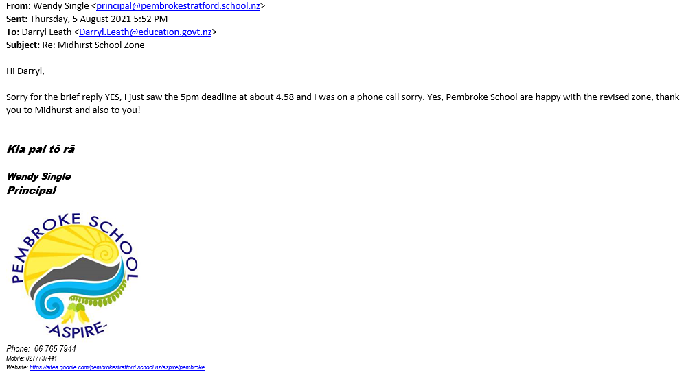

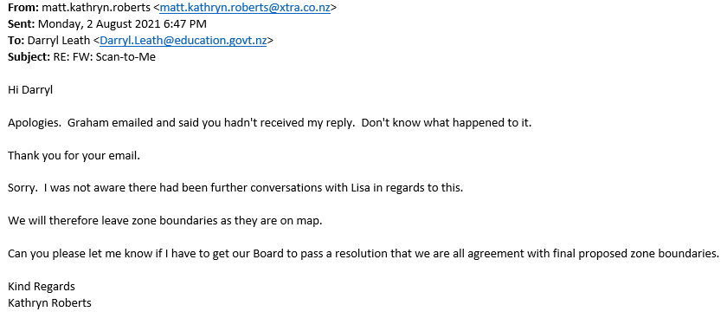

Informal consultation with the school community

A public meeting was advertised via the Facebook and School Newsletters of Midhirst School and the schools listed in the table above. No one attended the public meeting as verified by the principal below.

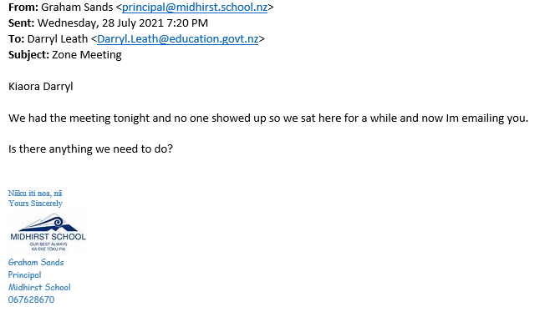

Follow up from informal consultation with the school community
As a result of a nil attendance at the arrange public meeting there was no need to follow up informal consultation with the community.

Formal Consultation |  |  | Dates: 24 August – 21 September
On 22 August 2021 the Manager Education, Taranaki, Whanganui, Manawatū approved formal consultation as required by schedule 20, clause 4(2) of the Education and Training Act 2020.

Formal consultation was via the MoE consultation page and ran from 24 August through to 21 September 2021.

Midhirst School, and all those schools informally consulted, advertised the link to formal consultation via their individual school Facebook and newsletters.

The respondents’ comments are listed below. We responded to respondents E, F and G regarding their concerns and received no further follow up.

What is your name? - Name | What is your organisation? - Organisation | Do you agree or disagree with the proposed enrolment scheme? - Agree/Disagree - Agree | Do you agree or disagree with the proposed enrolment scheme? - Agree/Disagree - Disagree | Please add any comments or suggestions that will help us understand any concerns you may have regarding the proposed enrolment scheme - Comments | Last Modified Date
A |  | Agree |  |  | 2021-09-06 14:48:11
B | Parent | Agree |  |  | 2021-09-06 14:53:57
C |  | Agree |  |  | 2021-09-06 15:09:11
D |  | Agree |  |  | 2021-09-06 15:12:22
E | Parent | Agree |  | We live out of zone but my son is in his third year at Midhirst School. I am hoping the proposal is for new student, not current students. | 2021-09-06 15:20:40
F |  |  | Disagree | I disagree because I feel a child’s education should be the main priority, and that means if they are better suited to go to a school that is out of zone, then so be it. Had my child not been able to go to Midhirst, she would still be struggling and being severely bullied. Midhirst was the right fit for her and I feel it takes away human rights for decent education to have a school zoned | 2021-09-07 07:45:25
G |  | Agree |  |  | 2021-09-16 07:44:34
H |  |  | Disagree | My daughter is already enrolled in Midhirst school and has been for nearly 2 years. We however live in Eltham which will likely be outside of the school zone. Will my daughter still be able to attend Midhirst? | 2021-09-20 19:48:25

Recommendation
Given an agreement on the zone map and description by neighbouring school boards and principals, an agreement by the community, we have recommended that the Midhirst School Enrolment Scheme is to be implemented, effective from 1 January 2022.

