Drury School

Amendment of Enrolment Scheme

Overview – what is changing?
Drury’s newest school, Ngākōroa School is set to open in Term 1, 2022. The Ministry of Education will establish a new enrolment scheme for this school and will also need to amend the existing enrolment scheme for Drury School.
The Ministry is proposing to amend the Drury School home zone. This is shown on the map below or here. This means that:
The following area will be removed from the Drury School zone and become part of the new enrolment scheme for Ngākōroa School:
Starting at the intersection of Bremner Road and SH 1, travel west along Bremner Road (27 and above only included) to Jesmond Road. Travel south along Jesmond Road (both sides included) to Karaka Road. From the intersection of Jesmond Road and Karaka Road (160 and below only included) travel across country southeast towards Burtt Road on the southern side of the railway. Travel south along Burtt Road (141 and above only included) to Needham Road (both sides included). From Needham Road, travel across country to the intersection of Kincora Lane and Runciman Road. Travel north along Runicman Road (733,726 and above only included) to Great South Road. From the intersection of Runicman Road and Great South Road (564-1176 only included), travel east across country to SH 1 and follow the motorway north back to the starting point.
Additionally, the area below will remain in the Drury School enrolment scheme home zone:
Starting at the intersection of Park Estate Road and SH1, travel east along Park Estate Road (even addresses 46 and below only included) to Great South Road. Travel south along Great South Road (see Note below) to Gatland Road. Travel east along Gatland Road (both sides included) to Sutton Road. Travel south along Sutton Road (both sides included) to the rail line. Travel south along the rail line to SH 1 (Waihoehoe Road, Fitzgerald Road, Drury Hills Road included; Quarry Road, Ramarama Road excluded). Follow SH1 north back to the starting point.
Note:
Great South Road (addresses 469-595 & 462-600; south of Park Estate Road intersection to Slippery Creek Reserve only included).
Great South Road (addresses 135-275 & 134-280; north of SH 1 intersection to Slippery Creek Reserve only included)

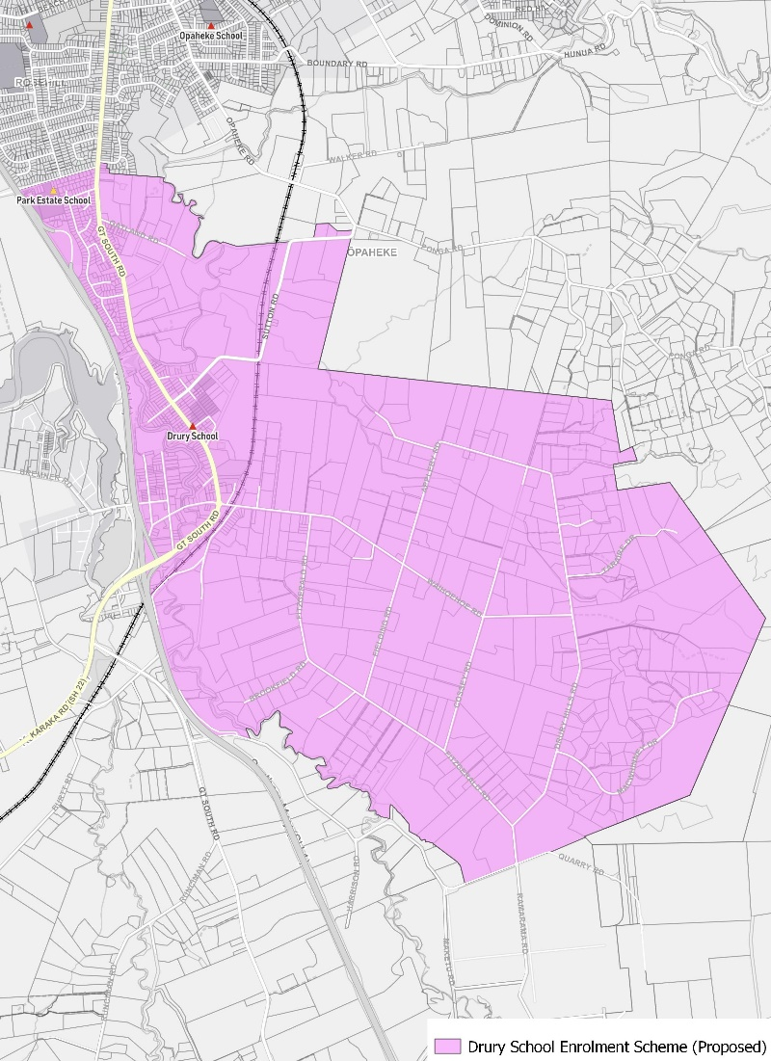
The Ministry is also considering including a transitional arrangement to minimise the impact for current families. This is a new process included in the Education and Training Act 2020 and will allow siblings of current students to retain the right to enrol at Drury School in the future, provided certain criteria are met.

What does this mean for my family?
Any student currently enrolled at Drury School will not be impacted by a change to the enrolment scheme. All students enrolled (and have started attending) will be entitled to continue attending Drury School, irrespective of where they currently live.
The change to the home zone will affect all enrolments starting in 2022. It is important to note that enrolment starts when you first attend school, not when enrolment forms are completed. This means the changes will includes current families who have a younger sibling looking to enrol at Drury School, and will start school in 2022 or later. The flowchart below will help you assess your indicative eligibility to enrol from 2022. There are also scenarios available to view below that show how this works in practice. Please note that if agreed, this grandparenting agreement will replace previous transitional arrangements developed in 2012.
An in zone enrolment is automatically entitled to enrol at the school. An out of zone enrolment is not guaranteed a place at the school and you will need to apply through the school’s out of zone processes if there are spaces available.
Does your child (enrolling in 2022 or later) live within the amended zone? (check map for reference)
In zone enrolment
YES

NO

Does your child (enrolling in 2022 or later) have a sibling enrolled at Drury School at the time the amendment was adopted (expected to be October 2021)?
NO
Out of zone
YES
NO
Does the sibling (currently enrolled child) live within the 2021 home zone at the time the amendment was adopted (expected to be October 2021)?
NO

YES
YES
In zone enrolment (due to grandparenting)
Does your child (enrolling in 2022 or later) live within the 2021 home zone?

Consultation process and timeline
The Ministry of Education is currently undertaking consultation about the proposed changes and new enrolment schemes. You can have your say by:
- Completing the survey at https://consultation.education.govt.nz/education/ngakaroa-drury-schools-enrolment-scheme/consultation/intro/
- Emailing auckland.enrolmentschemes@education.govt.nz if you have further questions or comments
Consultation will run from Monday 10th May, until 18th of June. The Ministry will consider all feedback and liaise with the Board before making a final decision. We expect the School community to be updated about progress made about mid-Term 3 The new schemes and changes will come into effect for the beginning of 2022.

