Ngākōroa School

New Enrolment Scheme

Overview – what is happening?
Enrolment schemes are implemented when new schools are established in a community. The Ministry of Education is developing an enrolment scheme for Ngākōroa School, which will be in effect for when the new school opens in 2022. Having an enrolment scheme in place will ensure the Establishment Board of Trustees has a fair and transparent mechanism to manage the roll as it grows. Like many new schools, Ngākōroa School is in a greenfields area of growth, and it’s important that local students have access to their local school.
As the area that Ngākōroa School will serve is in the current Drury School home zone, we also need to amend this enrolment scheme.
The new enrolment scheme for Ngākōroa School will have a home zone, like other schools with enrolment schemes in the area. Children that live within this area will have entitlement to enrol at Ngākōroa School. The home zone area is shown on the map below and here and includes:
Starting at the intersection of Bremner Road and SH 1, travel west along Bremner Road (27 and above only included) to Jesmond Road. Travel south along Jesmond Road (both sides included) to Karaka Road. From the intersection of Jesmond Road and Karaka Road (160 and below only included) travel across country southeast towards Burtt Road on the southern side of the railway. Travel south along Burtt Road (141 and above only included) to Needham Road (both sides included). From Needham Road, travel across country to the intersection of Kincora Lane and Runciman Road. Travel north along Runicman Road (733,726 and above only included) to Great South Road. From the intersection of Runicman Road and Great South Road (564-1176 only included), travel east across country to SH 1 and follow the motorway north back to the starting point.
The following area will remain in the Drury School enrolment scheme home zone:
Starting at the intersection of Park Estate Road and SH1, travel east along Park Estate Road (even addresses 46 and below only included) to Great South Road. Travel south along Great South Road (see Note below) to Gatland Road. Travel east along Gatland Road (both sides included) to Sutton Road. Travel south along Sutton Road (both sides included) to the rail line. Travel south along the rail line to SH 1 (Waihoehoe Road, Fitzgerald Road, Drury Hills Road included; Quarry Road, Ramarama Road excluded). Follow SH1 north back to the starting point.
Note:
Great South Road (addresses 469-595 & 462-600; south of Park Estate Road intersection to Slippery Creek Reserve only included).
Great South Road (addresses 135-275 & 134-280; north of SH 1 intersection to Slippery Creek Reserve only included)

As part of this consultation process, we are considering using new grandparenting provisions under the Education and Training Act 2020 for Queenstown Primary School and Drury School. These provisions are not needed for Ngākōroa School, as the school is not open for instruction, therefore no families are currently enrolled. If grandparenting clauses are agreed, it will mean that families that have school aged children may have entitlement to enrol younger siblings from 2022 at either their current school, or Ngākōroa School (subject to meeting all criteria).
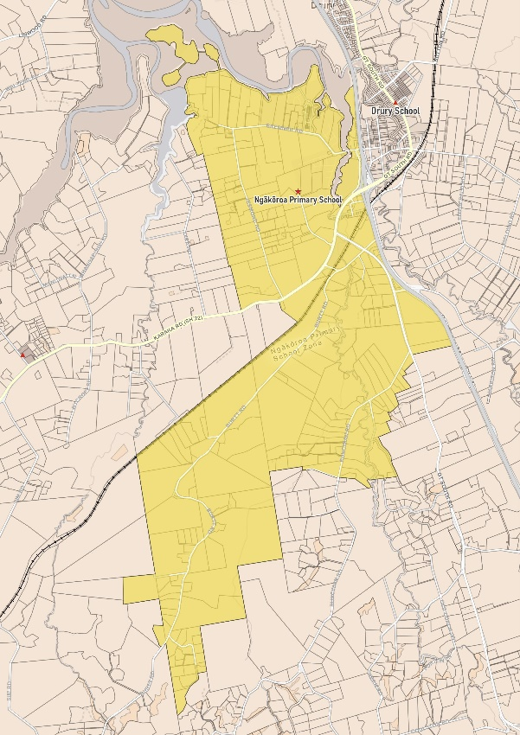

What does this mean for my family?
If you live in enrolment scheme home area for Ngākōroa School you will be entitled to enrol your child at the new school. This entitlement applies to new students starting school, as well as any primary school aged children currently attending another school in the area.
Families living in this area that have children already enrolled at Drury School may be able to enrol younger siblings from 2022 at either of these schools, if they qualify for entitlement under the new grandparenting clauses. You should refer to the fact sheets for these schools to see if this applies to you. Families in this situation will retain entitlement to Ngākōroa School as well.
Families who live outside the enrolment scheme home zone of Ngākōroa School do not have entitlement to enrol and could only attend if the Establishment Board of Trustees planned to enrol any out of zone enrolments. The enrolment scheme will establish the process for this, and places will only be available if the Establishment Board considers it has the capacity to allow for this. Further information about whether any out of zone places will be made available will be made later in 2021.

Consultation process and timeline
The Ministry of Education is currently undertaking consultation about the proposed changes and new enrolment schemes. You can have your say by:
- Completing the survey at https://consultation.education.govt.nz/education/ngakaroa-drury-schools-enrolment-scheme/consultation/intro/
- Emailing auckland.enrolmentschemes@education.govt.nz if you have further questions or comments
Consultation will run from Monday 10th May, until 18th of June. The Ministry will consider all feedback and liaise with the Board before making a final decision. We expect the School community to be updated about progress made about mid-Term 3 The new schemes and changes will come into effect for the beginning of 2022.

