Oamaru Intermediate School

New Enrolment Scheme

Overview – what is changing?
The Ministry of Education regularly monitors enrolment patterns, population growth and anticipated school roll changes across the Waitaki district. As part of this monitoring and regular review, we now consider an enrolment scheme is necessary for Oamaru Intermediate School. This is due to growth of the school roll and because we need to ensure the Board has a fair and transparent mechanism to manage the roll. It also means we can ensure we are making best use of educational facilities across the wider Oamaru area.
The new enrolment scheme will have a home zone, like other schools with enrolment schemes in the area. Children that live within this area will have entitlement to enrol at Oamaru Intermediate School. The home zone area is shown on the map below and here and includes:
- McEneany Road and the intersection of Georgetown-Pukeuri Road and Ferry Road to the North

- Reservoir Road, Eden Street (before Ardgowan Road by Old Mill Road), Maudes Road, and Awamoa Road to the West

- And as far as the corner of Awamoa Road and Beach Road to the South

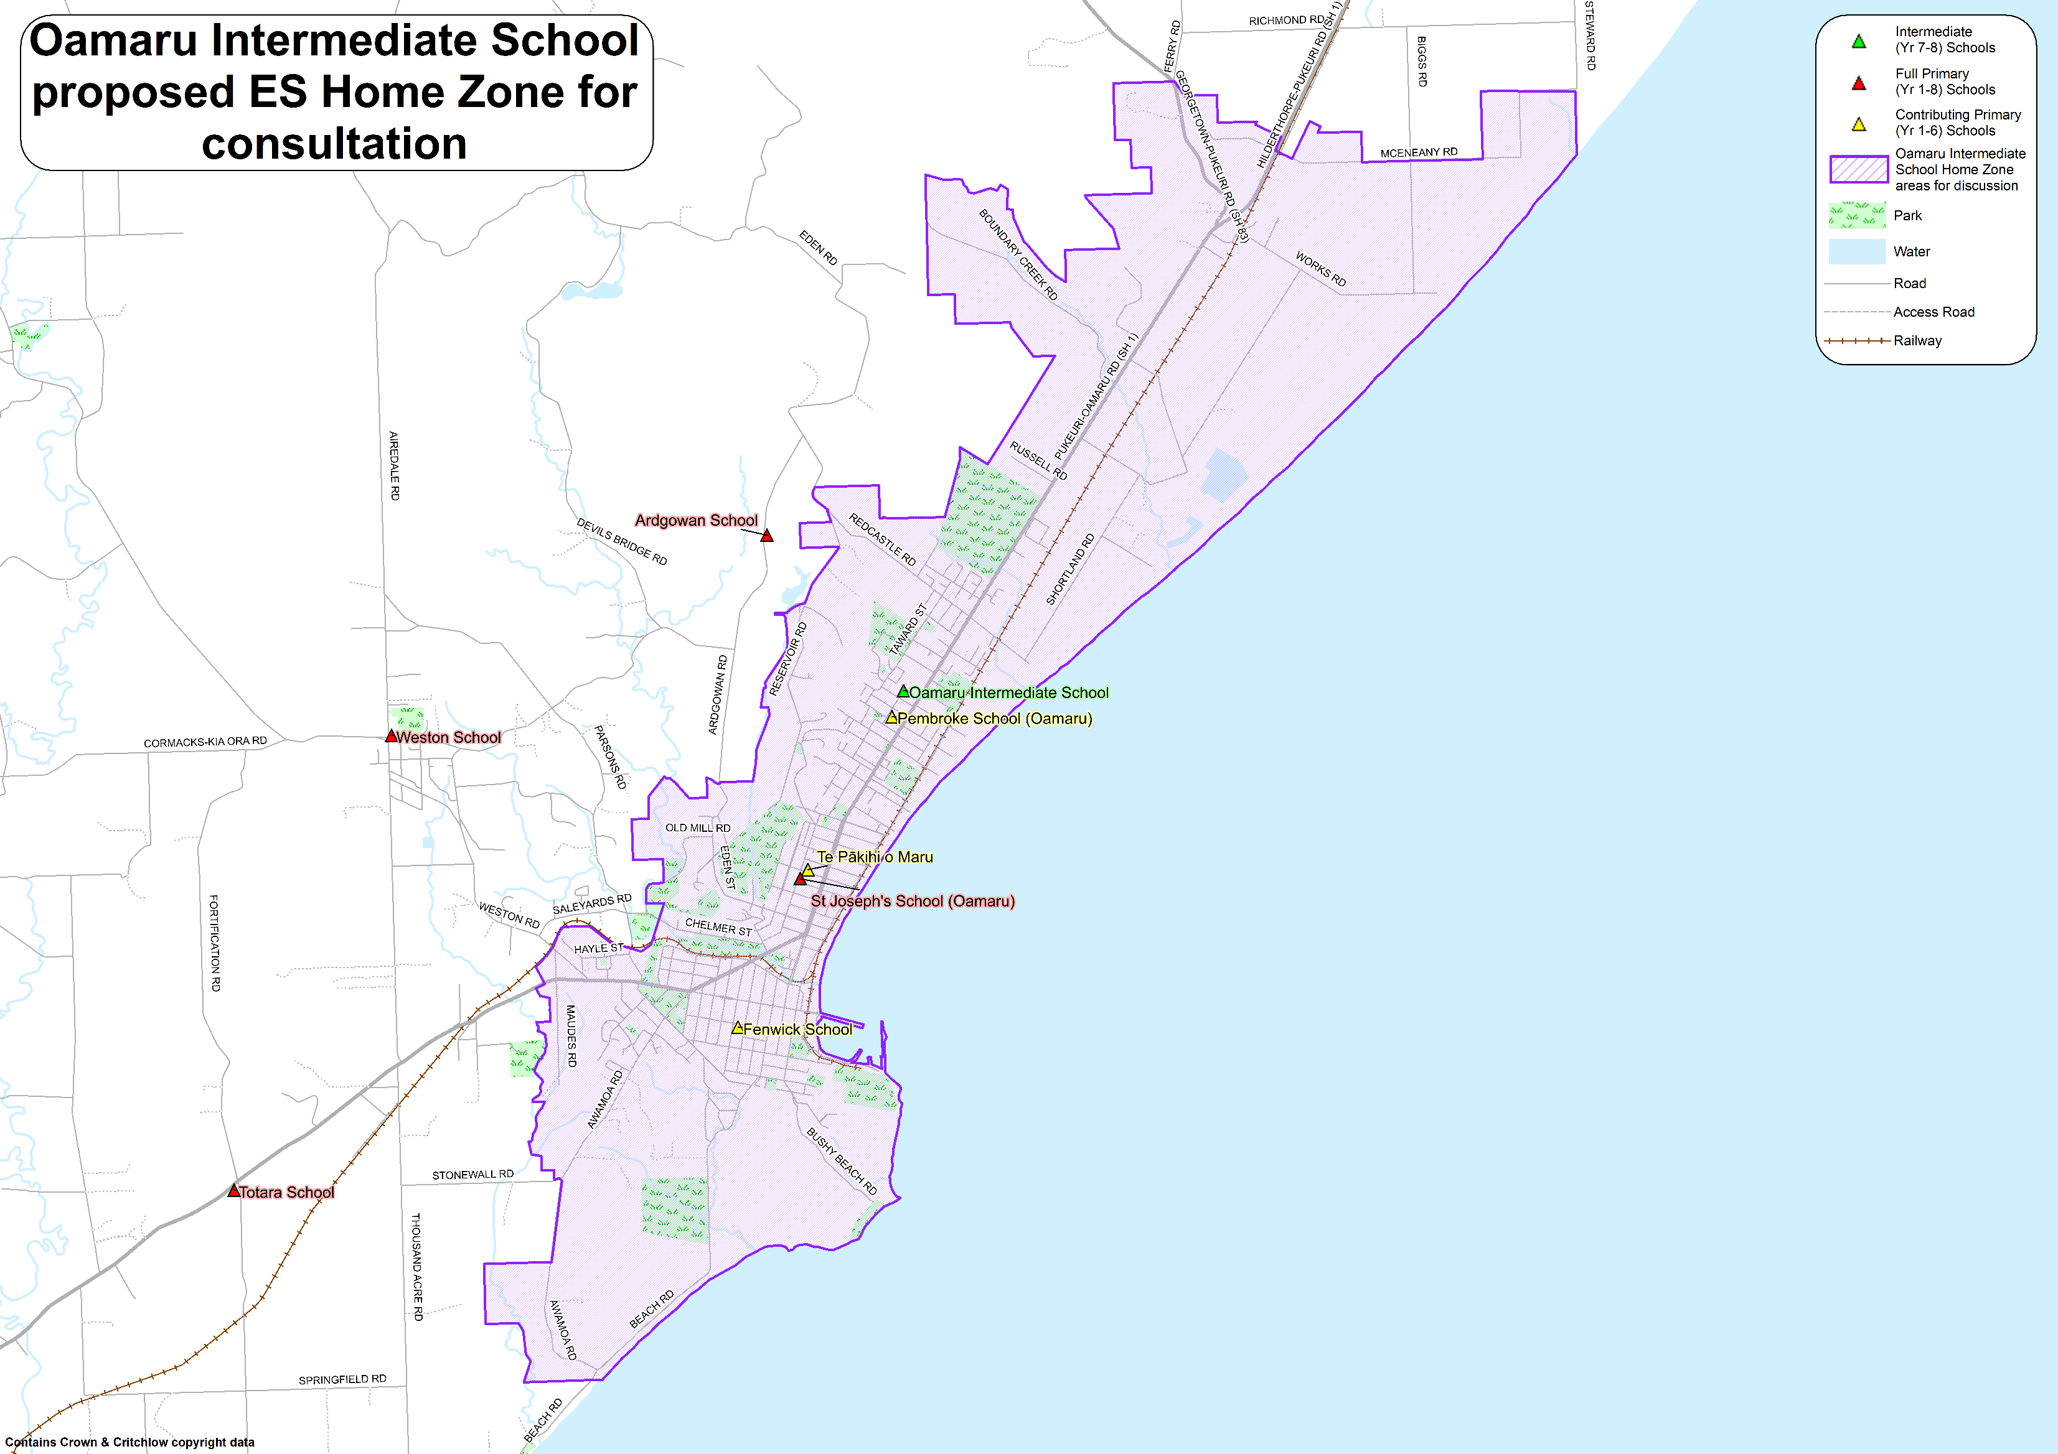
What does this mean for my family?
Any student currently enrolled at Oamaru Intermediate School will not be impacted by the new enrolment scheme. All students enrolled (and attending school) will be entitled to continue attending Oamaru Intermediate School, irrespective of where they currently live.
The change to the home zone will affect all enrolments starting in 2022. This includes current families who have a younger sibling looking to enrol at Oamaru Intermediate School and starting in 2022 or later. The flowchart below will help you assess your indicative eligibility to enrol from 2022.
Does your child (enrolling in 2022 or later) live within the enrolment scheme home zone? (check map for reference)
In zone enrolment
YES

NO
Out of zone enrolment
(if places available)

YES
Does your child (enrolling in 2022 or later) live outside of the zone?

Consultation process and timeline
The Ministry of Education is currently undertaking consultation about the proposed changes and new enrolment schemes. You can have your say by:
- Completing the survey at https://consultation.education.govt.nz/education/oamaru-intermediate-es. This site also has further information about the proposed scheme.
- Emailing otagosouthland.enrolmentschemes@education.govt.nz if you have further questions or comments.
Consultation will run until Friday 9 July 2021. The Ministry will consider all feedback and liaise with the Oamaru Intermediate School Board before making a final decision. We expect the School community to be updated about progress made about mid-Term 3. The new scheme and changes will come into effect for 2022 enrolments.

