Oranga School

Amendment of Enrolment Scheme

Overview – what is changing?
The Ministry is proposing to amend the Oranga School home zone so that the southern portion of the home zone is reduced to better align with Te Papapa School’s proposed zone, and that the western portion of the home zone is extended to introduce an larger overlap with Onehunga Primary School. This is shown on the map below. The written description is as follows:
Starting at the intersection of Great South Road and Campbell Road, travel southwest along Campbell Road (odd addresses 69 and above only included) to Onehunga Mall. Travel south along Onehunga Mall (odd addresses 419 and above only included) to Mount Smart Road. Travel southeast along Mount Smart Road (even addresses 84-148 only included) to Athens Road. Follow Athens Road (2, 33 and above only included) north and then travel across to Paihia Road. Travel north along Paihia Road (40, 23 and above only included) to Namata Road. From Namata Road (35, 32 and above only included) travel northeast along Oranga Avenue (both sides included; Olea Road included) to Waitangi Road. From Waitangi Road (odd addresses 43 and above only included) travel west to the intersection of Nissan Place and State Avenue. Follow State Avenue (20-68, 23-67 only included) north to Edmonton Avenue (44, 46 only included). Continue east to Rockfield Road (135, 128 and below only included) and then travel east again onto Walls Road. Travel east along Walls Road (odd addresses only included) to Station Road (excluded) and then onto Great South Road. Follow Great South Road (289-555 only included) north back to the starting point.
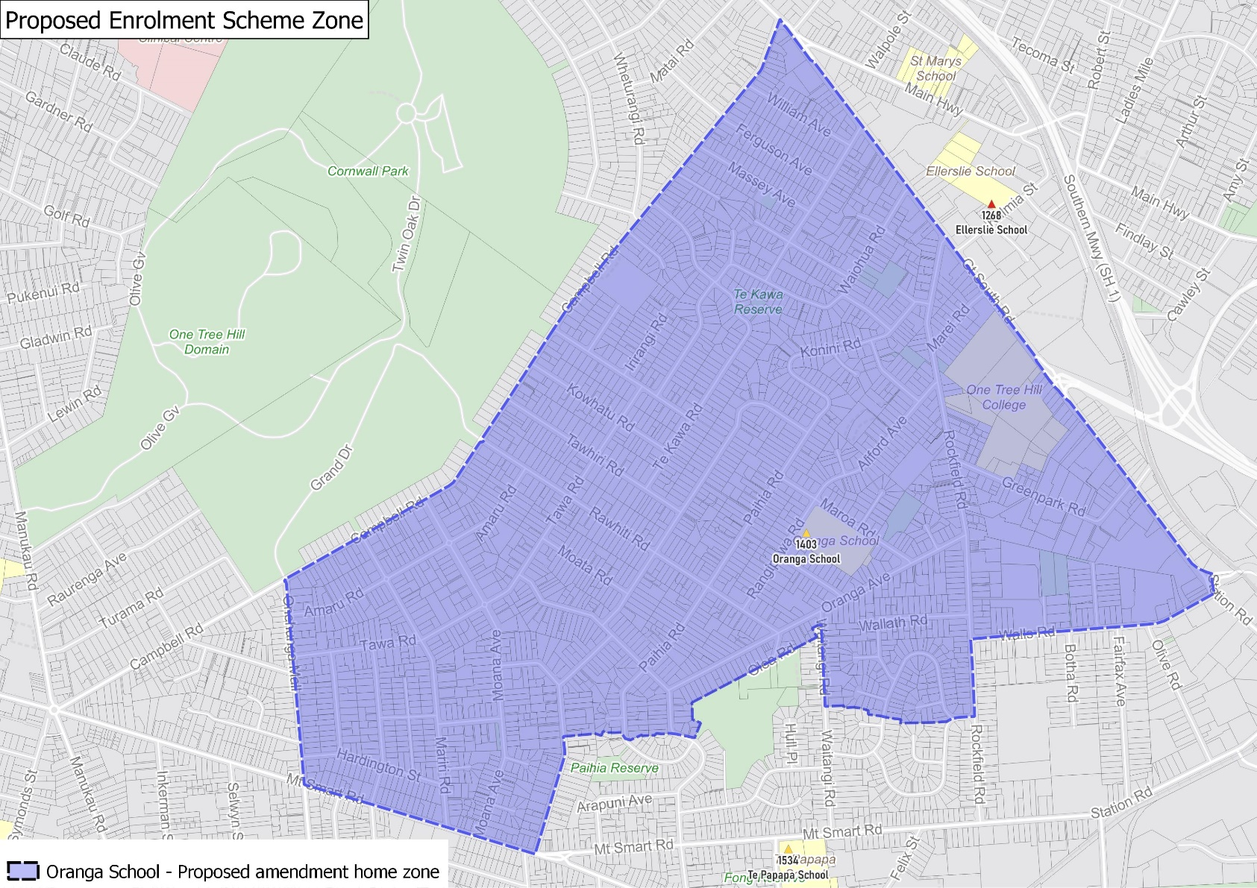

What does this mean for my family?
Any student currently enrolled at Oranga School will not be impacted by a change to the enrolment scheme. All students enrolled (and have started attending) will be entitled to continue attending Oranga School, irrespective of where they currently live.
The change to the home zone will affect all enrolments starting in 2022. It is important to note that enrolment starts when you first attend school, not when enrolment forms are completed.
An in zone enrolment is automatically entitled to enrol at the school. An out of zone enrolment is not guaranteed a place at the school and you will need to apply through the school’s out of zone processes if there are spaces available.

Consultation process and timeline
The Ministry of Education is currently undertaking consultation about the proposed changes and new enrolment schemes. You can have your say by:
- Completing the survey at https://consultation.education.govt.nz/education/oranga-te-papapa-proposals/consultation/intro/
- Emailing auckland.enrolmentschemes@education.govt.nz if you have further questions or comments
The Ministry will consider all feedback and liaise with the Board before making a final decision. The new schemes and changes will come into effect for the beginning of 2022.

