Dairy Flat School

Amended Enrolment Scheme

Overview – what is happening?
The Ministry of Education is proposing an amendment of Dairy Flat School’s enrolment scheme alongside implementing a scheme at neighbouring Milldale School. The proposed amendment will come in to effect January 1 2023.
In-zone constitutes all the areas within the following boundaries:
Starting from where the Hibiscus Coast Highway (excluded) meets East Coast Road, travel south along East Coast Road (Eastern addressed between Haigh Access Road and 2183, western addressed from Awanohi Road and Hibiscus Coast Highway Included, Forge Road Excluded) to Haigh Access Road (Included).

From Haigh Access Road continue south east along the centre of East Coast Road to Awanohi Road. Travel west along Awanohi Road and south west along Durey Road (Foley Quarry Road excluded) to Dairy Flat Highway (Wright Road excluded). Travel south along the Dairy Flat Highway (693, 668 and above included) to Potter Road. Travel north along the centre of Potter Road (2 – 10, even addresses only included) and continue north on Kennedy Road back to Dairy Flat Highway. Travel north west along Dairy Flat Highway to Blackbridge Road (Green Road included), and travel west along Blackbridge Road (608, 457 and below included) to number 608 (included). Travel cross country to Burne Road (included) and continue north to Horseshoe Bush Road. Travel east along Horseshoe Bush Road (571, 572 and below included), and north east along Austin Road to Kahikatea Flat Road. Travel north west along Kahikatea Flat Road (311, 258 and below included) to Pine Valley Road. Travel east along Pine Valley Road to Dairy Flat Highway. Travel east across the motorway to Hibiscus Coast Highway (excluded) and back to the starting point (Painton Road and Alberto Lane included).

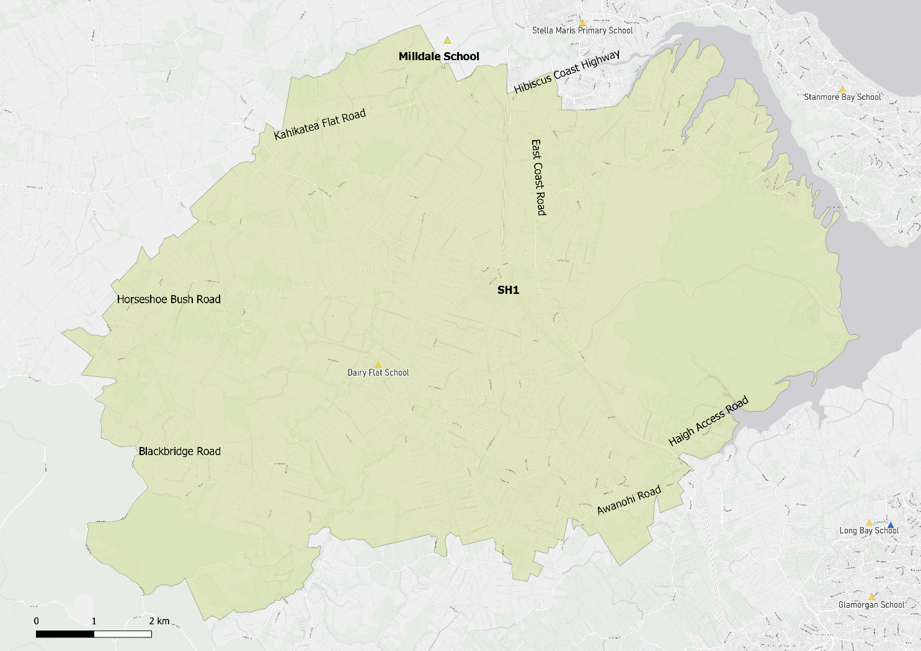

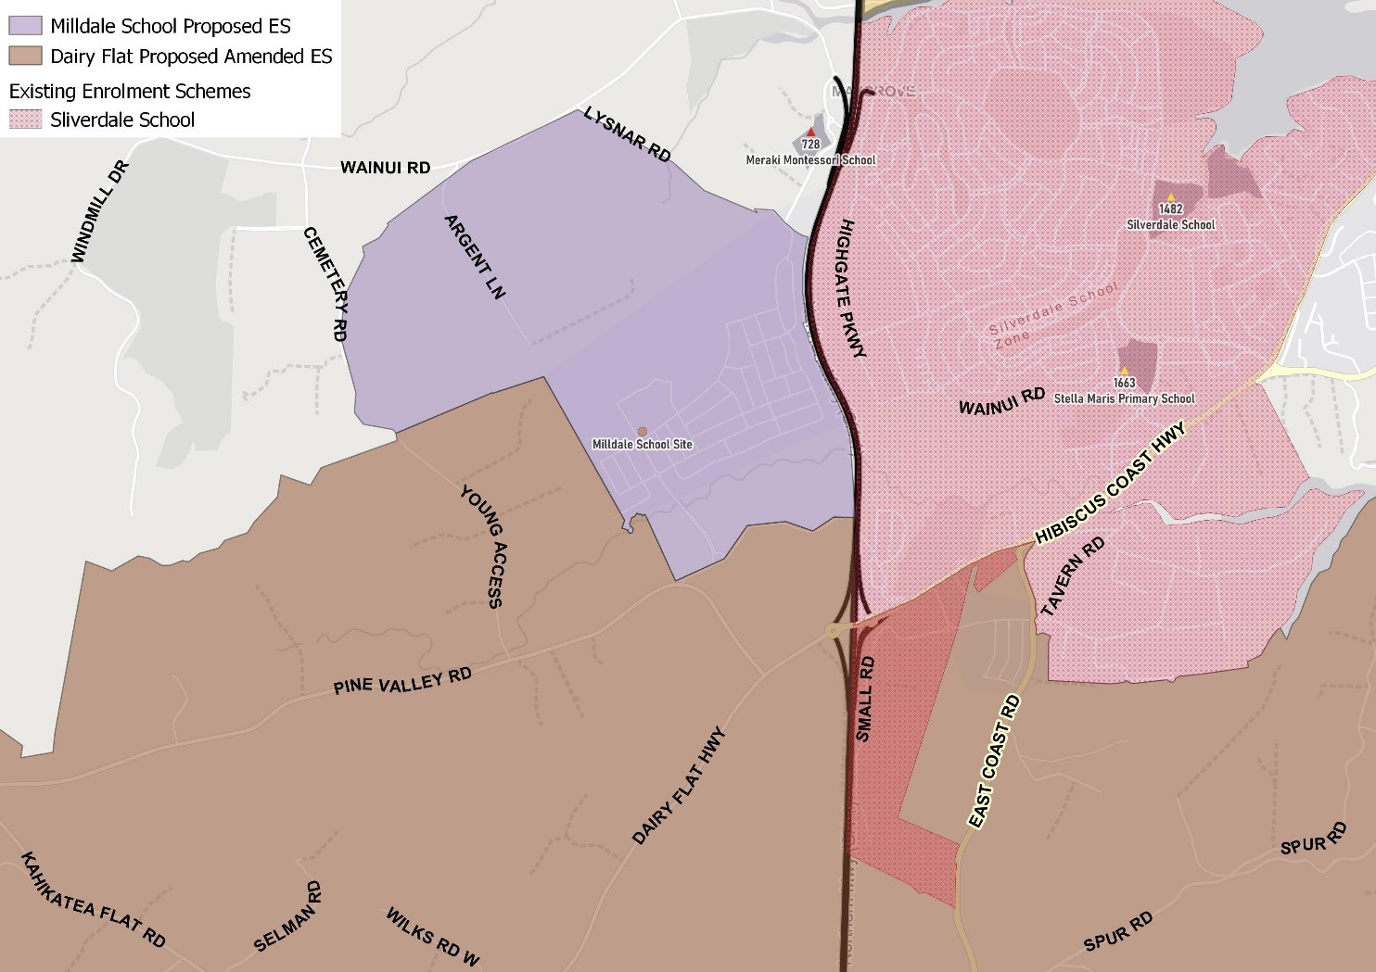

What does this mean for my family?
Any student currently enrolled at Dairy Flat School will not be impacted by a change to the enrolment scheme. All students enrolled (and have started attending) will be entitled to continue attending Dairy Flat School, irrespective of where they currently live.
The change to the home zone will affect all enrolments starting 1 January 2023. It is important to note that enrolment starts when you first attend school, not when enrolment forms are completed.
An in-zone enrolment is automatically entitled to enrol at the school. An out of zone enrolment is not guaranteed a place at the school and you will need to apply through the school’s out of zone processes if there are spaces available.

Consultation process and timeline
The Ministry of Education is currently undertaking consultation about the proposed changes and new enrolment schemes. You can have your say by:
- Completing the survey at https://consultation.education.govt.nz/education/Dairy Flat Beach-primaries-enrolment-schemes
- Emailing auckland.enrolmentschemes@education.govt.nz if you have further questions or comments
The Ministry will consider all feedback and liaise with the Board before making a final decision. The new schemes and changes will come into effect 1 January 2023.

