Milldale School

New Enrolment Scheme

Overview – what is happening?
The Ministry of Education is developing an enrolment scheme for Milldale School, which will be in effect for 1 January 2023. Having an enrolment scheme in place will ensure the Board of Trustees has a fair and transparent mechanism to manage the roll as it grows. Children that live within this area will have entitlement to enrol at Milldale School. The home zone area is shown on the map on the next page and includes:
Starting on the western side of SH1 where Wainui Road crosses the motorway. Follow Wainui Road (northern address between Orewa River and Upper Orewa Road excluded) until Upper Orewa Road (eastern address excluded). Turn right into Upper Orewa Road (western addresses included) and continue until it crosses the Orewa River (northern addresses excluded). Follow Orewa River west (southern addresses included) until Gervin Road crosses (western addresses excluded). Follow Gervin Road (eastern addresses included) south to the intersection with Wainui Road, and cross Wainui Road and continue along Cemetery Road (eastern addresses 42 and below included). Travel across country south until the northern end of Young Access (excluded), then travel across country east until the southern end of Argent Lane (included), travel across country south until the intersection of Pine Valley Road (excluded) and Old Pine Valley Road (northern addresses included). Follow Old Pine Valley Road east, at road end, continue east until SH1. Follow SH1 north back to the starting point.

All residential addresses on included sides of boundary roads and all no exit roads off included sides of boundary roads are included in the zone unless otherwise stated.
All no exit roads within the boundaries described above are included in the zone unless otherwise stated.
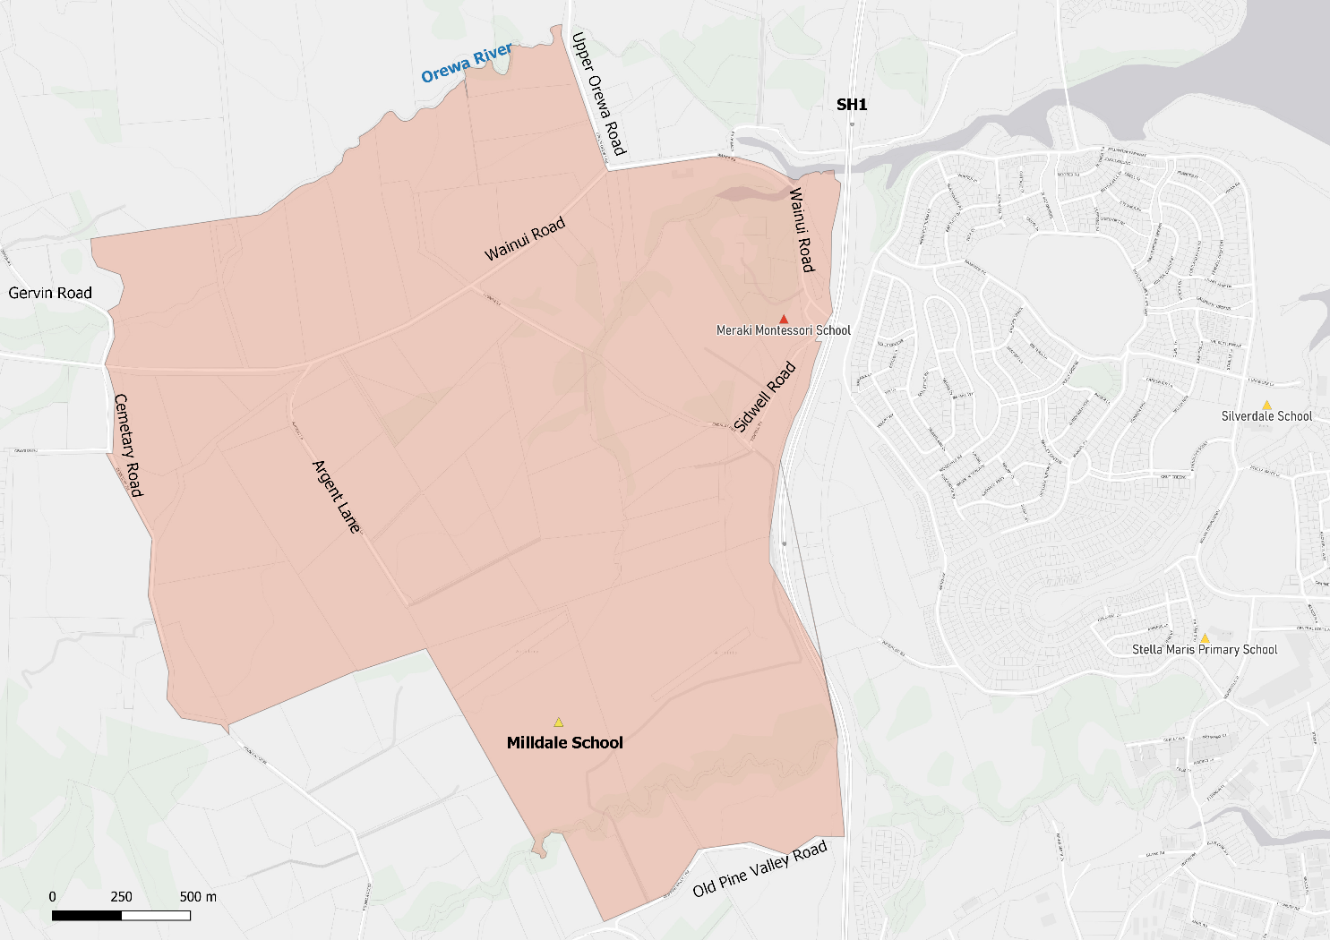

What does this mean for my family?
If you live in enrolment scheme home area for Milldale School you will be entitled to enrol your child at the school. This entitlement applies to new students starting school, as well as any primary school aged children currently attending another school in the area.
Families who live outside the enrolment scheme home zone of Milldale School do not have entitlement to enrol and could only attend if the Board of Trustees planned to enrol any out of zone students. The enrolment scheme will establish the process for this, and places will only be available if the Board of Trustees considers it has the capacity to allow for this. Further information about whether any out of zone places will be made available will be made later in 2022.

Consultation process and timeline
The Ministry of Education is currently undertaking consultation about the proposed changes and new enrolment schemes. You can have your say by:
- Completing the survey at https://consultation.education.govt.nz/education/orewa-primaries-enrolment-schemes
- Emailing auckland.enrolmentschemes@education.govt.nz if you have further questions or comments
The Ministry will consider all feedback and liaise with the Board before making a final decision. The new schemes and changes will come into effect 1 January 2023.

