Orewa Northwest School

New Enrolment Scheme

Overview – what is happening?
The Ministry of Education is developing an enrolment scheme for Orewa Northwest School, which will be in effect for 1 January 2023. Having an enrolment scheme in place will ensure the Board of Trustees has a fair and transparent mechanism to manage the roll as it grows. Children that live within this area will have entitlement to enrol at Orewa Northwest School. The home zone area is shown on the map on the next page and includes:
Starting on the eastern side of SH1 where it crosses the Nukumea Stream, follow SH1 south until Grand Drive. Head East along Grand Drive (southern side excluded) until in line with the western boundary of 31 Syd Grant Crescent (excluded). From Grand Drive head across country to the eastern end of Maraeariki Avenue.
Follow Maraeariki Avenue (included) until it West Hoe Heights (51 and above, 100 and above included).

Following West Hoe Heights until Orewa Heights Crescent:
- North side roads included.
- Maire Road (excluded)
- Savoy Road (included), following down to Ambassador Glade (15 and below, 4 and below included), Waldorf Crescent (included), Grovenor Drive (28 and below included)
- Orewa Heights Crescent (included)

From Orewa Heights Crescent, head north to the Nukumea Stream, and follow the stream west back to the starting point.

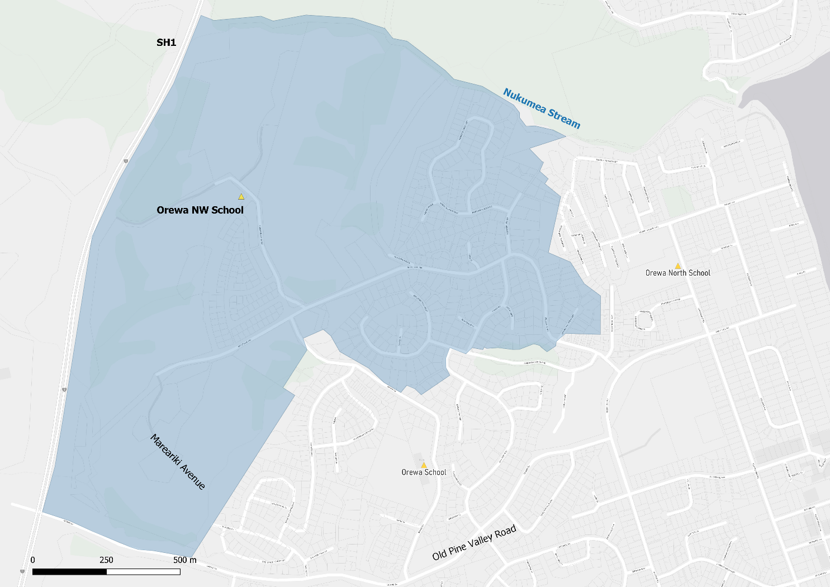

What does this mean for my family?
If you live in enrolment scheme home area for Orewa Northwest School you will be entitled to enrol your child at the school. This entitlement applies to new students starting school, as well as any primary school aged children currently attending another school in the area.
Families who live outside the enrolment scheme home zone of Orewa Northwest School do not have entitlement to enrol and could only attend if the Board of Trustees planned to enrol any out of zone students. The enrolment scheme will establish the process for this, and places will only be available if the Board of Trustees considers it has the capacity to allow for this. Further information about whether any out of zone places will be made available will be made later in 2022.

Consultation process and timeline
The Ministry of Education is currently undertaking consultation about the proposed changes and new enrolment schemes. You can have your say by:
- Completing the survey at https://consultation.education.govt.nz/education/orewa-primaries-enrolment-schemes
- Emailing auckland.enrolmentschemes@education.govt.nz if you have further questions or comments
The Ministry will consider all feedback and liaise with the Board before making a final decision. The new schemes and changes will come into effect 1 January 2023.

