Orewa School

Amended Enrolment Scheme

Overview – what is happening?
The Ministry of Education is proposing an amendment of Orewa School’s enrolment scheme, as well as neighbouring Orewa Beach Primary to implement an enrolment scheme at new Orewa Northwest School opening 2023. Therefore, the proposed amendment will come in to effect January 1 2023.
In-zone constitutes all the areas within the following boundaries:
Starting at the Hibiscus Coast Highway that crosses Orewa River, travel north along Hibiscus Coast Highway (even addresses 214 and above, odd addresses 265 and above included, off roads included, Skyes Avenue, Waiwera Place, Waiwera Road and The Strand included) to State Highway One – Waiwera On Ramp (Northbound).
Travel northwest along State High Way One and continue north onto the Northern Motorway and continue north back onto State Highway One (683 and below included, Link Road and Hungry Creek Road included).
Travel south-west across country to Ahuroa Road (85 and below included – Rosa Villa Lane included). Travel east along Ahuroa Road (off roads included) and continue south to Puhoi Road. Continue south along Puhoi Road and travel southwest along Krippner Road (180 and below included and Fiddlers Hill Road).
Travel southeast across country to Fowler Access Road (included). From Fowler Access Road, travel south across to Weranui Rd (536 and below included).
Travel south across country to Hillcrest Road (157 and below included) and then south across country to the intersection of Puriri Boulevard and Centreway Road. Follow Centreway Road south and turn right into West Hoe Road.
Following West Hoe Road to Hatton Road.
- West Hoe Heights (25 and below, 98 and below included), Orewa Heights Crescent (excluded), Ambassador Glade (19-27 and 30 Included), Carlton Way (included)
- Grand Drive (excluded)
Continue south along Hatton Road (odd addresses only) to Riverside Road (83 and below 80 and below included). Follow the western boundary of Orewa College until it meets the Orewa River. Follow the coastline east back to the starting point.

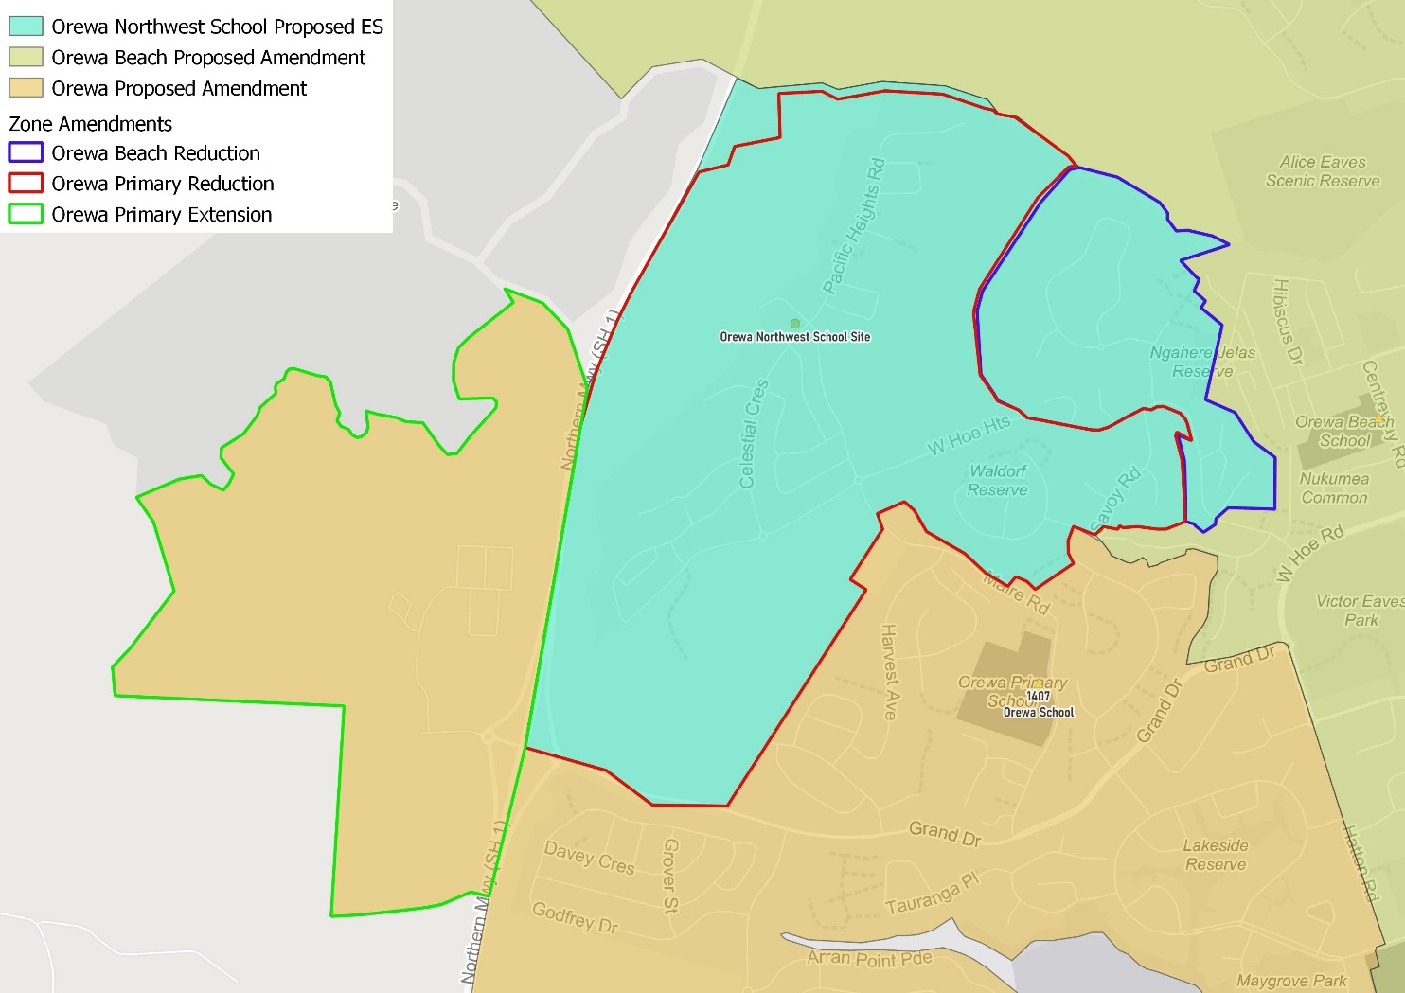
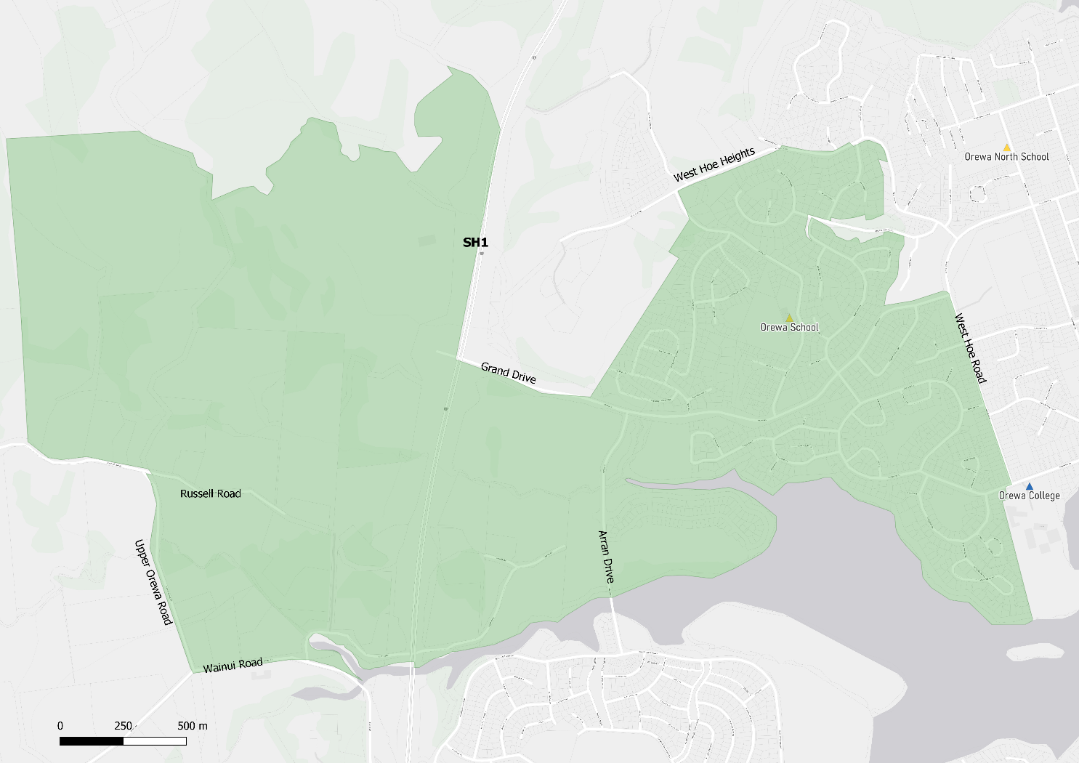

What does this mean for my family?
Any student currently enrolled at Orewa School will not be impacted by a change to the enrolment scheme. All students enrolled (and have started attending) will be entitled to continue attending Orewa School, irrespective of where they currently live.
The change to the home zone will affect all enrolments starting 1 January 2023. It is important to note that enrolment starts when you first attend school, not when enrolment forms are completed.
An in-zone enrolment is automatically entitled to enrol at the school. An out of zone enrolment is not guaranteed a place at the school and you will need to apply through the school’s out of zone processes if there are spaces available.

Consultation process and timeline
The Ministry of Education is currently undertaking consultation about the proposed changes and new enrolment schemes. You can have your say by:
- Completing the survey at https://consultation.education.govt.nz/education/Orewa Beach-primaries-enrolment-schemes
- Emailing auckland.enrolmentschemes@education.govt.nz if you have further questions or comments
The Ministry will consider all feedback and liaise with the Board before making a final decision. The new schemes and changes will come into effect 1 January 2023.

