Wainui School

New Enrolment Scheme

Overview – what is happening?
The Ministry of Education is developing an enrolment scheme for Wainui School, which will be in effect for 1 January 2023. Having an enrolment scheme in place will ensure the Board of Trustees has a fair and transparent mechanism to manage the roll as it grows. Children that live within this area will have entitlement to enrol at Wainui School. The home zone area is shown on the map on the next page and includes:
Starting at the intersection of Waitoki Road and Whitehills Road, head northeast along Waitoki Road (both sides included) until Hararu Road. Head west along Hararu Road (both sides included) until Tahekeroa Road and head east along Tahekeroa Road (both sides included) until Krippner Road. Follow Krippner Road (both sides included) to Noakes Hill Road. Head south along Noakes Hill Road (both sides included) to Upper Waiwera Road and head southeast down Upper Waiwera Road to Weranui Road. Head south along Weranui Road (626A to 544 and 649 to 547 eastward included) until Upper Orewa Road. Follow Upper Orewa Road (both sides included) south to Wainui Road.
Following Wainui Road east until SH1:
- Kowhai Road (27 to 19D, 20 to 42 included)
- Sidwell Road (included)
Head west along Wainui Road (both sides included) to Waitoki Road and follow Waitoki Road to Whitehills Road. Head south down Whitehills Road (both sides included) until Kahikatea Flat Road.

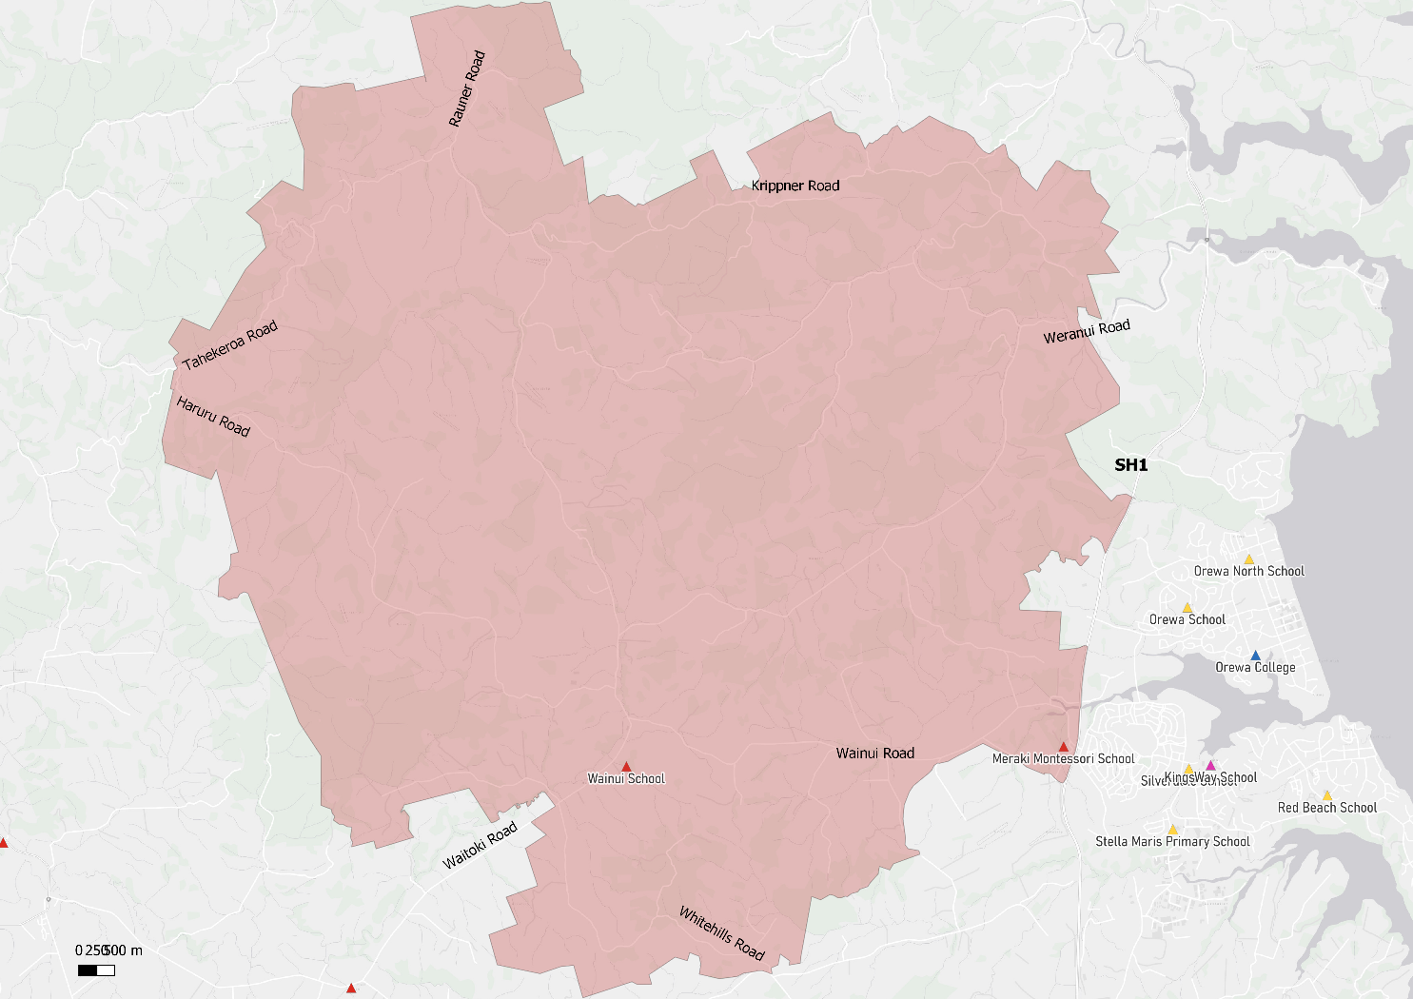

What does this mean for my family?
If you live in enrolment scheme home area for Wainui School you will be entitled to enrol your child at the school. This entitlement applies to new students starting school, as well as any primary school aged children currently attending another school in the area.
Families who live outside the enrolment scheme home zone of Wainui School do not have entitlement to enrol and could only attend if the Board of Trustees planned to enrol any out of zone students. The enrolment scheme will establish the process for this, and places will only be available if the Board of Trustees considers it has the capacity to allow for this. Further information about whether any out of zone places will be made available will be made later in 2022.

Consultation process and timeline
The Ministry of Education is currently undertaking consultation about the proposed changes and new enrolment schemes. You can have your say by:
- Completing the survey at https://consultation.education.govt.nz/education/orewa-primaries-enrolment-schemes
- Emailing auckland.enrolmentschemes@education.govt.nz if you have further questions or comments
The Ministry will consider all feedback and liaise with the Board before making a final decision. The new schemes and changes will come into effect 1 January 2023.

