Fairburn School

New Enrolment Scheme

Overview – what is happening?
The Ministry of Education is developing an enrolment scheme for Fairburn School, which will be in effect for the beginning of term 2 in 2023. Having an enrolment scheme in place will ensure the Board of Trustees has a fair and transparent mechanism to manage the roll as it grows. Children that live within this area will have entitlement to enrol at Fairburn School. The home zone area is shown on the map on the next page and includes:
Starting at the intersection of Hospital Road and Mangere Road, travel northeast along Mangere Road (148 and below even addresses, 35 and below odd addresses, and Piki Thompson Way included) to Great South Road. Travel north along Great South Road (396-626 even addresses, 455-689 included) and continue north along the centre of Atkinson Avenue (24 – 82, even addresses only). Travel east along Princes Street (23 and above odd addresses only) to the Southern Motorway - State Highway 1 (SH1). Travel north along SH1 to Deas Place (included) follow the coastline from 22 Deas Place around to Seaside Park and southwest to Stringers Point Reserve. Continue to follow the coastline to the Royal Auckland and Grange Golf Course, following to Hospital Road. Travel northwest along Hospital Road (100 and below even addresses only) back to the starting point.

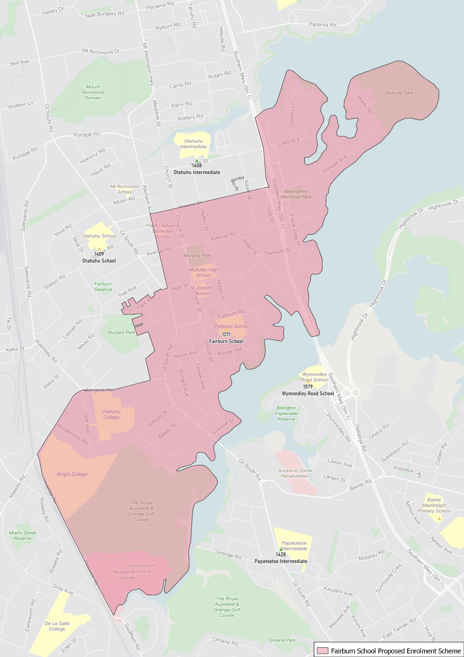

What does this mean for my family?
If you live in enrolment scheme home area for Fairburn School, you will be entitled to enrol your child at the school. This entitlement applies to new students starting school, as well as any primary school aged children currently attending another school in the area.
Families who live outside the enrolment scheme home zone of Fairburn School do not have entitlement to enrol and could only attend if the Board of Trustees planned to enrol any out of zone students. The enrolment scheme will establish the process for this, and places will only be available if the Board of Trustees considers it has the capacity to allow for this. Further information about whether any out of zone places will be made available will be made later in 2022.

Consultation process and timeline
The Ministry of Education is currently undertaking consultation about the proposed changes and new enrolment schemes. You can have your say by:
- Completing the survey at https://consultation.education.govt.nz/education/otahuhu-enrolment-schemes
- Emailing auckland.enrolmentschemes@education.govt.nz if you have further questions or comments
The Ministry will consider all feedback and liaise with the Board before making a final decision. The new schemes and changes will come into effect for the beginning of term 2 in 2023.

