Otahuhu Intermediate

New Enrolment Scheme

Overview – what is happening?
The Ministry of Education is developing an enrolment scheme for Otahuhu Intermediate, which will be in effect for the beginning of term 2 in 2023. Having an enrolment scheme in place will ensure the Board of Trustees has a fair and transparent mechanism to manage the roll as it grows. Children that live within this area will have entitlement to enrol at Otahuhu Intermediate. The home zone area is shown on the map on the next page and includes:
Starting at intersection of Savill Drive and Favona Road, travel northeast along the coastline to the railway line. Follow the railway track east past Anns Creek Reserve and Great South Road (801-851 odd addresses, 1048-1120 even addresses included) to the Southern Motorway (SH1). Continue northeast to Clemow Drive (1address only) to Carbine Road. Travel south down Carbine Road (88 and above included) and then east along Gabador Place (both sides and Paisley Place included) out to the coastline. Travel south down the coastline past Ian Shaw Park, Seaside Park to Hospital Road. Travel northwest along Hospital Road (100 and below addresses included) before turning southwest at Massey Road (excluded) and then northwest along Savill Drive (178-180 addresses included only) to the zone’s starting point.

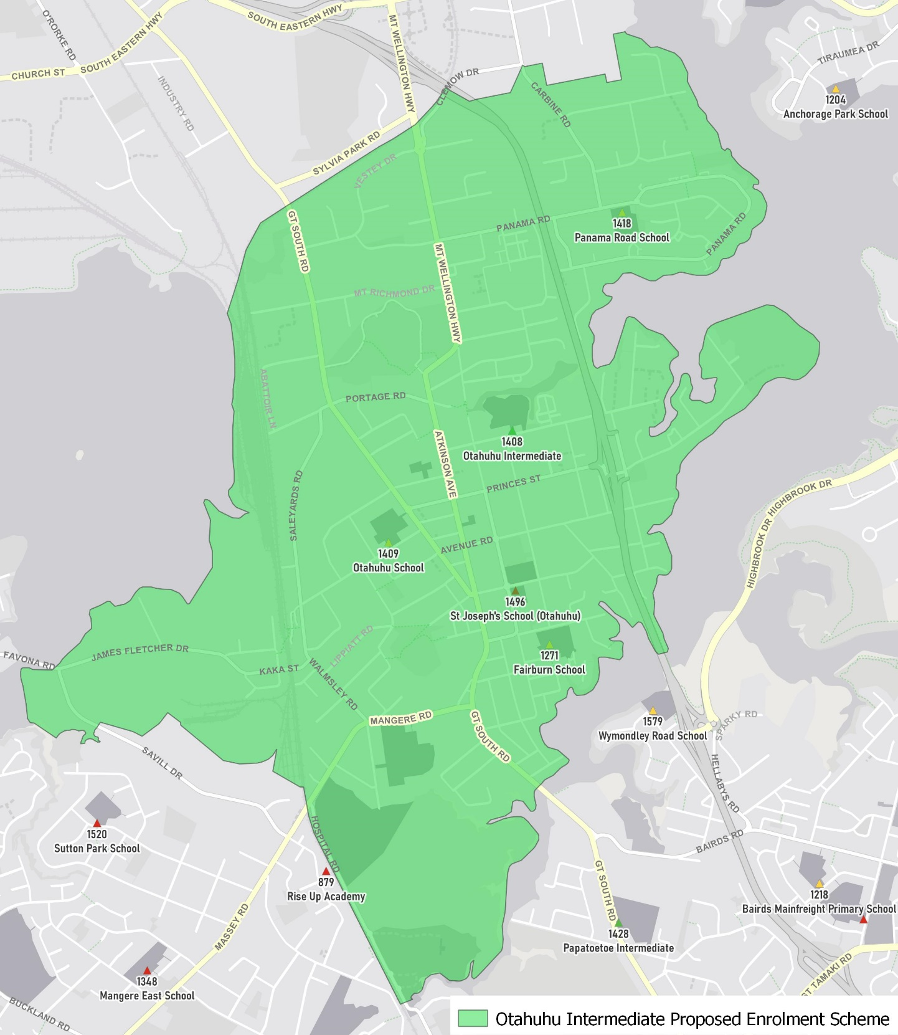

What does this mean for my family?
If you live in enrolment scheme home area for Otahuhu Intermediate, you will be entitled to enrol your child at the school. This entitlement applies to new students starting school, as well as any intermediate school aged children currently attending another school in the area.
Families who live outside the enrolment scheme home zone of Otahuhu Intermediate do not have entitlement to enrol and could only attend if the Board of Trustees planned to enrol any out of zone students. The enrolment scheme will establish the process for this, and places will only be available if the Board of Trustees considers it has the capacity to allow for this. Further information about whether any out of zone places will be made available will be made later in 2022.

Consultation process and timeline
The Ministry of Education is currently undertaking consultation about the proposed changes and new enrolment schemes. You can have your say by:
- Completing the survey at: https://consultation.education.govt.nz/education/otahuhu-enrolment-schemes
- Emailing auckland.enrolmentschemes@education.govt.nz if you have further questions or comments
The Ministry will consider all feedback and liaise with the Board before making a final decision. The new schemes and changes will come into effect for the beginning of term 2 in 2023.

