Otahuhu School

New Enrolment Scheme

Overview – what is happening?
The Ministry of Education is developing an enrolment scheme for Otahuhu School, which will be in effect for the beginning of term 2 in 2023. Having an enrolment scheme in place will ensure the Board of Trustees has a fair and transparent mechanism to manage the roll as it grows. Children that live within this area will have entitlement to enrol at Otahuhu School. The home zone area is shown on the map on the next page and includes:
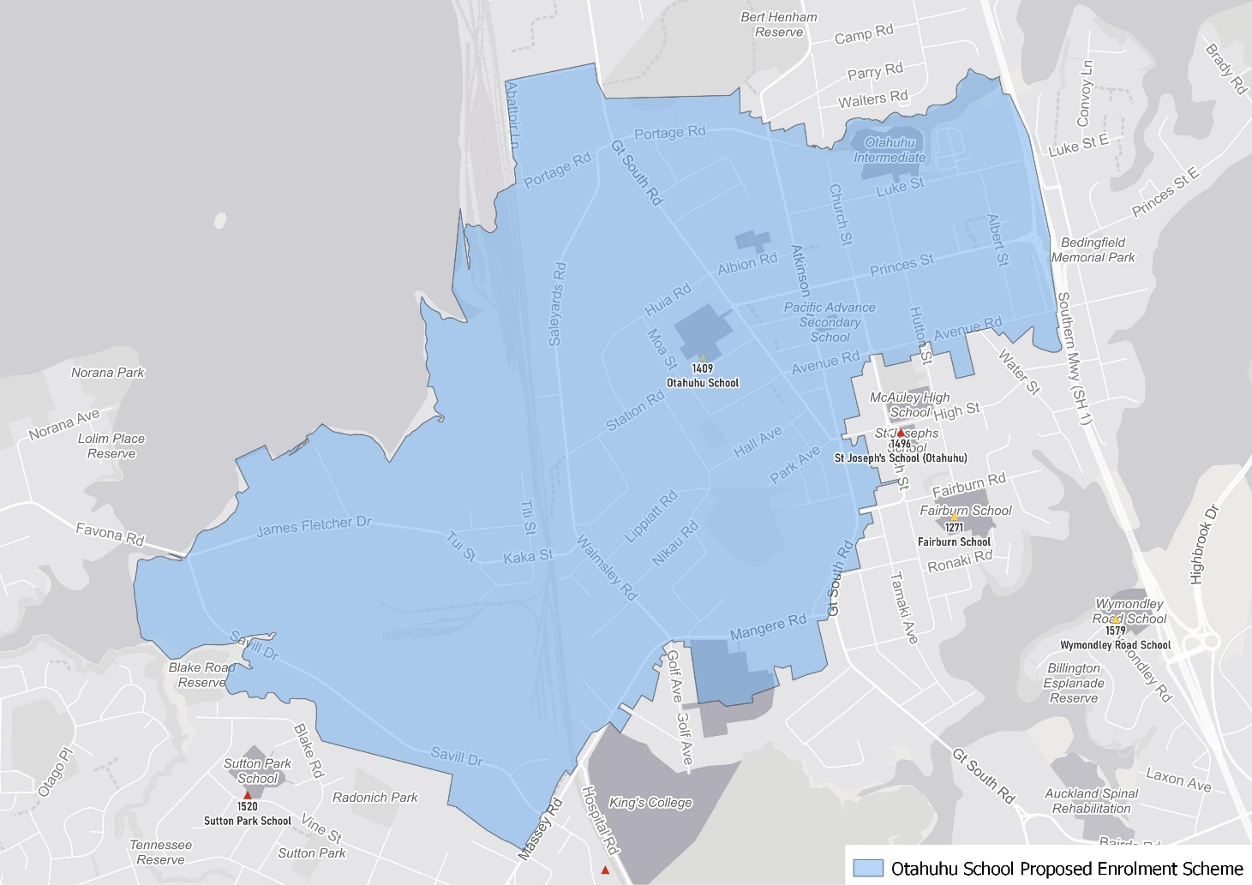
Starting at intersection of Avenue Road and the Southern Motorway, travel west along Avenue Road (113 and below addresses included) until turning south at Atkinson Avenue (included) and continuing south down Great South Road (851, 597 and below, odd addresses, 1120, 540 and below even addresses included) until Mangere Road (Piki Thompson Way included). Travel west along Mangere Road (both sides included) and continue slightly along Massey Road (1 and 6 addresses included) until turning northwest along Savill Drive (included) until the coastline at the end of Savill Drive. Follow the coastline east and then north until the end of Portage Road. Travel east along Portage Road (both sides included, and Abattoir Lane included) to Atkinson Avenue. Head south down Atkinson Avenue (both sides included) and then east along Luke Street (included) until turning south and travelling along the Southern Motorway back to the starting point.

What does this mean for my family?
If you live in enrolment scheme home area for Otahuhu School, you will be entitled to enrol your child at the school. This entitlement applies to new students starting school, as well as any primary school aged children currently attending another school in the area.
Families who live outside the enrolment scheme home zone of Otahuhu School do not have entitlement to enrol and could only attend if the Board of Trustees planned to enrol any out of zone students. The enrolment scheme will establish the process for this, and places will only be available if the Board of Trustees considers it has the capacity to allow for this. Further information about whether any out of zone places will be made available will be made later in 2022.

Consultation process and timeline
The Ministry of Education is currently undertaking consultation about the proposed changes and new enrolment schemes. You can have your say by:
- Completing the survey at https://consultation.education.govt.nz/education/otahuhu-enrolment-schemes
- Emailing auckland.enrolmentschemes@education.govt.nz if you have further questions or comments
The Ministry will consider all feedback and liaise with the Board before making a final decision. The new schemes and changes will come into effect for the beginning of term 2 in 2023.

