Anchorage Park School

New Enrolment Scheme

Overview – what is happening?
The Ministry of Education is developing an enrolment scheme for Anchorage Park School, which will be in effect for the beginning of term 1 in 2023. Having an enrolment scheme in place will ensure the Board of Trustees has a fair and transparent mechanism to manage the roll as it grows. Children that live within this area will have entitlement to enrol at Anchorage Park School. The home zone area is shown on the map below and includes:
Starting at the intersection of Ti Rakau Drive, Pakuranga Highway and Reeves Road (3-11 odd addresses and Cortina Place included), head southwest along Pakuranga Highway (both sides excluded) towards Neil Morrison Park. Follow the coastline southwest around Tiraumea Drive Reserve then east to Raewyn Place Esplanade Reserve. Follow Edgewater Drive (both sides and all no exit roads included) until Ti Rakau Drive. Head northwest along Ti Rakau Drive (37-149 odd addresses, 60 included) back to the starting point.
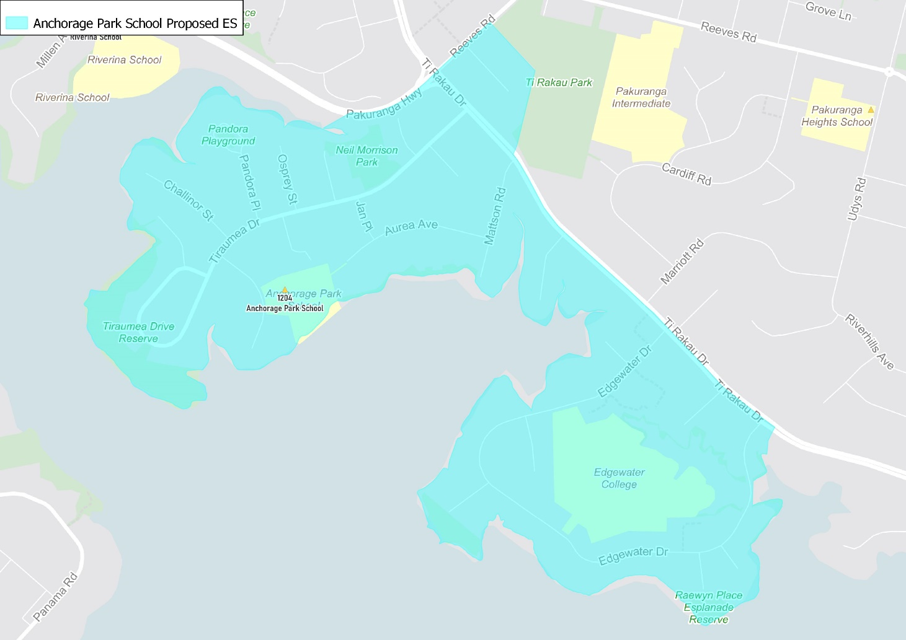

What does this mean for my family?
If you live in enrolment scheme home area for Anchorage Park School you will be entitled to enrol your child at the school. This entitlement applies to new students starting school, as well as any primary school aged children currently attending another school in the area.
Families who live outside the enrolment scheme home zone of Anchorage Park School do not have entitlement to enrol and could only attend if the Board of Trustees planned to enrol any out of zone students. The enrolment scheme will establish the process for this, and places will only be available if the Board of Trustees considers it has the capacity to allow for this. Further information about whether any out of zone places will be made available will be made later in 2022.

Consultation process and timeline
The Ministry of Education is currently undertaking consultation about the proposed changes and new enrolment schemes. You can have your say by:
- Completing the survey at https://consultation.education.govt.nz/education/pakuranga-primaries-enrolment-schemes
- Emailing auckland.enrolmentschemes@education.govt.nz if you have further questions or comments
The Ministry will consider all feedback and liaise with the Board before making a final decision. The new schemes and changes will come into effect for the beginning of 2023.

