Elm Park School

New Enrolment Scheme

Overview – what is happening?
The Ministry of Education is developing an enrolment scheme for Elm Park School, which will be in effect for the beginning of term 1 in 2023. Having an enrolment scheme in place will ensure the Board of Trustees has a fair and transparent mechanism to manage the roll as it grows. Children that live within this area will have entitlement to enrol at Elm Park School. The home zone area is shown on the map on the next page and includes:
Starting at the intersection of Pakuranga Road and Aviemore Drive, travel west along Pakuranga Road (499-273 odd addresses included only) until Udys Road. Head south down Udys Road (2-10 even addresses only) until Larne Avenue (both sides included). Follow Larne Avenue east until Pooley Street and travel south along Pooley Street (2-28 even addresses only) and continue onto Beechdale Crescent. Travel south along Beechdale Crescent (1-39, 87-109 odd addresses and 2-80 even addresses included) until Fleur Avenue (2-4 even addresses included only). Travel down Fleur Avenue until Reeves Road. Head east along Reeves Road (74-116 even addresses included only) until La Trobe Street (33 and below odd, 32 and below even addresses included). Jump eastwards to Megan Avenue (21 and below odd, 18 and below even addresses included) and jump eastwards again to Ennis Avenue (71 and below odd, 74 and below even addresses and Beldon Place 4-18 even addresses included only). Follow the coastline northwards towards Elm Park and then southeast to Rylock Place (both sides included). Head northeast to Ben Lomond Crescent (both sides included) and continue along to Cascades Road (149 and below odd and 180 and below even addresses included). Follow Botany Creek north (De Quincey Terrace, Aviemore Drive excluded) back to the starting point.
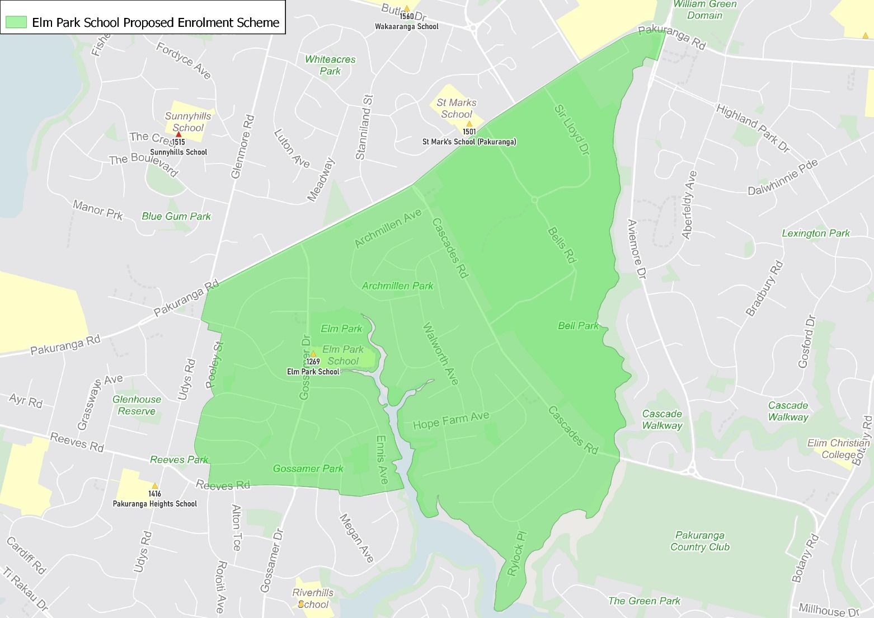

What does this mean for my family?
If you live in enrolment scheme home area for Elm Park School you will be entitled to enrol your child at the school. This entitlement applies to new students starting school, as well as any primary school aged children currently attending another school in the area.
Families who live outside the enrolment scheme home zone of Elm Park School do not have entitlement to enrol and could only attend if the Board of Trustees planned to enrol any out of zone students. The enrolment scheme will establish the process for this, and places will only be available if the Board of Trustees considers it has the capacity to allow for this. Further information about whether any out of zone places will be made available will be made later in 2021.

Consultation process and timeline
The Ministry of Education is currently undertaking consultation about the proposed changes and new enrolment schemes. You can have your say by:
- Completing the survey at https://consultation.education.govt.nz/education/pakuranga-primaries-enrolment-schemes
- Emailing auckland.enrolmentschemes@education.govt.nz if you have further questions or comments
The Ministry will consider all feedback and liaise with the Board before making a final decision. The new schemes and changes will come into effect for the beginning of 2023.

