Pakuranga Heights School

New Enrolment Scheme

Overview – what is happening?
The Ministry of Education is developing an enrolment scheme for Pakuranga Heights School, which will be in effect for the beginning of term 1 in 2023. Having an enrolment scheme in place will ensure the Board of Trustees has a fair and transparent mechanism to manage the roll as it grows. Children that live within this area will have entitlement to enrol at Pakuranga Heights School. The home zone area is shown on the map below and includes:
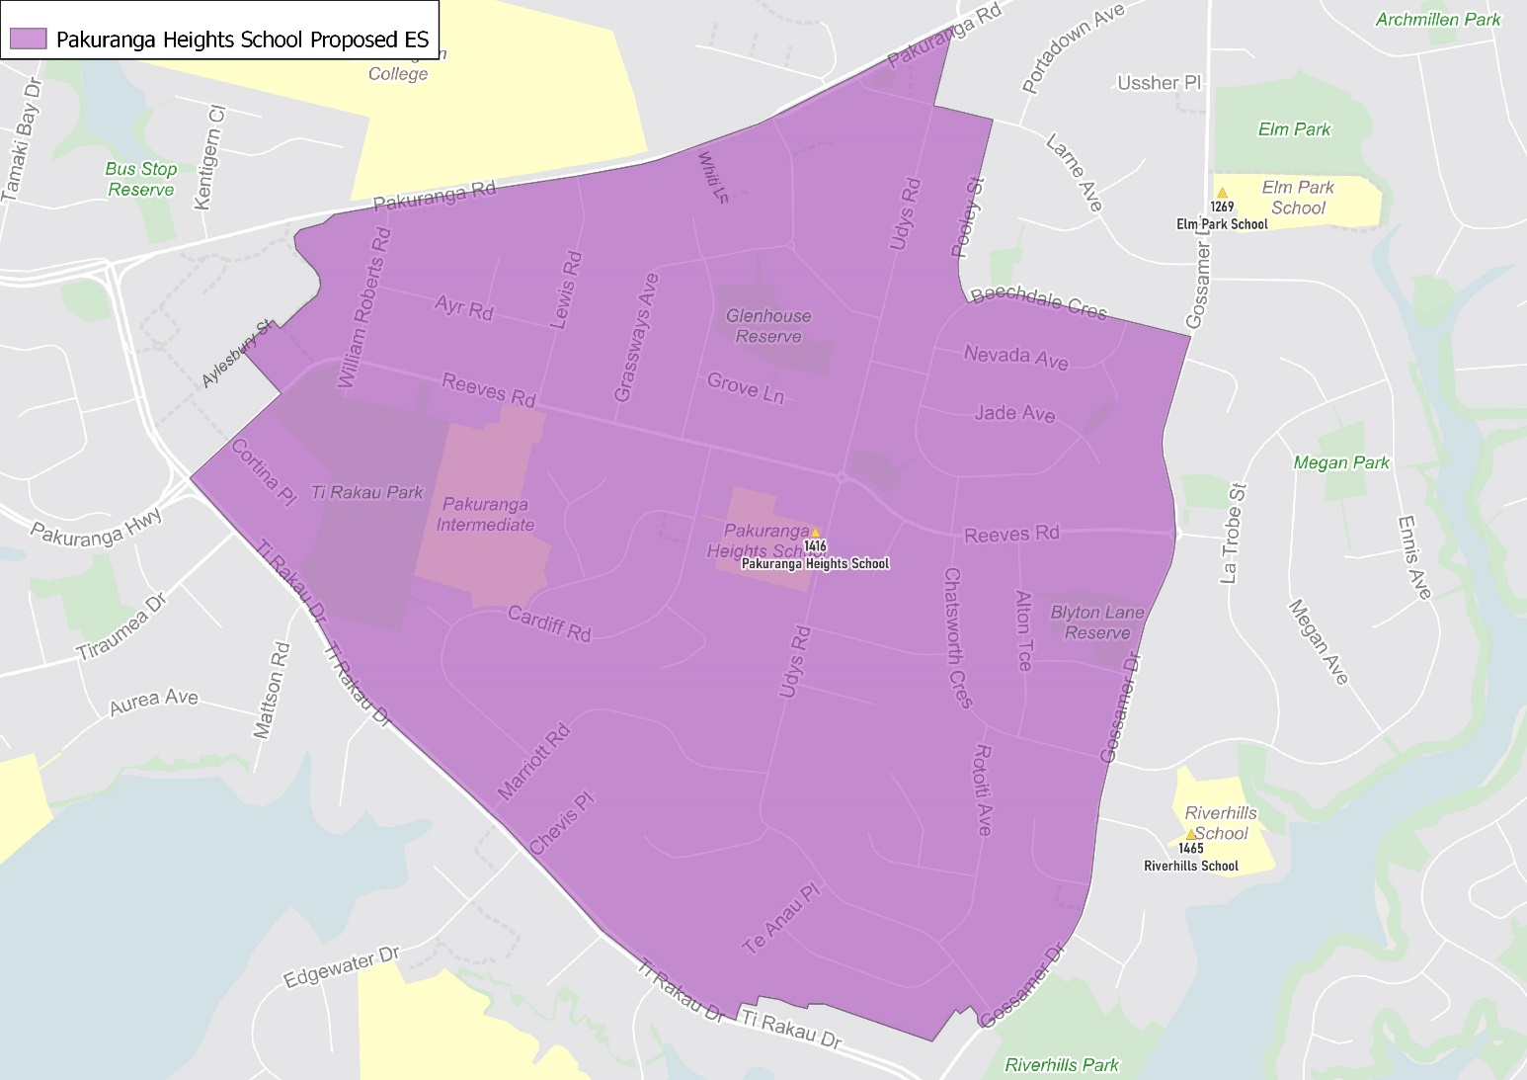
Starting at the intersection of Udys Road (all odd addresses, 14 and above even addresses included) and Pakuranga Road (167-267 odd addresses included) travel west along Pakuranga Road before turning south onto William Roberts Road. Head south down William Roberts Road (both sides included) and continue along Reeves Road (both sides and 7 Aylesbury Street included) before turning southeast on Ti Rakau Road (60-184 even addresses included only) and traveling until Gossamer Drive (65-165 odd addresses included only). Travel north on Gossamer Drive and turn west along Beechdale Crescent (all even addresses and odd addresses 41 and above included) and traveling until Pooley Street. Travel north along Pooley Street (odd addresses included only) and then turn west at Larne Avenue (5 and below odd addresses included only) until turning north at Udys Road and traveling back to the zone’s origin point.

What does this mean for my family?
If you live in enrolment scheme home area for Pakuranga Heights School you will be entitled to enrol your child at the school. This entitlement applies to new students starting school, as well as any primary school aged children currently attending another school in the area.
Families who live outside the enrolment scheme home zone of Pakuranga Heights School do not have entitlement to enrol and could only attend if the Board of Trustees planned to enrol any out of zone students. The enrolment scheme will establish the process for this, and places will only be available if the Board of Trustees considers it has the capacity to allow for this. Further information about whether any out of zone places will be made available will be made later in 2022.

Consultation process and timeline
The Ministry of Education is currently undertaking consultation about the proposed changes and new enrolment schemes. You can have your say by:
- Completing the survey at https://consultation.education.govt.nz/education/pakuranga-primaries-enrolment-schemes
- Emailing auckland.enrolmentschemes@education.govt.nz if you have further questions or comments
The Ministry will consider all feedback and liaise with the Board before making a final decision. The new schemes and changes will come into effect for the beginning of 2023.

