Riverhills School

New Enrolment Scheme

Overview – what is happening?
The Ministry of Education is developing an enrolment scheme for Riverhills School, which will be in effect for the beginning of term 1 in 2023. Having an enrolment scheme in place will ensure the Board of Trustees has a fair and transparent mechanism to manage the roll as it grows. Children that live within this area will have entitlement to enrol at Riverhills School. The home zone area is shown on the map on the next page and includes:
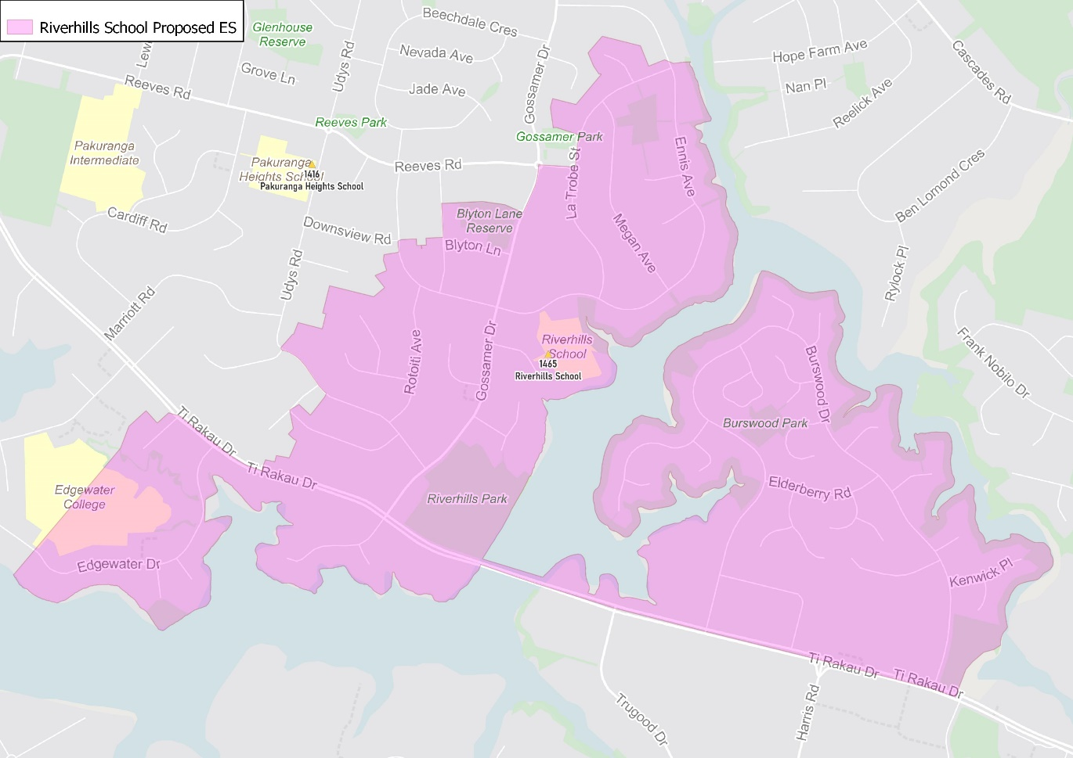
Starting at the intersection of Burswood Drive and Ti Rakau Drive (184-320 even, 141-229 odd included), follow the coastline northwest and then southwest to Ti Rakau Bridge. Head west towards Riverhills Park and turn northwards, following the coastline north to the intersection of Ennis Avenue (addresses 44 and above included) and La Trobe Street. Head west along La Trobe Street (both sides included) and then travel west along Reeves Road (153-157 included) before turning south down Gossamer Drive (88 and above even, 113 and above odd included) before traveling west along the northern edge of Blyton Lane Reserve to Alton Terrace (12 and above even, 25 and above odd included). Travel south along Alton Terrace before turning west along Chatsworth Crescent (20 and above even, 25 and above odd included) and south down Rotoiti Avenue (included) to Riverhills Avenue (odd addresses and 14 and above even addresses included, Ellesmere Crescent also included). Continue along Riverhills Avenue to Gossamer Drive and turn south to Ti Rakau Drive. Head west along Ti Rakau Drive to Wheatley Avenue (both sides and Edgewater Drive 80 and above even addresses, 93 and above odd addresses included). Return to Ti Rakau Drive and continue east back to the starting point.

What does this mean for my family?
If you live in enrolment scheme home area for Riverhills School you will be entitled to enrol your child at the school. This entitlement applies to new students starting school, as well as any primary school aged children currently attending another school in the area.
Families who live outside the enrolment scheme home zone of Riverhills School do not have entitlement to enrol and could only attend if the Board of Trustees planned to enrol any out of zone students. The enrolment scheme will establish the process for this, and places will only be available if the Board of Trustees considers it has the capacity to allow for this. Further information about whether any out of zone places will be made available will be made later in 2022.

Consultation process and timeline
The Ministry of Education is currently undertaking consultation about the proposed changes and new enrolment schemes. You can have your say by:
- Completing the survey at https://consultation.education.govt.nz/education/pakuranga-primaries-enrolment-schemes
- Emailing auckland.enrolmentschemes@education.govt.nz if you have further questions or comments
The Ministry will consider all feedback and liaise with the Board before making a final decision. The new schemes and changes will come into effect for the beginning of 2023.

