Riverina School

New Enrolment Scheme

Overview – what is happening?
The Ministry of Education is developing an enrolment scheme for Riverina School, which will be in effect for the beginning of term 1 in 2023. Having an enrolment scheme in place will ensure the Board of Trustees has a fair and transparent mechanism to manage the roll as it grows. Children that live within this area will have entitlement to enrol at Riverina School. The home zone area is shown on the map on the next page and includes:
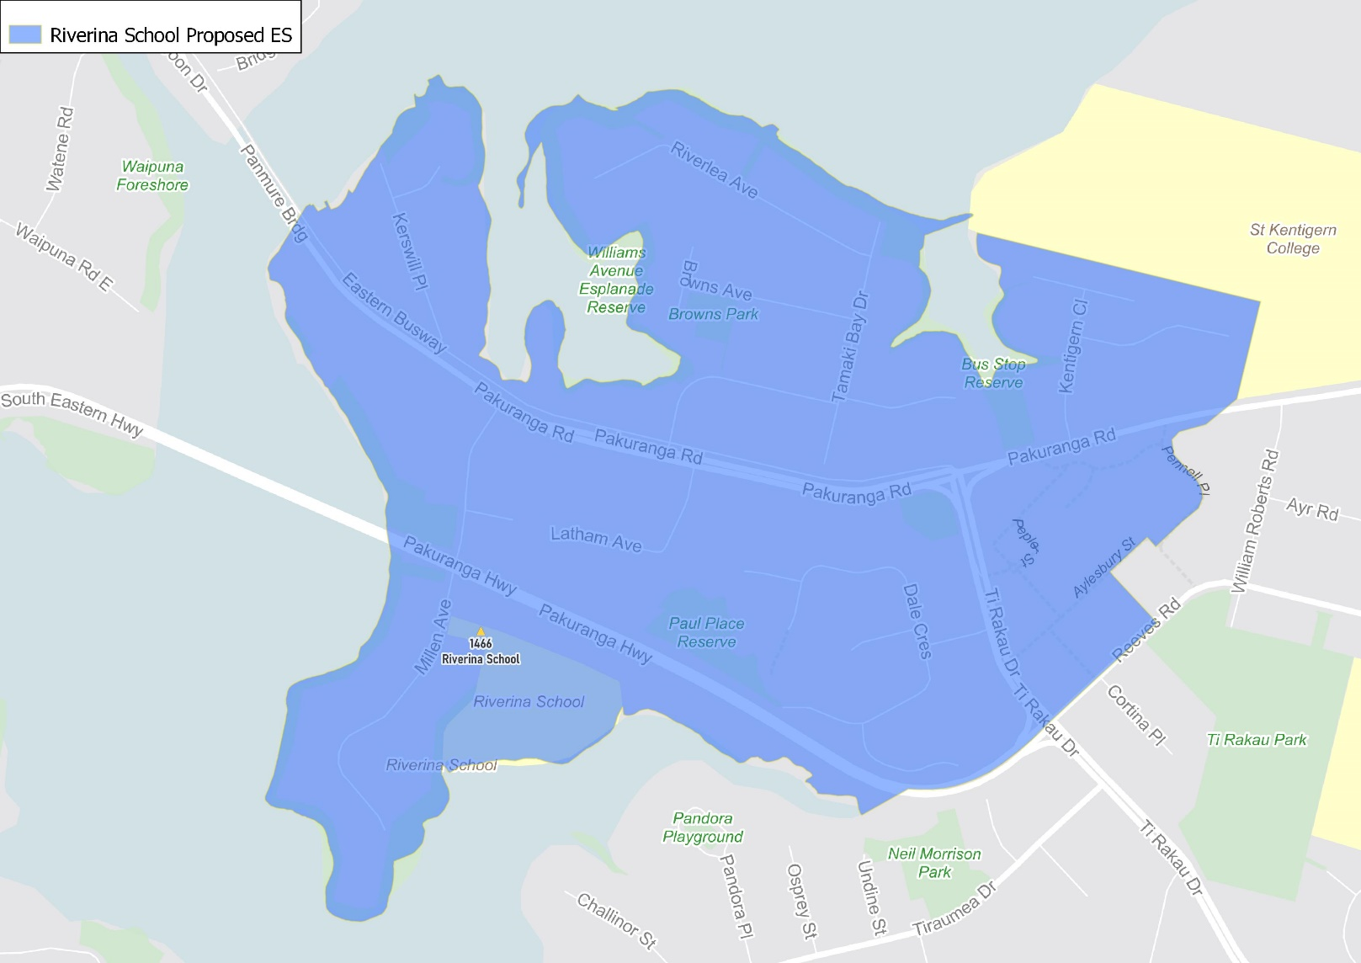
Beginning at 126 Pakuranga Road (126 and below even, 141 and below odd addresses included), travel north along the western boundary and then west along the southern boundary of St Kentigern College to the coastline. Travel initially south along the coastline and continue around the coastline to Waipuna Bridge. Continue east along the Pakuranga Highway to Ti Rakau Drive and then along Reeves Road before traveling northwest along the western boundary of 7 Aylesbury Street (excluded) to Aylesbury Street and then continue northwest along Pennell Place (all even addresses included) back to the zone’s starting point.

What does this mean for my family?
If you live in enrolment scheme home area for Riverina School you will be entitled to enrol your child at the school. This entitlement applies to new students starting school, as well as any primary school aged children currently attending another school in the area.
Families who live outside the enrolment scheme home zone of Riverina School do not have entitlement to enrol and could only attend if the Board of Trustees planned to enrol any out of zone students. The enrolment scheme will establish the process for this, and places will only be available if the Board of Trustees considers it has the capacity to allow for this. Further information about whether any out of zone places will be made available will be made later in 2022.

Consultation process and timeline
The Ministry of Education is currently undertaking consultation about the proposed changes and new enrolment schemes. You can have your say by:
- Completing the survey at https://consultation.education.govt.nz/education/pakuranga-primaries-enrolment-schemes
- Emailing auckland.enrolmentschemes@education.govt.nz if you have further questions or comments
The Ministry will consider all feedback and liaise with the Board before making a final decision. The new schemes and changes will come into effect for the beginning of 2023.

