Panmure District School

New Enrolment Scheme

Overview – what is happening?
The Ministry of Education is developing an enrolment scheme for Panmure District School, which will be in effect for the beginning of term 1 in 2023. Having an enrolment scheme in place will ensure the Board of Trustees has a fair and transparent mechanism to manage the roll as it grows. Children that live within this area will have entitlement to enrol at Panmure District School. The home zone area is shown on the map on the next page and includes:
Starting at the intersection of Penrose Road and Barrack Road, travel east along Penrose Road (228 and above even included) and continue straight onto Waipuna Road (30 and below even included) to Ireland Road. Travel north along Ireland Road (included) to Lagoon Drive and then travel east along Lagoon Drive (34 and below included) to Basin View Lane. Travel north along Basin View Lane (odd addresses included) to Queens Road. Travel west along Queens Road (113 and below odd, 66 and below even included) to Pilkington Road. Travel north along Pilkington Road (41 and below odd, 52 and below even included) and then turn west onto Green Road (odd addresses included) and then north along Jellicoe Road (61 and below odd, 60 and below even included) to Morrin Road. Travel west along Morrin Road (80 and below even included; Homestead Drive, Fraser Road included) to Te Horeta Road. Follow Te Horeta Road south to Ellerslie-Panmure Highway. Travel west along Ellerslie-Panmure Highway (445 and above odd, 462 and above even included; Mountain Road included) to Barrack Road. Travel south along Barrack Road (both sides included; streets Banks Road, Mccracken Road, and Boakes Road are excluded) back to the starting point.

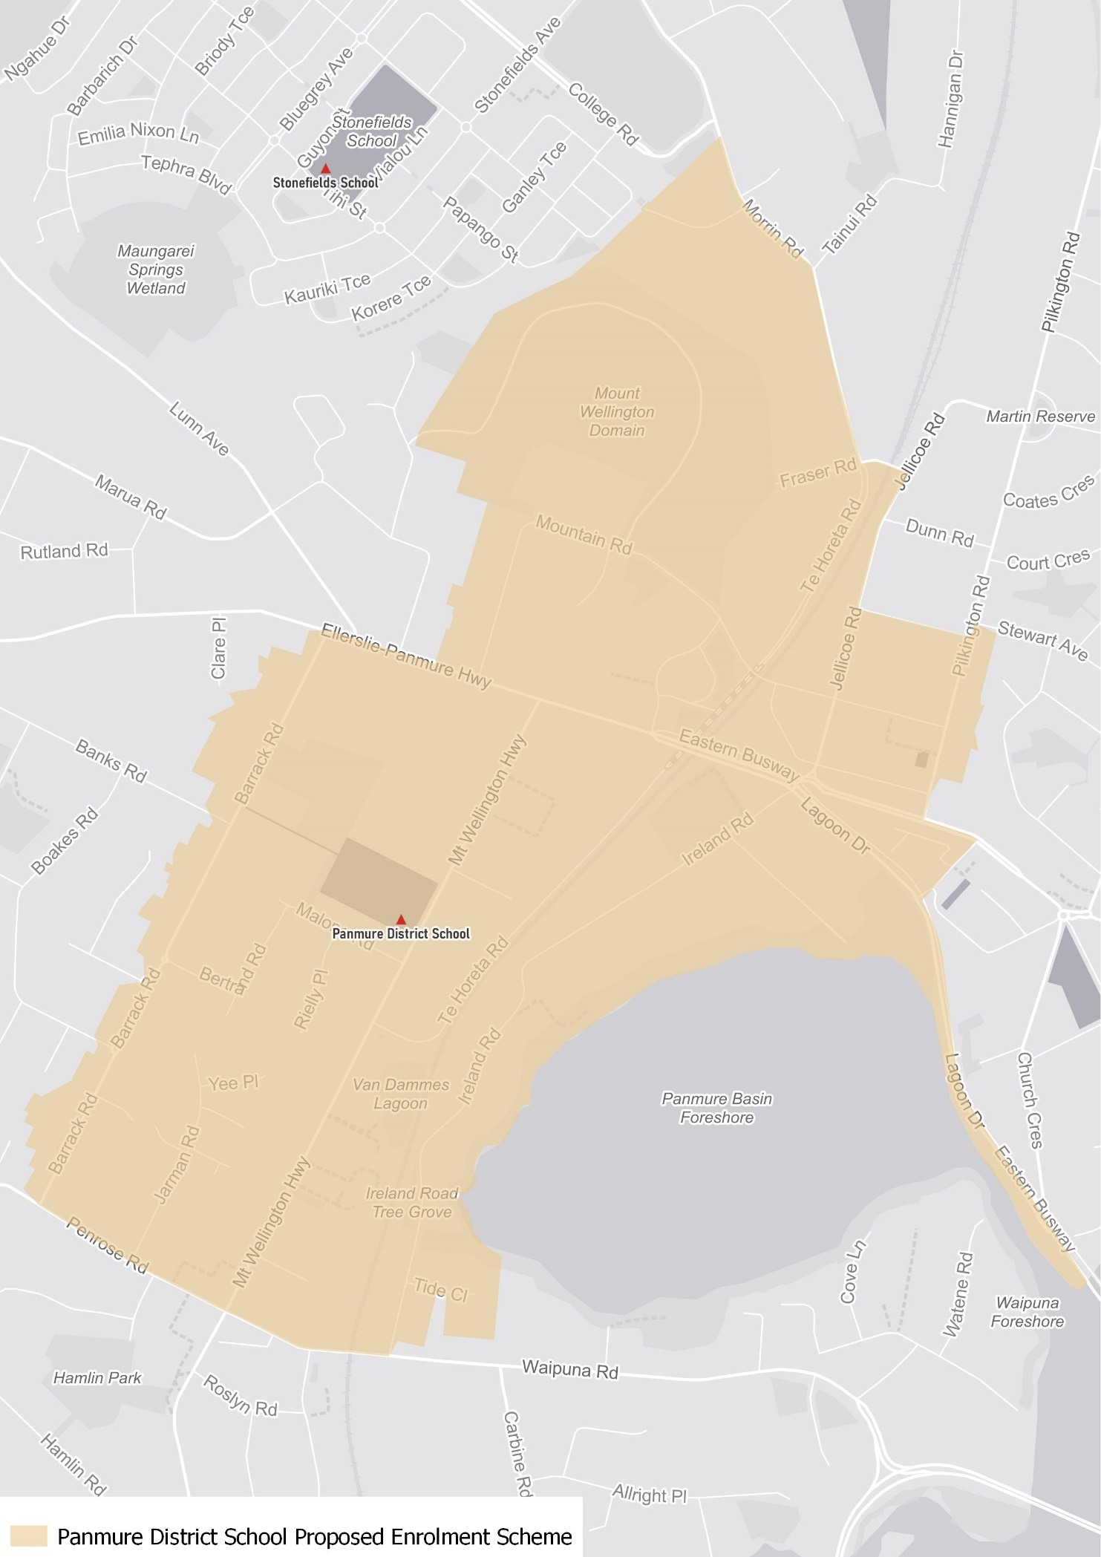

What does this mean for my family?
If you live in enrolment scheme home area for Panmure District School you will be entitled to enrol your child at the school. This entitlement applies to new students starting school, as well as any primary school aged children currently attending another school in the area.
Families who live outside the enrolment scheme home zone of Panmure District School do not have entitlement to enrol and could only attend if the Board of Trustees planned to enrol any out of zone students. The enrolment scheme will establish the process for this, and places will only be available if the Board of Trustees considers it has the capacity to allow for this. Further information about whether any out of zone places will be made available will be made later in 2022.

Consultation process and timeline
The Ministry of Education is currently undertaking consultation about the proposed changes and new enrolment schemes. You can have your say by:
- Completing the survey at https://consultation.education.govt.nz/education/panmure-district-school-school-enrolment-schemes/consultation/intro/
- Emailing auckland.enrolmentschemes@education.govt.nz if you have further questions or comments
The Ministry will consider all feedback and liaise with the Board before making a final decision. The new schemes and changes will come into effect for the beginning of 2023.

