Parakai School

New Enrolment Scheme

Overview – what is happening?
The Ministry of Education is developing an enrolment scheme for Parakai School, which will be in effect for the beginning of term 1 in 2023. Having an enrolment scheme in place will ensure the Board of Trustees has a fair and transparent mechanism to manage the roll as it grows. Children that live within this area will have entitlement to enrol at Parakai School. The home zone area is shown on the map on the next page and includes:
Starting at the intersection of Parkhurst Road and State Highway 16 travel north along Parkhurst Road until South Head Road, including both sides of the road. Along Parkhurst Road the zone also extends out to the end of Fordyce Road, and includes Parakai Avenue, Waiwera Avenue, Te Moua Avenue, Chic Gardens, Springs Road and Green Road, and any no-exit roads off those roads. At South Head Road travel northeast, including both sides of the road up to 901 South Head Road. Along South Head Road the zone also includes Evans Road, Tarawera Road, Slater Road, Haranui Road, and any no-exit roads off those roads.
All no exit roads within the boundaries described above are included in the zone unless otherwise stated.
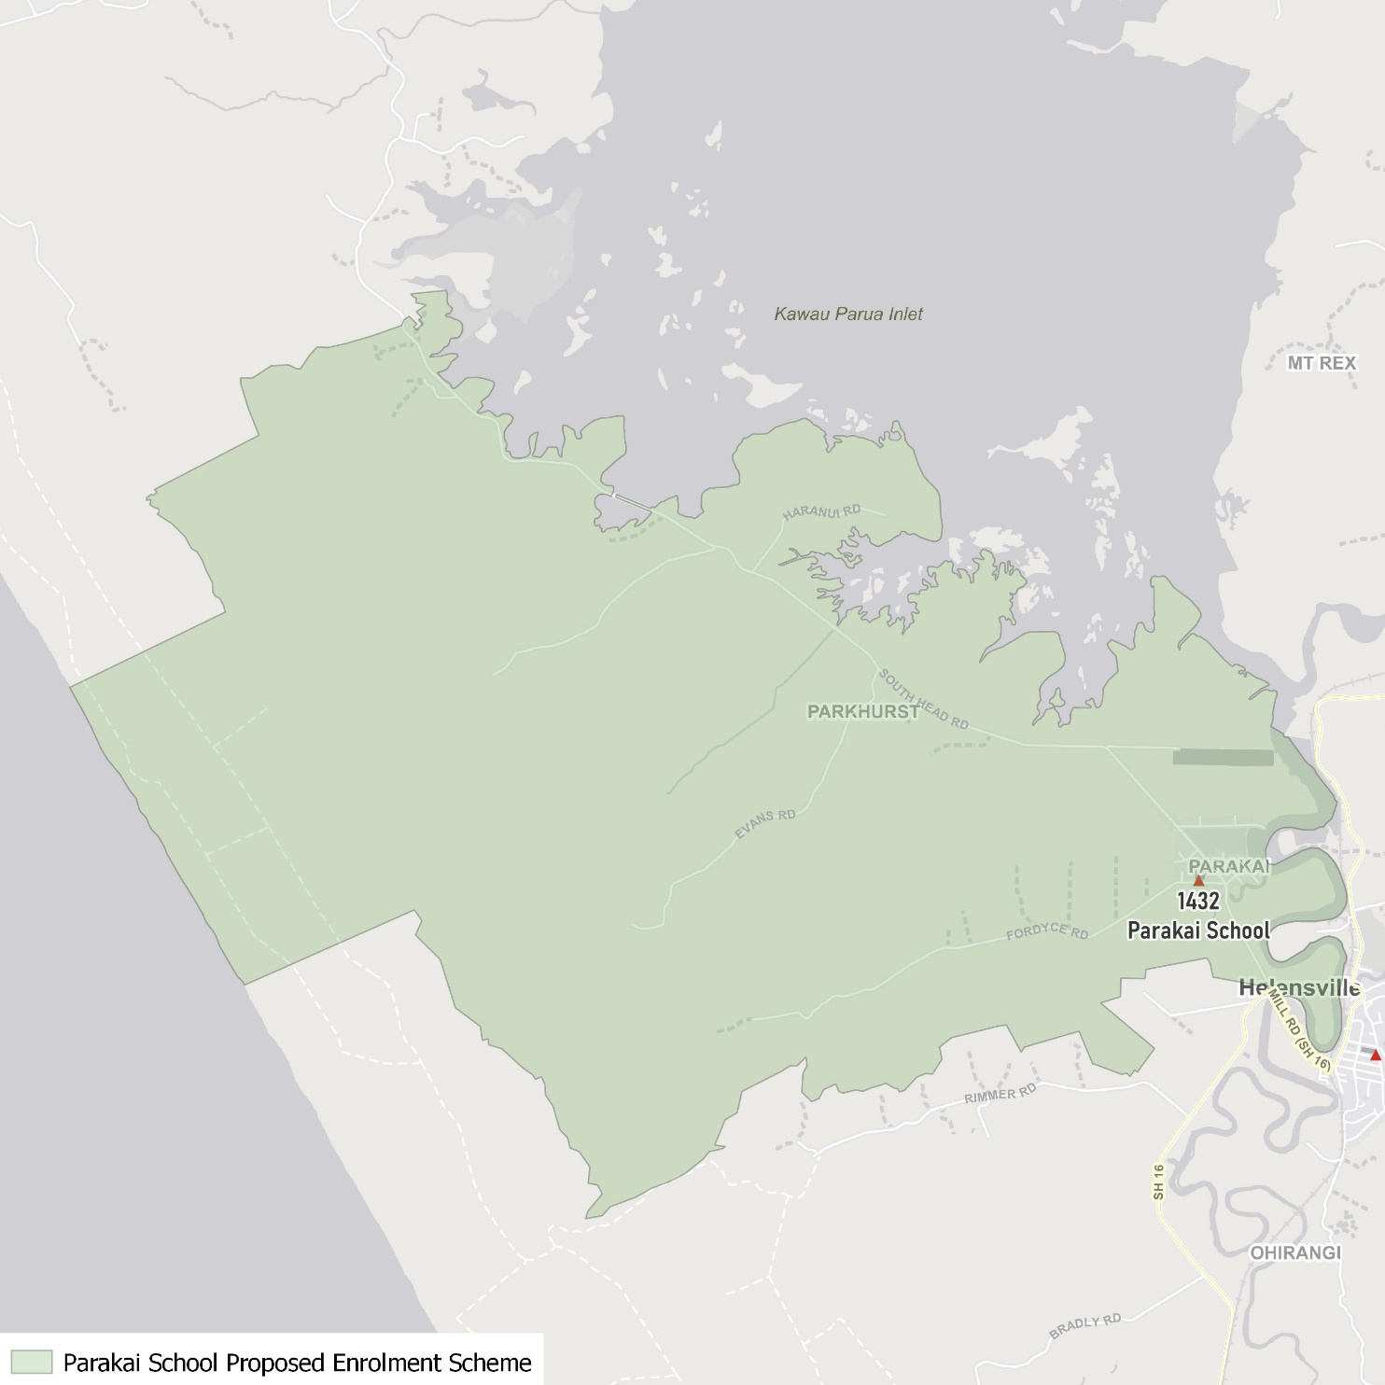

What does this mean for my family?
If you live in enrolment scheme home area for Parakai School, you will be entitled to enrol your child at the school. This entitlement applies to new students starting school, as well as any students currently attending another school in the area.
Families who live outside the enrolment scheme home zone of Parakai School do not have entitlement to enrol and could only attend if the Board of Trustees planned to enrol any out of zone students. The enrolment scheme will establish the process for this, and places will only be available if the Board of Trustees considers it has the capacity to allow for this. Further information about whether any out of zone places will be made available in early 2022.

Consultation process and timeline
The Ministry of Education is currently undertaking consultation about the proposed changes and new enrolment schemes. You can have your say by:
- Completing the survey at https://consultation.education.govt.nz/education/parakai-school-enrolment-scheme/
- Emailing auckland.enrolmentschemes@education.govt.nz if you have further questions or comments
The Ministry will consider all feedback and liaise with the Board before making a final decision. We expect the School community to be updated about progress. The new schemes and changes will come into effect for the beginning of term 1 2023.

